July 2022

2022 KBDi National Conference and Awards winners

Winners of the 2022 KBDi National Awards were announced over two nights on the 12 & 13 August in Sydney. Congratulations to Stefan Vignogna CKD Au – Winner of the coveted KBDi Kitchen Designer of the Year 2022.

Monday, 29 August 2022

South Australian kitchen wins KBDi’s highest national award partnered by Hettich Australia.

Stefan Vignogna in South Australia won the pinnacle award held at the cutting-edge Australian & International Museum of Contemporary Arts in the heart of The Rocks.

The Kitchen and Bathroom Awards were well attended by an audience of industry leaders and suppliers.

The winning kitchen was part of a “1930’s-character villa that had received a stunning transformation at the hands of a skilled designer. The reinvented space is both elegant and modern, meeting the client's brief of a minimalistic style while still retaining respect for the heritage architecture” says the Kitchen and Bathroom Designers Institute.

The panel of seven experienced judges from Glow Building Design, Studio Minosa, Milvia Hannah, Rex Hirst and Elizabeth Luke commended Stefan on his innovative design solution, striking concept presentation and exceptionally high standard of credentials. The kitchen also won the KBDi Kitchen Designer of the Year 2022 – South Australia, partnered by Hettich Australia.

The KBDi recognised exceptional projects by designers from all around Australia.

Hettich Australia’s Managing Director Martin Gane said “the KBDi National Awards recognised the best in Australian Kitchen and Bathroom designers”.

During the conference Hettich Australia proudly displayed the new AvanTech YOU Illumination signature lighting for our luxury drawer system and Cadro shelving system at the elegant Shangri-La Group Hotel, Sydney.
The Partner Product Expo was a great opportunity for our Business Development Managers - Bobby Salami, Andrew Haigh, Shelby Hood and Dean Pendlebury to network with key designers within the industry, sharing what’s new and upcoming products in the pipeline from Hettich.

For a full list of the winning projects visit https://www.kbdimembers.org.au/awards/kbdi-designer-awards-2022-national-winners/

Image 1
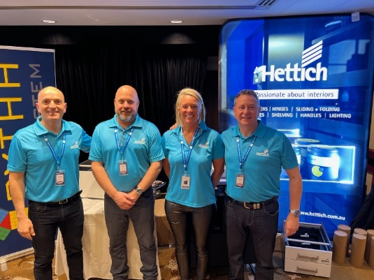
Image 2
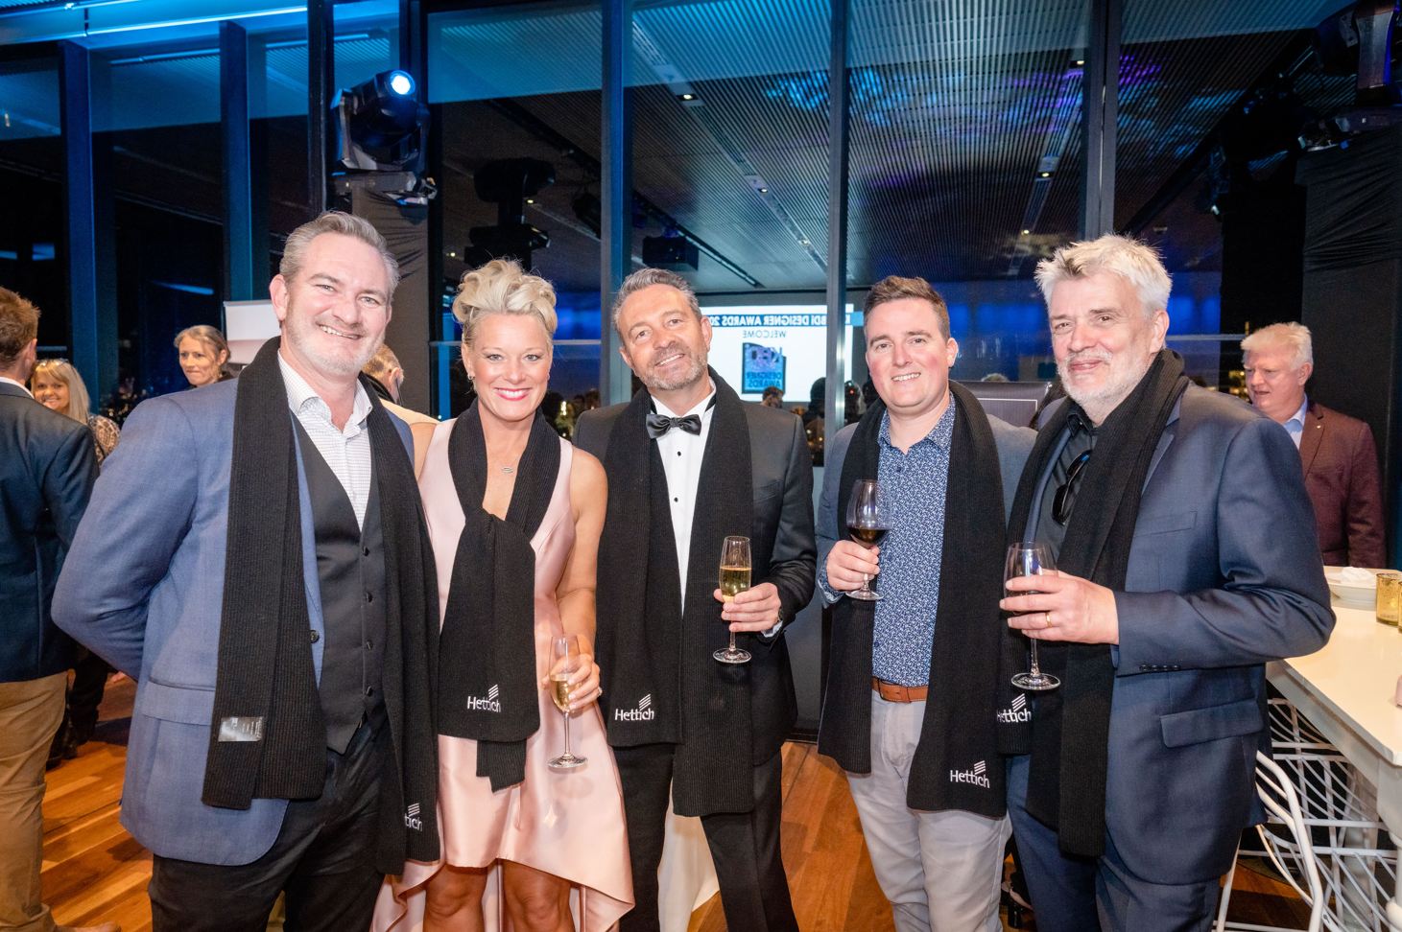
Image 3
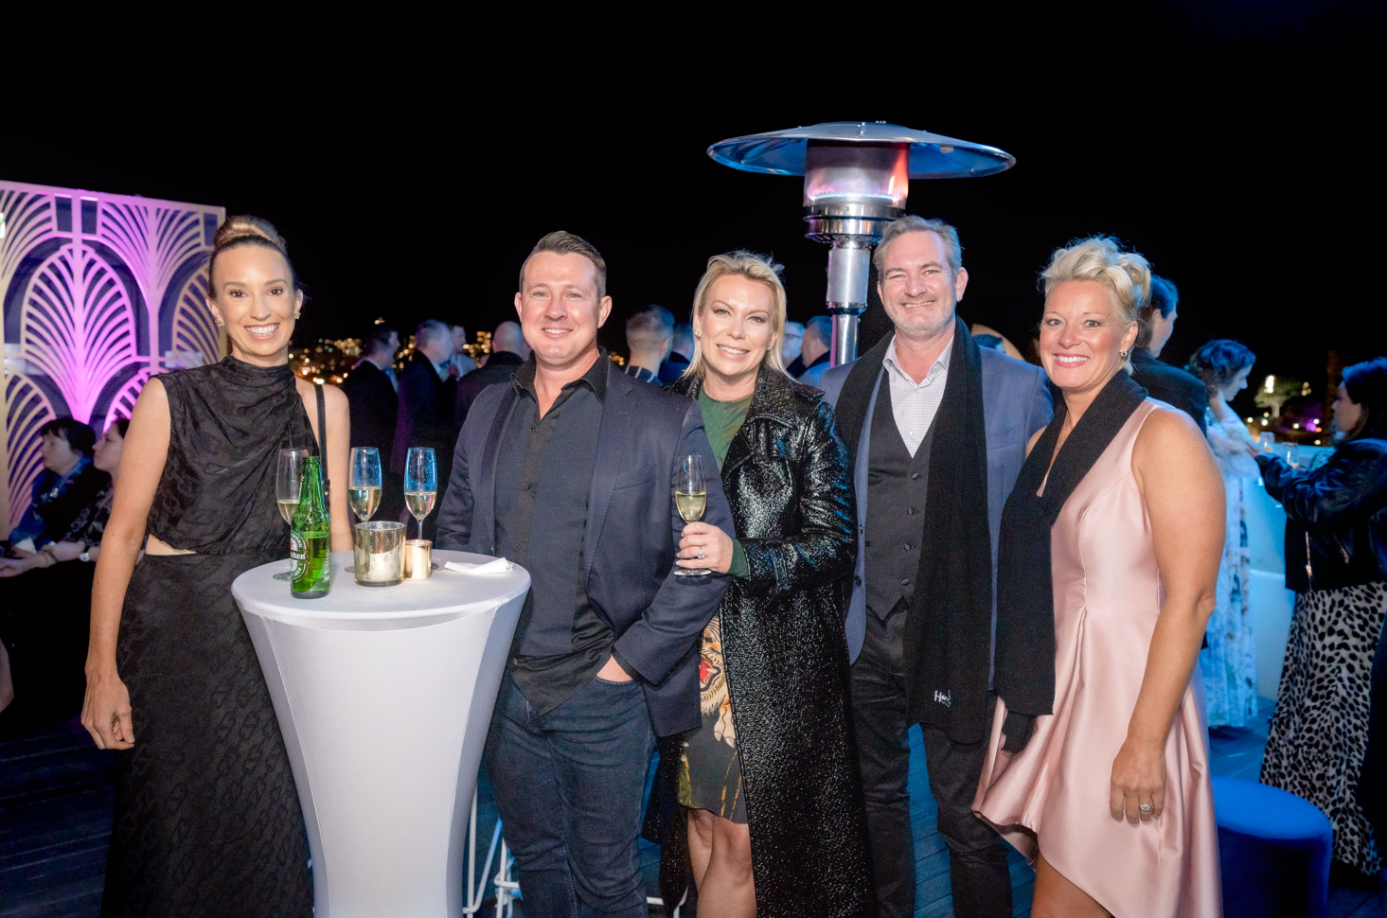
Image 4
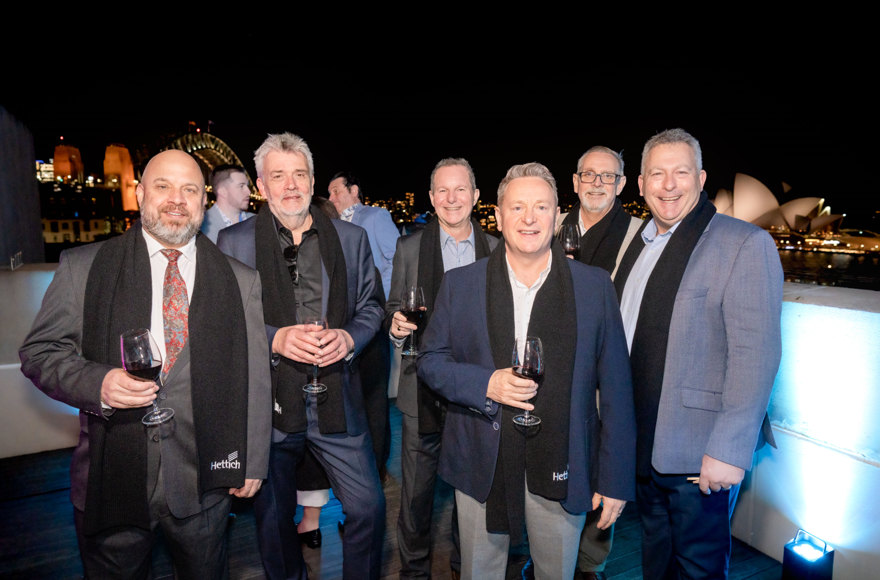

Image 5
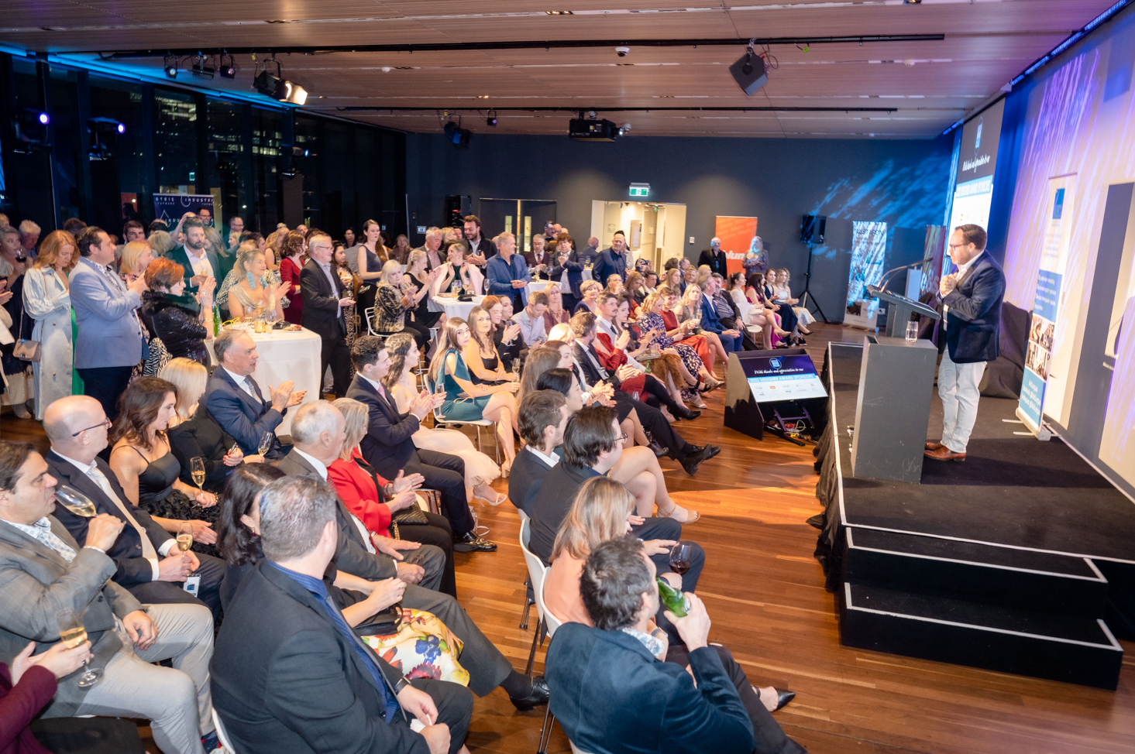
Image 6
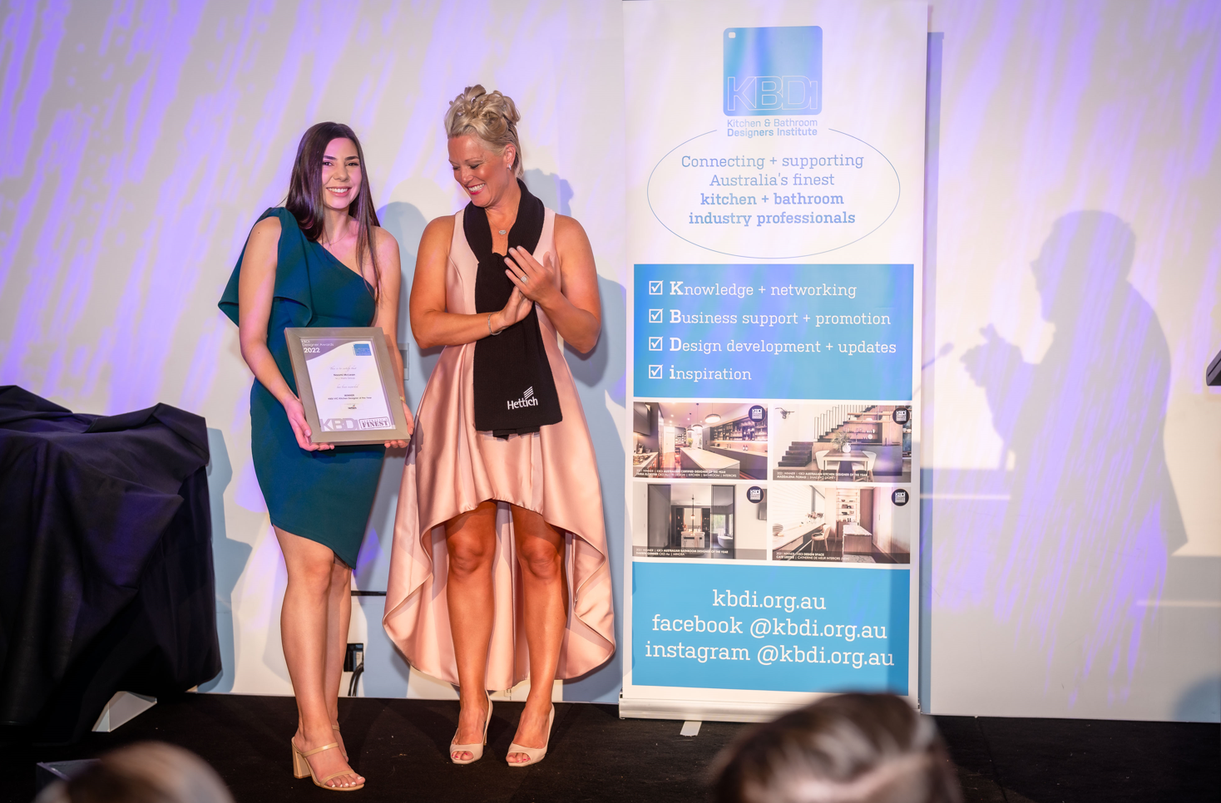
Image 7
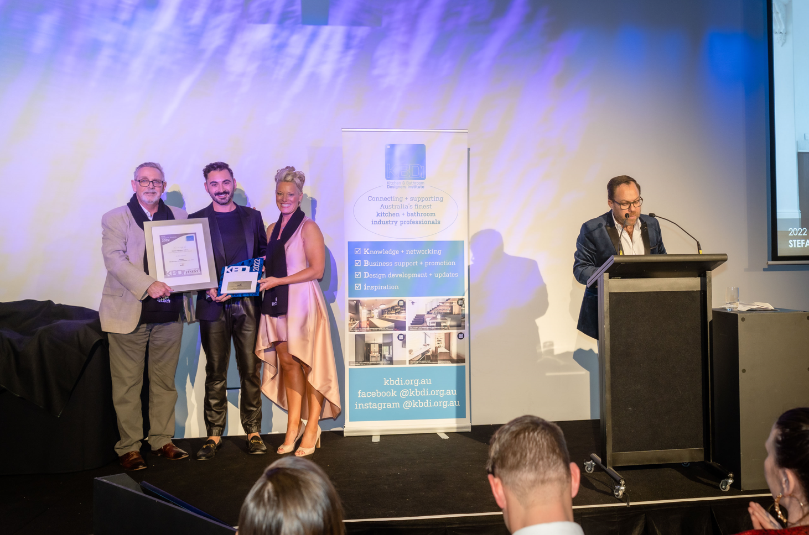
Image 8
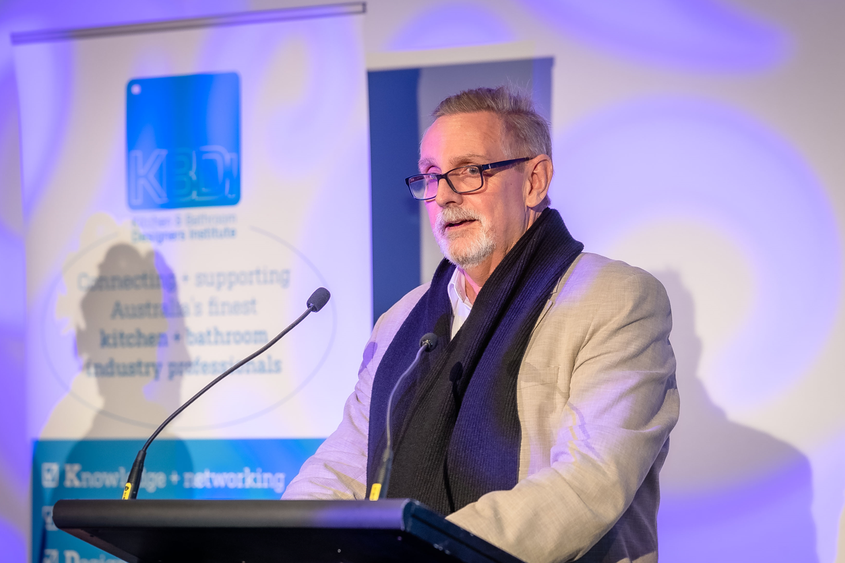
Image 9


