Hettich: new "Furniture Fittings and Innovations 2022" catalogue
Flip page catalogue and eServices – the unbeatable combination

New name – new service: Hettich's familiar "Furniture Fittings & Applications" catalogue is now called "Furniture Fittings & Innovations". Launching the latest "Furniture Fittings and Innovations 2022" version, Hettich is now making everything far more convenient for its customers and partners: in the form of an online flip page catalogue, "Furniture Fittings & Innovations" gives users all of the manufacturer's product knowledge, including eService tools – always up to date, available around the clock from anywhere and, of course, on mobile devices too.

The idea behind the new "Furniture Fittings & Innovations" is simple: Hettich wants to offer its products and services wherever users happen to need them.
This is why "Furniture Fittings & Innovations is set up as an online flip page catalogue. All very easy, clicking the article number now takes you directly to the eShop. "Furniture Fittings & Innovations" is also linked to the wide range of Hettich eServices on the web:
A digital new products tour introduces users to the latest product highlights and, whenever needed, they also have access to the Hettich Technical Assistant, CAD data, product configurators, the media library with assembly/installation videos or to the Design Gallery for creative ideas on all aspects of modern furniture and spatial solutions. Offering this lineup, Hettich has taken a further step in the digitisation process and now assists its customers and partners even more efficiently in every project phase, from advising customers and finding ideas, in planning and procuring materials as well as in realising furniture and in marketing.
Further details are available on Hettich's "Furniture Fittings & Innovations" landing page:
https://web.hettich.com/en-de/products-eshop/furniture-fittings-and-innovations-2022
The following picture material is available for downloading from the "Press" menu at www.hettich.com:

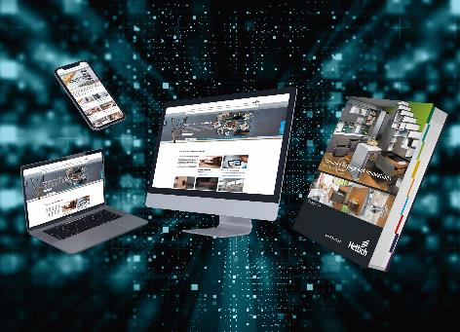
0820222_a
Product knowledge and service tools whatever the time and place: the latest Furniture Fittings & Innovations 2022" online flip page catalogue from Hettich is directly linked with practical eService– needless to say, from mobile devices too. Photo: Hettich

About Hettich
Hettich was founded in 1888 and is today one of the world's largest and most successful manufacturers of furniture fittings. Over 6,600 members of staff in almost 80 countries work together towards the objective: developing intelligent technology for furniture. Hettich thus inspires people all over the world and is a valuable partner for the furniture industry, trade and craft. The Hettich brand stands for consistent values: for quality and innovation. For reliability and customer proximity. Despite its size and international significance, Hettich has remained a family business. Independent of investors, the company's future is shaped freely, humanely and sustainably. www.hettich.com

