25 years of partnership: Hettich and N.A.A.
Joint development for becoming lead trading partner in Ireland

Over the past 25 years N.A.A., based in Dublin, has developed into Ireland's leading trading partner for fittings and wood-based materials. In addition to the comprehensive range of products and services, the quality and reliability of Hettich fittings have contributed to the success story and continuous growth of N.A.A.

Just as on the German market, the current living and kitchen trends play an important role on the Emerald Isle as well. Product innovations such as the AvanTech YOU drawer system or the TopLine XL sliding door system are therefore very popular. Last year, Hettich launched a new full range catalog to support customers in Ireland. At the same time digitization is becoming increasingly important. The catalog thus combines the best of both worlds: the printed reference work as a traditional offline tool and the digital links leading customers to the latest content in the online shop, CAD data, assembly aids and much more.

Successful teamwork for 25 years
N.A.A. customers in Ireland benefit from Hettich's extensive knowledge and constant willingness to innovate. At the same time, N.A.A. can play to its own strengths: valuable business relationships and a high level of product know-how as well as comprehensive services and precise knowledge of the Irish market. To mark the anniversary of this successful partnership, Hettich presented N.A.A. a certificate and a trophy. As a further surprise, "Hettich on Tour" started in Ireland for the first time at the same time. With the mobile showroom, N.A.A is now traveling across the country for 4 weeks to meet customers in all four provinces. Equipped with a perfect presentation of the new products and the traditional top sellers, this saves customers the trip to the N.A.A. showroom in Dublin. The rolling event is accompanied by a social media campaign, limited offers and special giveaways. Hettich and N.A.A. are looking forward to many interested craftsmen and furniture manufacturers!

The following image material is available for download at www.hettich.com, menu: Press:
Images & captions
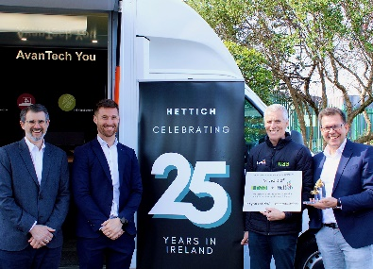
172022_a
Looking forward to the successful partnership and to the next 25 years together: (from left to right) Patrick Parthe, Hettich Sales Manager for N.A.A., Luke Kickey and Connor Hickey, Managing Directors of N.A.A. and
Thomas Kröger, Regional Sales Director.
Image: Hettich

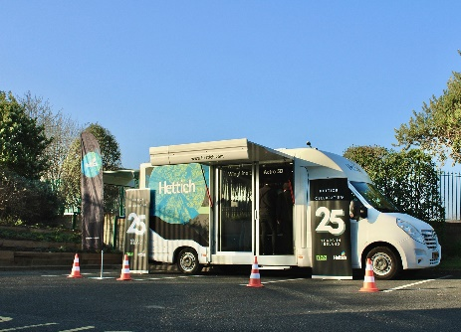
172022_b
Hettich on tour in Ireland: N.A.A. is on the road in Ireland for 4 weeks and is presenting Hettich's solutions on the spot.
Image: Hettich

About Hettich
Hettich was founded in 1888 and is today one of the world's largest and most successful manufacturers of furniture fittings. Over 6,600 members of staff in almost 80 countries work together towards the objective: developing intelligent technology for furniture. Hettich thus inspires people all over the world and is a valuable partner for the furniture industry, trade and craft. The Hettich brand stands for consistent values: for quality and innovation. For reliability and customer proximity. Despite its size and international significance, Hettich has remained a family business. Independent of investors, the company's future is shaped freely, humanely and sustainably. www.hettich.com

