Hettich proud of holding EMAS validation for 25 years
Hettich's Kirchlengern/Bünde and Frankenberg operating bases have been EMAS validated for a quarter of a century

The Hettich Group is the only leading manufacturer of furniture fittings to meet the voluntary, stringent EU requirements laid down in EMAS – and doing so for 25 years.

The Hettich Group has been taking part in the European Union's Eco Management and Audit Scheme (EMAS) for as long ago as 1997. Any environmental management system under EMAS includes the requirements laid down in international environmental management systems standard ISO 14001. The stringent EMAS criteria provide effective instruments that systematically take into account and measurably improve direct environmental aspects, such as energy and resource efficiency and hazard management, but also indirect environmental aspects, such as legal compliance. In the meantime, four of Hettich's German bases as well as our operations abroad in Spain and the Czech Republic now take part in the annual review cycles.

Once again, the Hettich Group's largest operating base in Kirchlengern/Bünde as well as the Frankenberg facility have now passed this independent, external validation by the state approved environmental auditors. "We can be very proud of holding the EMAS validation for a quarter century. Because EMAS not only continuously helps us to review the impact we have on the environment but also to document improvement measures and present them in a transparent manner," Lisa Castro Lago, Corporate Strategy Manager at Hettich, is pleased to report. "This is an investment in the responsibility we take for the environment under our sustainability strategy. We are aiming to achieve climate neutral Hettich operating bases, want to continue conserving resources and boost our energy efficiency."

The following picture material is available for downloading from www.hettich.com:

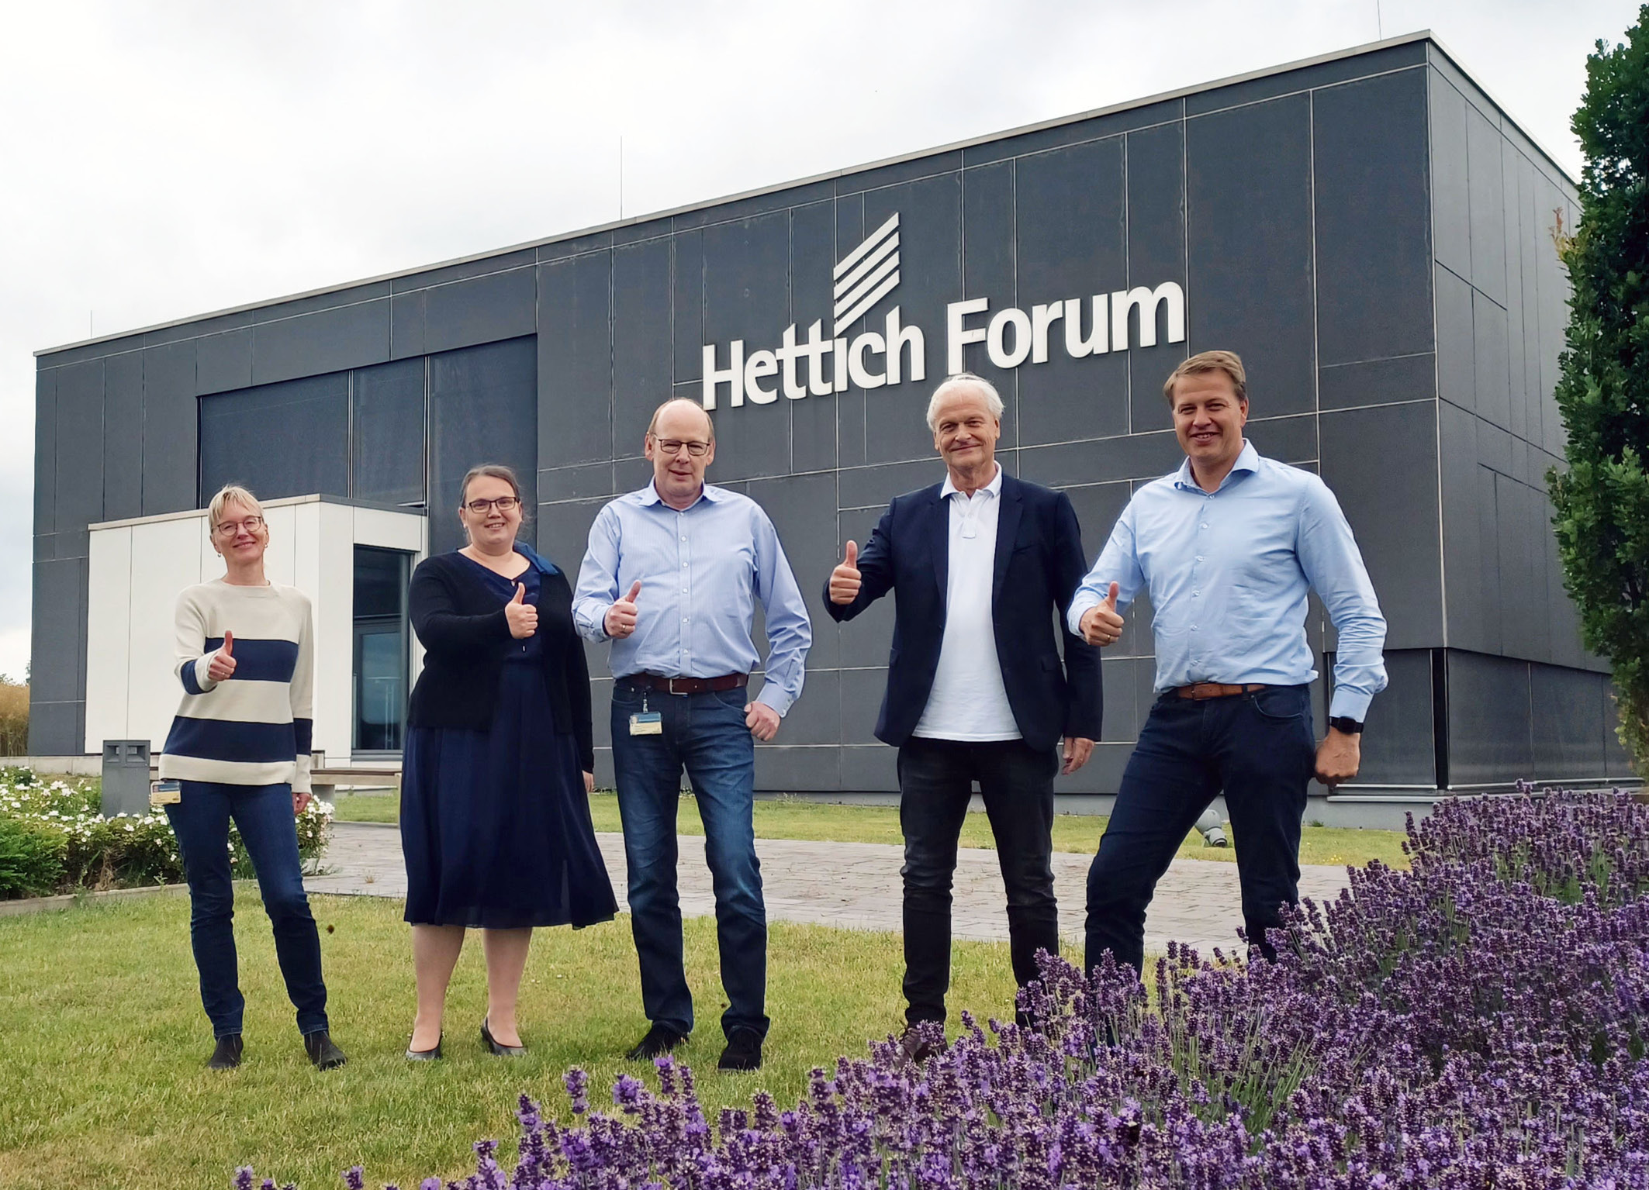

382022_a
Environmental auditor Dr. Ralf Rieken carried out the EMAS audit at the Kirchlengern/Bünde site. Hettich passed with flying colours.
(from left to right: Ute Schulz, Corporate Responsibility Team at Hettich; Irene Schirokow, Environmental Management Officer at Hettich; Thomas Kohlmeier, Project Planning at Hettich; Dr. Ralf Rieken, Environmental Auditor C&S; Michael Lehmkuhl, Managing Director at Hettich) Photo: Hettich

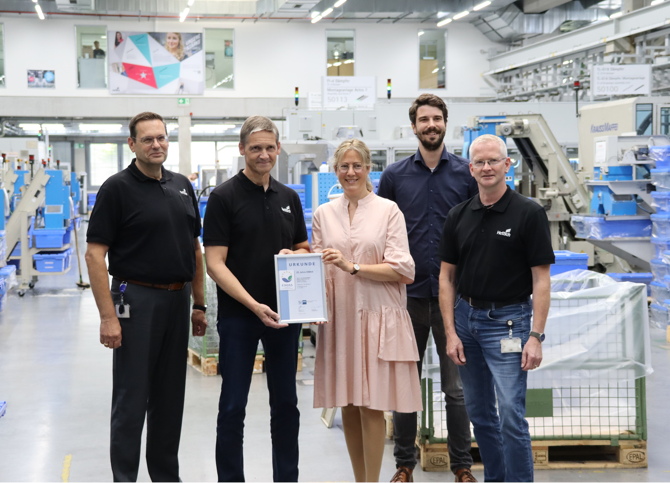

382022_b
EMAS 25th anniversary certificate presented by the Chamber of Industry and Commerce to colleagues at Hettich Druck- und Spritzgusswerk in Frankenberg. (from left to right Frank Blanke, Managing Director at Hettich in Frankenberg;
Hubert Engel, Quality and Environmental Management Officer at Hettich in Frankenberg; Elke Elsner, Environmental Consultant at the Kassel-Marburg Chamber of Industry and Commerce; Marcel Werner, Energy and Environmental Consultant at the Kassel-Marburg Chamber of Industry and Commerce; Frank Mütze, Environmental Coordinator and Occupational Health and Safety Specialist at Hettich in Frankenberg) Photo: Hettich

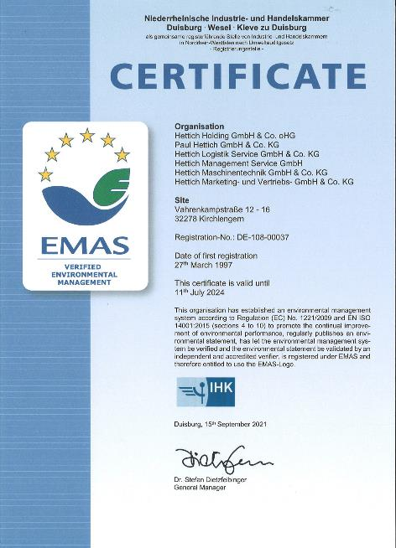

382022_c
Hettich's Kirchlengern/Bünde operating base once again receives EMAS certification.
Photo: EMAS/Hettich

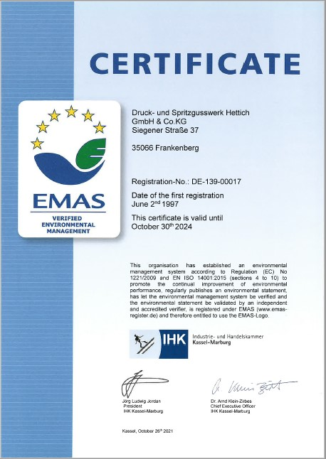

382022_d
Hettich's Frankenberg facility once again gets EMAS certification.
Photo: EMAS/Hettich

About Hettich
Hettich was founded in 1888 and is today one of the world's largest and most successful manufacturers of furniture fittings. Over 7,400 members of staff in almost 80 countries work together towards the objective: developing intelligent technology for furniture. On this basis, Hettich inspires people across the globe and is a valuable partner to the furniture industry, retailers and the trades. The Hettich brand is synonymous with consistent values: with quality and innovation. For reliability and closeness to customers. Despite its size and international significance, Hettich has remained a family run business. Independent of investors, the company's future is shaped freely, humanely and sustainably. www.hettich.com

