Hettich Group on course for growth
€ 1.35 billion turnover in 2021

The Hettich group of companies, one of the world's largest manufacturers of furniture fittings with headquarters in Kirchlengern, generated sales of around € 1.35 billion in 2021. That's 26 per cent up on the year before. 74 per cent of business was done abroad. Worldwide, Hettich invested € 79 million in new products, buildings and machinery. Hettich currently employs over 7,400 members of staff around the globe, more than 3,700 of them in Germany.

The Hettich Group brought 2021 to a successful close. The upturn in demand in the home furnishings market that started in the second half of 2020 continued into 2021. In the second year of the pandemic too, home improvement and home furnishings continued to be high on consumers' agenda across the globe. Many people invested in their own homes in 2021. "We have done our best to work with our customers in an effort to bring new and beautiful home furnishing solutions to as many consumers as possible", reports Jana Schönfeld, Managing Director of Hettich Holding. Kitchens, sofas; as well as home working furniture were particularly popular among the new purchases made. In addition to new furniture, DIY projects were also highly popular. Hettich was able to underpin this trend with its solutions for the Do-It-Yourself sector.

High demand meets challenges

In just the same way as the market as a whole, the Hettich Group faced a whole raft of challenges in 2021. "Sometimes raw materials were lacking, supply chains were backed up or capacity was overloaded", reveals Sascha Gross, Managing Director of Hettich Holding. Time and again there were temporary interruptions in the supply chains. Reasons included chaotic snow conditions in Hettich's home region of East Westphalia, the Ever Given container ship lodged in the Suez Canal and local lockdowns in various countries. Irreparable damage to the company's electroplating facilities in Berlin was also a particular headache in early 2021.
On top of this came the skyrocketing cost of raw materials and logistics. This is now being followed by ever higher energy prices. "Our customers would have liked to place even more orders with us. It was important for us to remain a reliable and transparent partner in these challenging times", Gross reports. More than ever before, the past two years have taught Hettich to demonstrate flexibility and continue to keep a quick pace with changing parameters. "Across the globe, this is where the entire Hettich team has done a great job. We are so grateful to all colleagues and share a sense of pride in what we have achieved", Schönfeld adds.

A family business continues to develop

As a family run business, Hettich has continued to evolve since it was founded in 1888. Hettich acts today while always thinking of tomorrow and the generations to come. This is why the company, now in its fourth generation, is continuing to innovate and grow. Spurring it on, the Hettich Group last year invested € 79 million into the future. The investment focus was on new products, expanding capacity and developing infrastructure. For instance, production facilities were expanded in Germany, China and India. The Hettich Group has also grown by acquiring a majority stake in Kuhn, the Bünde based sliding and partitioning system specialist, as well as in Actiforce, a specialist in height adjustable work tables from the Netherlands and Malaysia. "With our new family members and our own creative office solutions, we now offer our customers an even broader portfolio for designing future working environments – both at the office and working from home", says Gross. Furthermore, the Hettich group of companies has added a newly founded company with an unusual setup: Hettich NewCo GmbH is jointly controlled by apprentices as well as colleagues from the fields of apprenticeship and further training at Hettich.

Hettich is with those suffering from the war in Ukraine

The war in Ukraine will affect the Hettich Group because it operates in both countries. "We condemn this war in the strongest possible terms. This military aggression against an independent country is a deep cut for all of us after decades of peace in Europe. What the war means for the people there and for us remains to be seen. Our unreserved solidarity is with the people in the war zone, and we hope that further suffering will be avoided", Gross says.

Hettich takes a glimpse at the future

Material and supply bottlenecks, high cost increases and ever changing pandemic restrictions will continue to accompany the Group. "This is where it is up to all in the process chain – from our suppliers and partners and from us at Hettich to our customers and consumers – to deal with all this in a responsible and solution focused manner. No one in the process chain can handle it all alone", Schönfeld hastens to add.
Hettich is in the fortunate position of being able to fall back on a reliable network of partners and suppliers. The family run company is firmly committed to working with its customers to create stunning furnishing solutions for millions of people all over the world. Fired on in this way, Hettich confidently looks towards continued high demand in 2022. There's pent up demand among people in many countries when it comes to working on home improvements. Online retailing is opening up new options, creating new office environments and home working solutions. In just the same way as the megatrends of individualisation and new work, urbanisation is also providing all manner of opportunities. Because in many countries, people are continuing to flock into the urban environment.

Business sustainability: acting today – with a thought for tomorrow

Linking business success with showing responsibility for the environment and society, this is the long term aim of Hettich Group corporate strategy. "Sustainability has always been at the top of our agenda. First and foremost, that means taking responsibility – responsibility for ourselves, responsibility for others, responsibility for the environment," says Schönfeld, underscoring the relevance of sustainable business practice at Hettich. It is with a keen focus on social responsibility that the family run company takes care of its staff. We continue to place tremendous importance on health and safety at work. Hettich is also committed to a just and educated society. "We support the voluntary activities of our colleagues around the world and foster education, science and social causes with donations in cash and kind," says Gross, explaining Hettich's social responsibility.
Hettich has always taken its responsibility for the environment particularly seriously. In its responsibility for the environment and future generations, the fittings manufacturer has placed its focus on carbon footprint neutrality. It is under the “live sustainably" banner that the Hettich Group is working on avoiding greenhouse gas emissions wherever it can. "With this in mind, we put existing processes to the test and are planning new buildings as well as production facilities based on the highest sustainability standards. Our long lasting product solutions with the most exacting demands on quality and safety as well as environmental compatibility and energy efficiency help to benefit the environment and all of our colleagues", says Schönfeld, in closing.

The following picture material is available for downloading from www.hettich.com, menu: Press:
Images
Caption
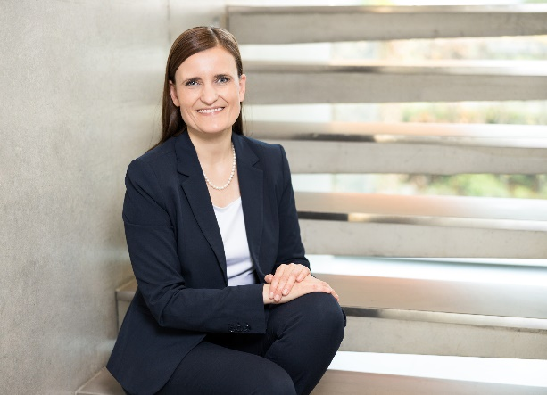
122022_a
Jana Schönfeld, Managing Director Hettich Holding, is grateful for the amazing cooperation and shared achievements of the 7,400 Hettich colleagues, partners and customers worldwide.
Photo: Hettich

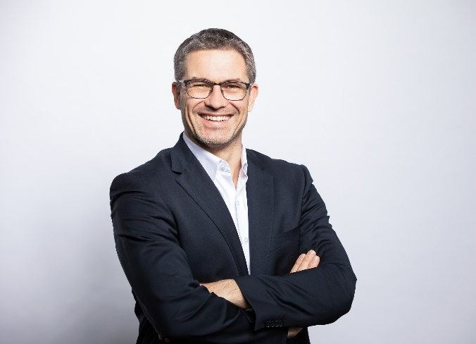
122022_b
Sascha Gross, Managing Director of Hettich Holding, is confident about the new financial year with demand remaining on a high.
Photo: Hettich

About Hettich
Hettich was founded in 1888 and is today one of the world's largest and most successful manufacturers of furniture fittings. Over 7,400 members of staff in almost 80 countries work together towards the objective: developing intelligent technology for furniture. Hettich thus inspires people all over the world and is a valuable partner for the furniture industry, trade and craft. The Hettich brand stands for consistent values: for quality and innovation. For reliability and customer proximity. Despite its size and international significance, Hettich has remained a family business. Independent of investors, the company's future is shaped freely, humanely and sustainably. www.hettich.com

