Hettich platforms as problem solvers
Process efficiency for customised furniture production

The "individualisation" megatrend is demanding more and more customised furniture concepts from industry and the skilled trades. Because customers are placing very personal demands and expectations on the design, use and function of spaces and furniture. Hettich's versatile platforms provide a simple and cost effective solution to these new challenges.

Responding to customer wishes with targeted precision? Producing customised furniture designs quickly and cost effectively? Also being able to serve different price segments with lean processes? And easily bringing individualisation to furniture even at a late stage in the production process? – Whether drawers, sliding door systems or door hinges – platforms from Hettich well equip tradespeople, fabricators and manufacturers for each of these challenges while enabling them to excite their customers time and again with innovative, tailor made furniture solutions.
Clear platform benefits
Hettich's tried and proven platform systems are versatile yet simple: within the platform, all components can be combined with each other. This significantly reduces production and stock keeping costs, makes it easier to differentiate and offer a broad product range from lean, flexible production. As a result, the platform also helps to open up new customer segments.
It was almost three decades ago that Hettich had the idea of using the platform principle to bring greater efficiency to furniture production. Since then, Hettich has regularly continued its success story with newly developed platforms. The basic idea remains unchanged: the platforms are geared to customers' needs, with each of them perfected in technical and practical terms – from straightforward assembly, adjustment and modification to user convenience in everyday use. Yet the look must be right too. This is why Hettich always attaches particular importance to high quality and appealing product design.

InnoTech: the platform pioneer from Hettich
The success story behind this ingenious principle for making furniture begins in 1996 with InnoTech from Hettich, the world's first drawer platform. From now on, it is possible to present a diverse range of furniture on the market on the basis of just one drawer side profile.

ArciTech: when quality becomes an experience
ArciTech, the second platform generation from Hettich, follows in 2011 with even more options for differentiating: thanks to new drawer and rear panel heights and further colour options, it is again possible to extend the range in line with customer requirements. And introducing the innovative Actro runner, Hettich can herald a new era in terms of smooth running action and stability with a load capacity of up to 70 kg.
InnoTech Atira: on the cutting edge
In 2015, Hettich once again goes a step further: developed on from the InnoTech range, the InnoTech Atira drawer system comes out with its characteristic, angular contour in a contemporary, unpretentious and sleek look. Different colours, a wide range of add on elements plus versatile interior organisation solutions permit even greater individuality. Time tested, perfected Quadro pull-out technology not only provides smooth running action and high load capacity but also the additional Push to Open Silent feature for the last word in convenience on handleless front panels.

AvanTech YOU: as individual as you.
In 2019, Hettich pushes ahead once again with its AvanTech YOU platform system: AvanTech YOU not only takes customisability to the next level, but drawer design too. Sharing the same cabinet body hole pattern, the drawer can be used on both Actro YOU and Quadro YOU runners. This creates the flexible and cost effective basis for addressing different market segments and fields of application. The slender AvanTech YOU drawer side profile comes in a thickness of only 13 mm and provides an immaculate look entirely without any visible holes, apertures or cover caps. The drawers can be configured in three colours and five heights with steel, aluminium or wooden rear panels. Clip on DesignProfiles and DesignCapes can be used to make statements that reflect personal style. And drawer side profile inlays provide the key to creating personalised design - even in any material the customer chooses.

The "AvanTech YOU Illumination" feature has been a new, attractive addition to Hettich's cost effective drawer platform since 2020. For kitchen and furniture manufacturers as well as the skilled trades, this opens up further opportunities to set themselves well apart from the competition and give their discerning customers attractively designed drawers with an exclusive feel and noticeable quality right up into the high end segment.

A dedicated website gives a quick overall picture of Hettich's latest drawer platforms and the benefits they provide: https://web.hettich.com/en-de/products-eshop/drawer-systems/drawer-platform

The following picture material is available for downloading from the Press section at www.hettich.com:
Images
Captions
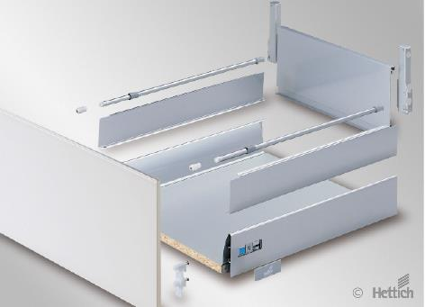
292022_a
Introducing InnoTech, the world's first drawer platform on the market, Hettich heralds in a new era in simple individualisation on furniture in 1996. Photo: Hettich

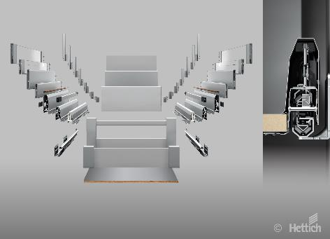
292022_b
ArciTech, the second platform generation from Hettich, offers further options in differentiating drawers. Photo: Hettich

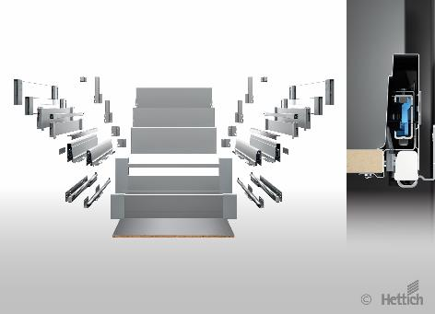
292022_c
InnoTech Atira leads on from the traditional InnoTech range. It comes with clean lines on the cutting edge of design while opening up even more flexibility in customising the look of furniture. Photo: Hettich

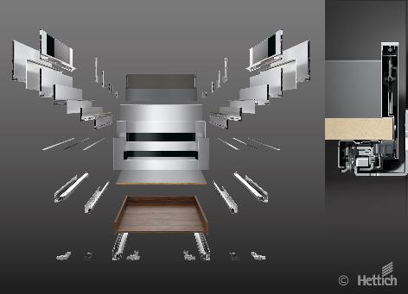
292022_d
AvanTech YOU: as individual as you. The latest platform generation is more versatile than ever. This permits any chosen design on a cost effective basis right up into the luxury segment. Photo: Hettich

About Hettich
Hettich was founded in 1888 and is today one of the world's largest and most successful manufacturers of furniture fittings. Over 7,400 members of staff in almost 80 countries work together towards the objective: developing intelligent technology for furniture. On this basis, Hettich inspires people across the globe and is a valuable partner to the furniture industry, retailers and the trades. The Hettich brand is synonymous with consistent values: with quality and innovation. For reliability and closeness to customers. Despite its size and international significance, Hettich has remained a family run business. Independent of investors, the company is free to shape its future in a humane and sustainable manner. www.hettich.com

