Huge commitment to voluntary work worldwide

Hettich supports charitable projects to the tune of € 59,500

Across the globe, colleagues from Hettich operating bases have been involved in various projects within the "Hettich Ehrenamt 2022" volunteering campaign. Each receiving funding worth € 500, the Hettich Group has helped no fewer than 119 projects in Germany, the Czech Republic, Australia and the United Kingdom, making out donation cheques totalling € 59,500. Of this, € 37,000 alone went to projects in Germany which involve Hettich colleagues.

Anyone working at Hettich can apply for funding in aid of projects they do voluntary work for. Funding in the amount of € 500 go to projects related to social matters, education, science, nutrition, exercise, culture and the environment.

"We are absolutely delighted to have once again been able to give meaningful support to numerous projects within our 'Hettich Ehrenamt' volunteering campaign. The tremendous amount of positive feedback we have had from associations, clubs and societies shows we are making a valuable contribution," says Laura-Sophie Putschies, Corporate Communications at Hettich.

Since the "Hettich Ehrenamt" volunteering campaign was launched to mark the company's 125th anniversary in 2013, over 1,200 projects have already received funding of no less than € 700,000.

The following picture material is available for downloading from www.hettich.com, menu: Press:
Images
Caption

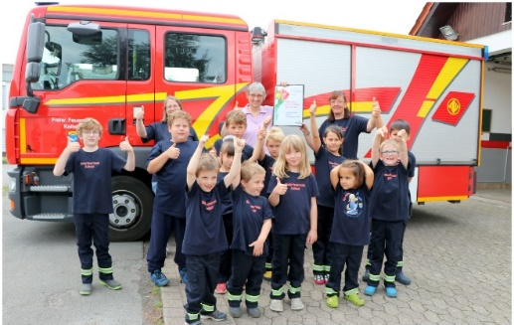
022023_a
Hettich colleague Ursula Kreitschmann from Vlotho is involved in the
Kalletal Erder children's fire brigade as the group's youth leader/supervisor.
Among other things, the young people there are familiarised with the objects found onboard a fire engine, practise first aid and are taught about potential hazards, such as faulty power cables. The funding from Hettich will be spent on a smoke house in aid of fire safety education. Photo: Hettich

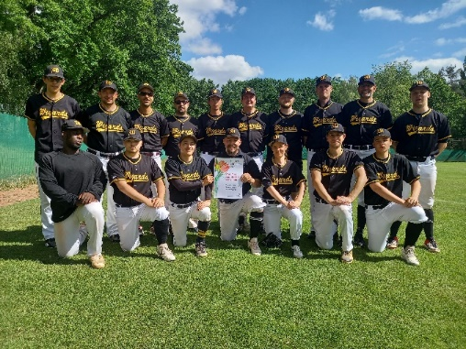
022023_b
Hettich colleague Gerhard Salomon from Berlin is volunteer equipment manager at the Berlin Wizards e.V. baseball and softball club.
The donation from Hettich will be used to buy new sports gear, repair existing equipment and reorganise the storage area. Photo: Hettich

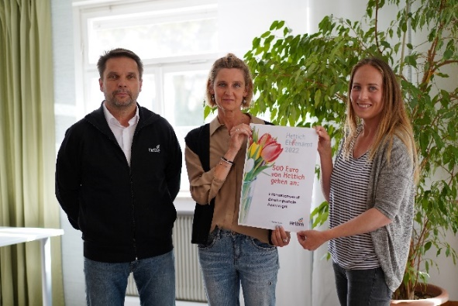
022023_c
Hettich colleague Axel Tantur from Balingen is involved in the Feuervogel e.V. counselling centre against sexualised violence. He provides counselling for women, children and young people who are going through or who have gone through sexual borderline experiences. The donation from Hettich will be used for a new information stand. Photo: Hettich

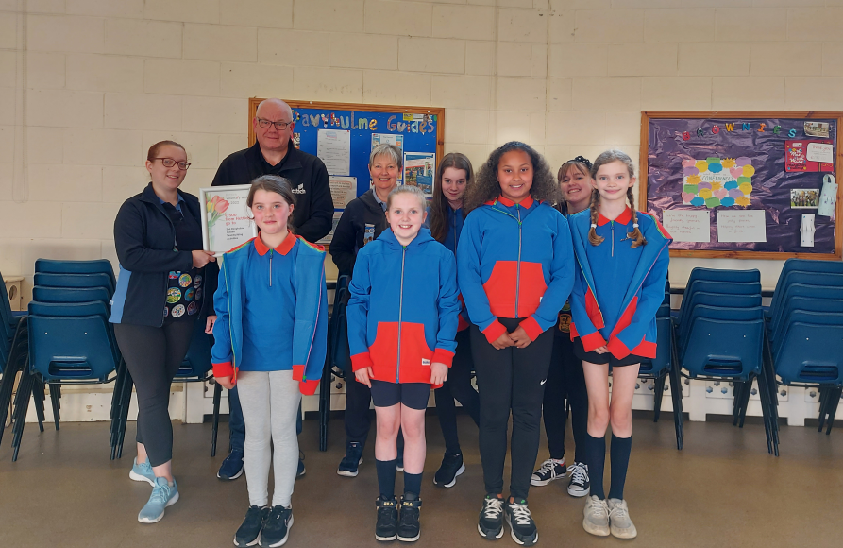
022023_d
Hettich colleague Mavis Waters from England is involved in girlguiding voluntary work for the "2nd Davyhulme Guides". The girls, aged ten to 14, take part in activities such as raft building, kayaking, canoeing and paddleboarding. The donation from Hettich will be used for a team building activity. Photo: Hettich

About Hettich
Hettich was founded in 1888 and is today one of the world's largest and most successful manufacturers of furniture fittings. Over 7,400 colleagues in almost 80 countries work together towards the objective: developing intelligent technology for furniture. On this basis, Hettich inspires people across the globe and is a valuable partner to the furniture industry, retailers and the trades. The Hettich brand is synonymous with consistent values: with quality and innovation. For reliability and closeness to customers. Despite its size and international significance, Hettich has remained a family run business. Independent of investors, the company's future is shaped freely, humanely and sustainably. www.hettich.com

