Hettich is "Steelcase 2022 Premier Supplier"
Office furniture manufacturer once again awards top supplier accolade to Hettich
In its annual supplier ratings, Steelcase, Grand Rapids, USA, gave the Hettich Group its "Premier Supplier" award in April 2022 for the third time in succession.

Steelcase, a multinational manufacturer of office furnishings and spatial solutions, employs some 11,700 members of staff and works with over 800 specialist retailers worldwide. The company's "Premier Supplier" award acknowledges exceptional performance and outstanding commitment on the part of its suppliers. This is by no means the first time Hettich has been given an award by Steelcase in a business relationship spanning over 20 years. The Hettich Group supplies Steelcase's European production plants in the Czech Republic and Spain. The sales mainstays are the Systema Top 2000 drawer system and the SlideLine 55 Plus sliding door system. Our strongest sales are in the Systema Top 2000 drawer system etc. The coronavirus pandemic means that the awards will not be presented in person at the Steelcase campus in the USA as they usually are.

Karlheinz Deutsch, Key Account Manager for Steelcase at Hettich, is proud of this recent accolade honor: "Hand in hand, we have been working with Steelcase for over two decades, and we are always keen to live up to our good reputation. Our greatest challenge last year was to give Steelcase a reliable delivery timeline of four days – and do so despite COVID, despite tense supply chains and despite the poor availability of raw materials such as steel. My thanks go to all colleagues at Hettich who all pulled together and managed to meet the brief with such efficiency and resolve."

The following picture material is available for downloading from www.hettich.com, menu: Press:
Images
Captions
202022_a
Office solutions provider Steelcase acknowledges Hettich's outstanding performance and reliability as a supplier for the third time in succession. Logo: Steelcase

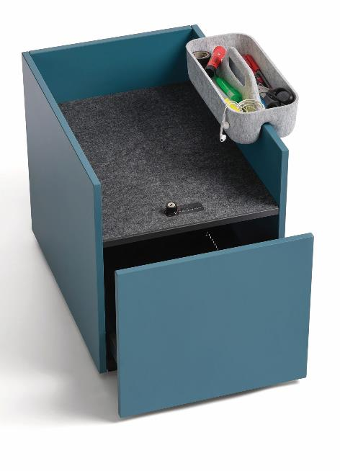
202022_b
This Steelcase Implicit pedestal with the Systema Top 2000 from Hettich combines the convenience and security of a lockable drawer with a sound absorbing bag drop. Foto: Steelcase

202022_c
Karlheinz Deutsch, Key Account Manager for Steelcase at Hettich: Our greatest challenge last year was to give Steelcase a reliable delivery timeline of four days – and do so despite COVID, despite tense supply chains and despite the poor availability of raw materials such as steel. My thanks go to all colleagues at Hettich who all pulled together and managed to meet the brief with such efficiency and resolve." Photo: Hettich

About Hettich
Hettich was founded in 1888 and is today one of the world's largest and most successful manufacturers of furniture fittings. Over 7,400 members of staff in almost 80 countries work together towards the objective of developing intelligent technology for furniture. Hettich thus inspires people all over the world and is a valuable partner for the furniture industry, trade and craft. The Hettich brand stands for consistent values: For quality and innovation. For reliability and customer proximity. Despite its size and international significance, Hettich has remained a family business. Being independent of investors means that the company has a free hand in shaping its future with a focus on the human element and sustainability.

