Hettich keeping track of trends
These furnishing and design trends are on their way

Hettich's trend scouts were out and about again in April at this year's Salone del Mobile in Milan, spotting the latest trends. No other event sets more trends in the international furnishing and design industry than this trade fair. Hettich is embracing the new design looks in developing its own furniture concepts and innovative fitting solutions.

Alongside the overarching social trends that are changing the way we live and work, while lifting up the furniture world with innovative furnishing concepts, it's the latest colours, shapes and materials that are making consumers want to buy new furniture and home accessories. Design trends come with a particular impact on the products Hettich develops because the manufacturer itself has become a trendsetter for constructive furniture design with its innovative fittings. This is where cost effectiveness and exacting design expectations go hand in hand.

Stunning simplicity
In terms of colour, muted shades are set to dominate furniture design. Beige and nude in all hues exude timeless elegance. The great advantage of this colour palette is that it goes with any style of home, and combines exceptionally well with natural materials or contrasting colours. As a contrasting colour, orange is an absolute favourite among designers. The trend towards natural authenticity is continuing, hence also the light shades. These make the ideal choice for setting off natural materials such as wood, stone and marble.

Vertical stripes
Whether as grooving in the surface decor, as wall decor or furniture front made of timber slats, as prints on paper or fabrics – there's no way around the retro look that's still the height of fashion. Three dimensional surface textures in particular cut a very classy figure that speaks quality. Accent colours in striped look add variation. A trend that's fun and provides huge creative scope.

Designer favourites – glass & marble
Glass is and remains ever present. Whether coloured, clear or etched: glass gives furniture a light and airy feel. The change being heralded in by the megatrend of urbanisation is leading to smaller homes such as mini apartments. This is making glass an increasingly important element in small spaces as the transparent material creates the bright and airy ambience that's needed here. Equally, glass gives furnishings a look of exquisite elegance and can be staged by indirect lighting with stunning effect. A heavy yet exceedingly vibrant counterbalance to glass is real marble. No two pieces of marble are alike, each having its own particular characteristics. This makes marble an exclusive material that's preferably used as an accent feature in high quality furniture lines.

Big hit: interplay of shapes
Purism yes, but with panache. Organic shapes are continuing to transcend stringent linearity. Lines are following natural structures, such as wood grain. Corners are becoming increasingly rounded, shapes more fluid. In shelving, the clear trend is towards the interplay of open and closed elements. Ideal for this are Hettich's sliding door fittings that make sliding doors incredibly easy to move back and forth or up and down in front of furniture. This lets you change a shelf element's look and conceal storage spaces in any way you choose. This trend is also catching on with room dividers. And makes the use of shelves even more attractive and versatile.

At Salone del Mobile, Hettich's trend scouts made an entertaining video in which they present the leading design and furnishing trends:
https://www.hettich.com/short/nm28xz

The following picture material is available for downloading from the "Press" menu at www.hettich.com:

Images
Captions

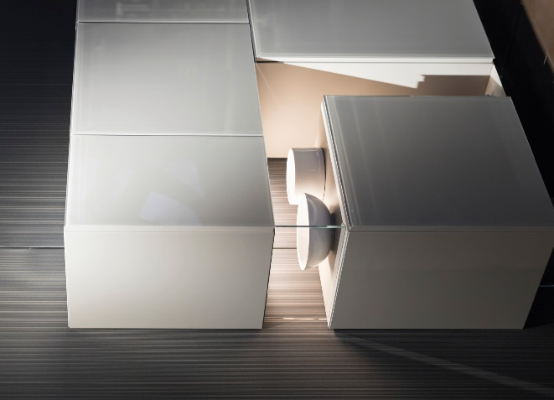
162023_a
Understated colours like white, cream and natural shades are still right on trend. Photo: Hettich

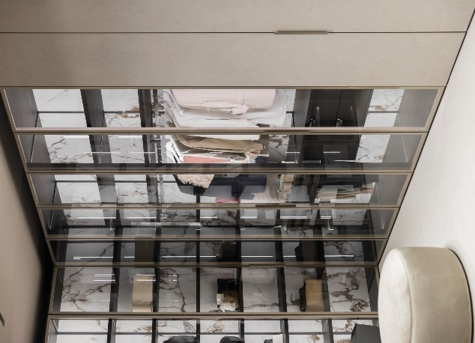
162023_b
Increasingly, glass is being used as a material for floor to ceiling furniture doors. This provides attractive ways of incorporating rear panels into furniture design. Photo: Hettich

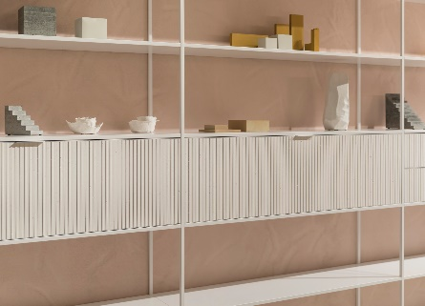
162023_c
Vertical structures on door fronts combined with slimline frames are giving a new light and airy feel to shelf units and room dividers. Photo: Hettich

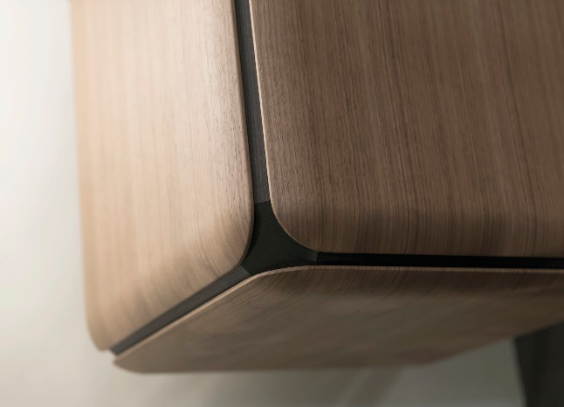
162023_d
Cuboid shapes with rounded corners in a combination of materials, e.g. with wooden surfaces, underscore the trend towards high quality natural authenticity. Photo: Hettich

162023_e
Muted orange brings a refreshing look to furnishings and goes wonderfully well with dark walls and floors. Photo: Hettich

About Hettich
Hettich was founded in 1888 and is today one of the world's largest and most successful manufacturers of furniture fittings. Over 7,400 members of staff in almost 80 countries work together towards the objective: developing intelligent technology for furniture. On this basis, Hettich inspires people across the globe and is a valuable partner to the furniture industry, retailers and the trades. The Hettich brand is synonymous with consistent values: with quality and innovation. For reliability and closeness to customers. Despite its size and international significance, Hettich has remained a family run business. Independent of investors, the company's future is shaped freely, humanely and sustainably. www.hettich.com

