Hettich wins three Red Dot Design Awards 2022
Awards go to lighting, soft closing and pull-out system

Hettich is triple winner of the world renowned Red Dot Award in the "Product Design" category. The AvanTech YOU Illumination feature, the Push to open Silent soft closing system for hinged doors and the Quadro Compact FE 20 drawer runner for wine refrigerators received the accolade for outstanding design quality.

With its three award winning products, Hettich clearly demonstrates that innovative fittings often form the basis for discerning and practical furniture design. The AvanTech YOU drawer system goes one step further and is quite simply the platform for design diversity. In addition to any choice of colour, format and material, the newly awarded AvanTech YOU Illumination feature speaks to the emotions with light: homogeneous LED light at 4,000°K in clip on profiles illuminates open drawers on the inside or makes a stunning statement on the outside. And glass inlays with polished or ground edges are also presented in the best light with AvanTech YOU Illumination. The system works without any additional cables in furniture which means it is easily fitted at any later stage.

Hettich's newly developed Push to open Silent for hinged doors also left the jury no doubt. This solution closes a convenience gap in handleless design because a soft and self closing mechanism has so far not existed for a mechanical opening system for hinged doors. The Push to open housing contains standard batteries. These supply the energy needed to return the push rod to its home position after the handleless door has been opened. The compact soft closing system simply screws into the cabinet body and matches its particular colour in a choice of either white, grey or anthracite.

The award winning Quadro Compact FE 20 pull-out system for wine refrigerators also combines design and user friendly convenience in a way that meets discerning expectations. Wine bottles should be moved without vibration so as not to impair quality and taste. Providing jerk-free action, the Quadro Compact pull-out system gently moves the wine refrigerator's pull-out shelves in and out. A hybrid ball bearing system ensures particularly smooth, low vibration running performance. Optional features such as the soft and self closing mechanism enhance user convenience. Coming in a dark surface finish, the pull-out runner perfectly matches the wine refrigerator's classy design too.

Three products, three different applications, all achieving one goal: outstanding, practical furniture design with emotional appeal.

The following picture material is available for downloading from www.hettich.com, menu: Press:

Images
Captions

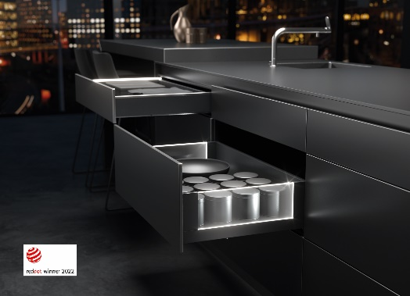

PR_132022_a
Red Dot Award winner 2022: The AvanTech YOU Illumination feature from Hettich brings elegant signature lighting to drawers.
Photo: Hettich

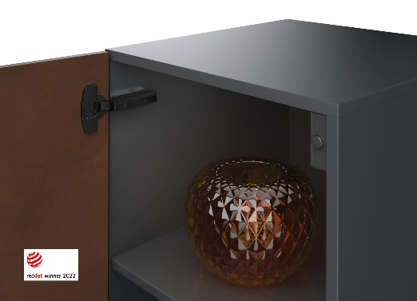
PR_132022_b
Red Dot Award winner 2022: Push to open Silent from Hettich softly closes handleless hinged doors.
Photo: Hettich

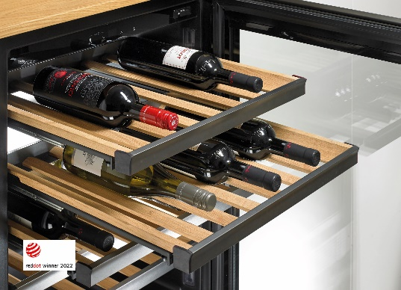
PR_132022_c
Red Dot Award winner 2022: Hettich's Quadro FE 20 runner system for wine refrigerators not only provides gentle running action, it looks good too.
Photo: Hettich

About Hettich
Hettich was founded in 1888 and is today one of the world's largest and most successful manufacturers of furniture fittings. Over 7,400 members of staff in almost 80 countries work together towards the objective: developing intelligent technology for furniture. Hettich thus inspires people all over the world and is a valuable partner for the furniture industry, trade and craft. The Hettich brand stands for consistent values: for quality and innovation. For reliability and customer proximity. Despite its size and international significance, Hettich has remained a family business. Being independent of investors means that the company has a free hand in shaping its future with a focus on the human element and sustainability.

