Hettich presents the future of assembly machinery at interzum 2023
Digital aids for the cabinetmaker's workshop

Hettich is taking the next step on the road to digital transformation in the cabinetmaker's workshop, linking its process technology with digital services, assembly aids in 3D printing and augmented reality. At interzum 2023, Hettich will be showing how digital capabilities can be used even today to benefit assembly machinery and prepare it for the future.

Open the AR app, use your smartphone or tablet to search for problems in the machine and find solutions all by yourself. What might sound like a long way off is already being applied successfully in many industries. If it were up to Hettich, augmented reality (AR) would soon be part of the standard workshop lineup. In just the same way as other digital aids.

Now more than ever, drilling and insertion machines from Hettich's BlueMax series are basic equipment in many workshops. Precision, ease of handling, safety and a product range that meets the demands of the customer all point towards this long time favourite. Users can now discover a very helpful feature right at start up: every machine comes with a QR code that takes them directly to the Hettich Technical Assistant. Not only providing assistance with installing and adjusting the settings of the machine, this digital aid also comes with other tools that aid the assembly process. This way, machine operators benefit from even easier operation and immediate assistance with application related questions. The digital assistant also provides up to date videos on the correct way to start up and adjust the settings of an assembly machine as well as on using it in the workshop. Machines already on the market are simply "upgraded" with the QR code in the form of a sticker.

Cabinet makers and interested parties are also invited to experience AR in practice at Hettich's booth in hall 8.1, booth C31/B40. On an actual BlueMax machine, Hettich's assembly experts will be showing what processing will look like in the future with the aid of a tablet and dedicated AR app. The user will benefit from self-explanatory instructions – from getting started to straightforward application assistance. The experts will also be explaining why AR is an important component in responding to the growing shortage of skilled workers.

Taking the example of 3D printing, Hettich will be illustrating the flexibility with which assembly machinery can be supplemented with digital peripherals, while also producing jigs in real time. These little tools and drilling jigs are key to processing furniture quickly and easily. In future, the required data will also be made available for download. What's more, a video will be giving visitors an impressive glimpse at Hettich's vast product portfolio and the digital services that are available on all features of these assembly machines.
For more on Hettich at interzum 2023, go to:
https://interzum.hettich.com

The following images are available for download from the "Press" menu at www.hettich.com:

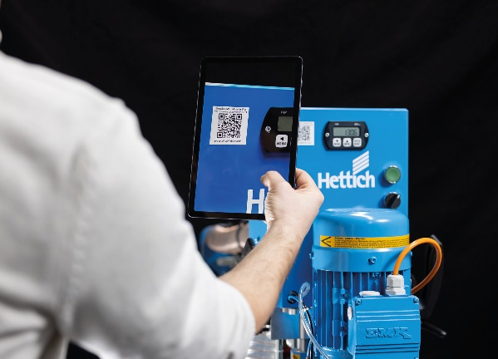
082023_a
The QR code on the BlueMax machine takes users directly to the Hettich Technical Assistant, which provides help on installing and adjusting the settings of the machine. Photo: Hettich

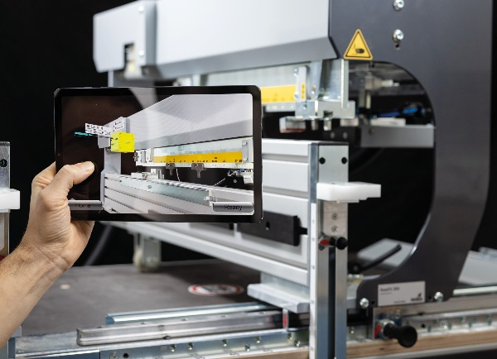
082023_b
In future, a dedicated AR app will give users self-explanatory instructions on getting started and provide a helping hand. Photo: Hettich

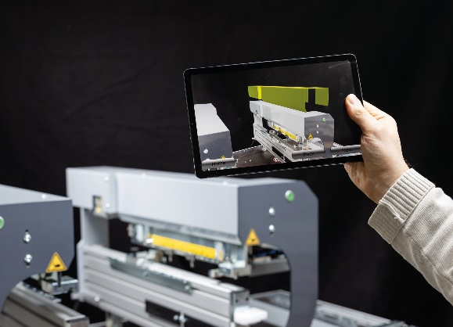
082023_c
A tablet or smartphone and the AR app will in future make it easier to diagnose and rectify faults. Photo: Hettich

About Hettich
Hettich was founded in 1888 and is today one of the world's largest and most successful manufacturers of furniture fittings. Some 8,000 colleagues in almost 80 countries work together towards the objective: developing intelligent technology for furniture. On this basis, Hettich inspires people across the globe and is a valuable partner to the furniture industry, retailers and the trades. The Hettich brand is synonymous with consistent values: with quality and innovation. For reliability and closeness to customers. Despite its size and international significance, Hettich has remained a family run business. Independent of investors, the company's future is shaped freely, humanely and sustainably. www.hettich.com

