New "Hettich on tour" season hits the road
2023 European roadshow to show top innovations

Hettich makes things particularly easy for its trade, retail and industry partners: letting entire teams in workshop and production test the latest product highlights in person, the fittings specialist will be rolling up right on their doorstep with a mobile showcase of its very latest product releases. Running since 2020, the customer focused "Hettich on tour" format is now embarking on its fourth season: from March to November 2023, two compact Hettich vehicles will once again be travelling right across Europe. And, needless to say, Hettich's all-new product highlights will be on board from Portugal to Lithuania.

Last year too, Hettich was on the road crossing the continent in two vans: over 80,000 kilometres of travel, hundreds of appointments and endless talks with customers and partners from Norway to Italy and from Belgium to Poland demonstrate the unwaning appeal "Hettich on tour" ignites.

After a short winter break, the two vehicles are now venturing out again on a long journey with a product show that's on the cutting edge. Among the products on display in the vans' newly revamped interior, Hettich will be presenting the brand new Novisys hinge family. This highly cost efficient solution is set to fire up the market for soft closing hinges. Because Novisys takes the luxurious feel of integrated soft closing to the mid price segment too. Hettich will, of course, also be presenting its premium, tried and tested Sensys door hinge in an exclusive dark Obsidian colour finish, while featuring a new "Push to open Silent" function. Showcasing the TopLine XL, SlideLine M and Wingline L trio, Hettich will also be demonstrating its particular expertise in sliding and folding door systems. Emotional appeal and top design, all this is promised by the AvanTech YOU drawer platform with "Illumination" LED signature lighting and the Cadro aluminium frame system, also coming with integrated lighting technology. Attracting the prestigious Red Dot and iF design awards, AvanTech YOU Illumination raises the profile of customers operating at design focused, upmarket level in the kitchen and furniture market segments. All of the solutions on display can be tried out first hand. And anyone wanting to find out even more can tap on the touchscreen in the "Hettich on tour" van to access further information on products, ease of construction and assembly, practical digital services or even the "Hettich eShop".

Efficiency and sustainability all the way
Making "Hettich on tour" as sustainable as possible, the tour vans will be setting out to conserve their hosts' energy resources, managing without any connection to the power supply at any port of call. A solar panel system on the roof makes the vehicles self sufficient. We may not be able to do the European tour in electric vehicles as yet, but planning and scheduling are very consciously aimed at using the two vans as efficiently as we can. This means as few miles as possible for as many customer appointments as possible. Short transfers between countries not only benefit staff, but the environment too.

In the know online: the tour landing page
And where's the journey heading this year? The 2023 agenda will be seeing "Hettich on tour" start in southern Germany and Portugal, moving on to the Czech Republic, the Netherlands and Belgium as well as Austria, Italy and Switzerland. The tour will also be going to Lithuania and Hungary and, after the summer, moving on to northern Germany as well as Romania and Slovakia before ending in southern Germany again in November.

Where and when "Hettich on Tour" will be making a call can be tracked on the landing page at http://www.hettich.com/short/afcb2n
This is also where you can find product information in greater depth. This way, interested customers and partners can get to know Hettich's new top releases in more detail, or get ready for a tour call, e.g. with specific questions about products as well as on assembling and fitting them. The "Hettich on tour" destinations will also be announced in the newsbox at www.hettich.com, and the teams involved will be reporting on their impressions during the European roadshow through Hettich's social media channels until the autumn.

The following picture material is available for downloading from www.hettich.com, menu: Press:
Images
Captions

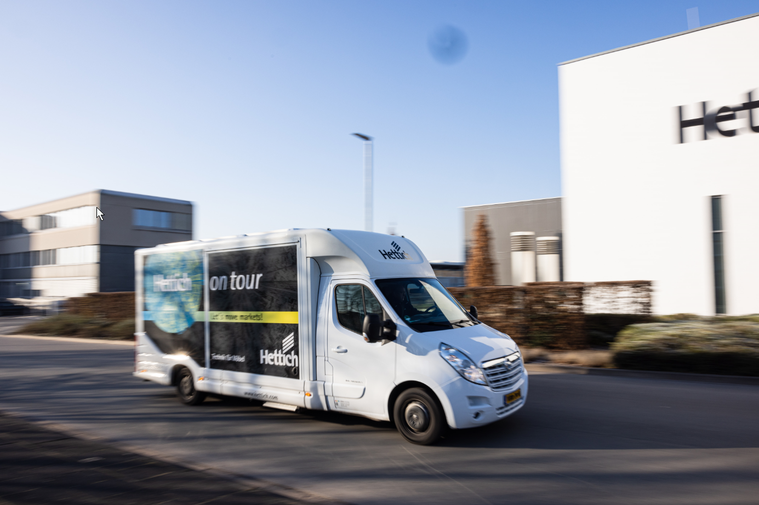
042023_a
En route for customers across Europe: "Hettich on tour" will be bringing the latest top new products directly to fabricators and specialist retailers. Photo: Hettich

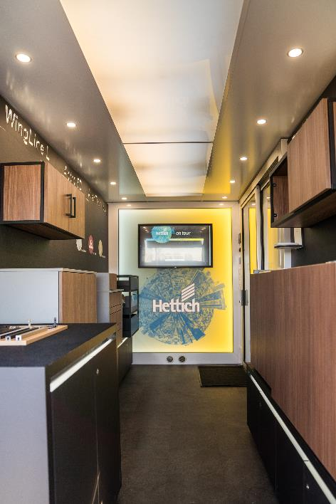
042023_b
Experience product innovations and eServices in real life: in 2023 too, "Hettich on tour" will be presenting the latest highlights in two specially converted vehicles. Photo: Hettich

About Hettich
Hettich was founded in 1888 and is today one of the world's largest and most successful manufacturers of furniture fittings. 8,800 members of staff in almost 80 countries work together towards the objective: developing intelligent technology for furniture. On this basis, Hettich inspires people across the globe and is a valuable partner to the furniture industry, retailers and the trades. The Hettich brand is synonymous with consistent values: with quality and innovation. For reliability and closeness to customers. Despite its size and international significance, Hettich has remained a family run business. Independent of investors, the company is free to shape its future in a humane and sustainable manner.

