Hettich is redefining workplaces
Exciting furniture ideas and innovative fitting solutions at interzum 2023

Goodbye conventional office – welcome to the new feel good working world. The workplace exhibits on display demonstrate the fittings manufacturer's immense expertise in creating home furnishing and office space solutions, showing exactly what the perfect symbiosis can look like. Because contemporary office and homeworking environments are placing particular demands on attributes such as feel good factor, homeliness, ergonomics and multifunctionality.

Not only is the new work megatrend driving the change from inflexible office structures to workplace versatility involving a now firmly established homeworking element - the shortage of skilled workers is also making a significant impact. The job applicant market has become an employers' market. To a large extent, the appeal of a company wanting to beckon potential skilled staff also goes hand in hand with its ability to provide a modern corporate culture offering flexible working hours and attractive office workplaces. Hettich has all sorts of ideas and suggestions on ways of giving office and homeworking furniture a look to create the ideal basis for boosting work motivation and productivity.

Homeworking: occupational health and safety in the home environment
Homeworking is a popular form of employment yet also comes with health related problems among the majority of those involved. For Hettich, this means homeworking furniture must permit an ergonomically sound and healthy working style while at the same time integrating into the home environment. Ideally after work, furniture should transform into living space furniture making it possible to switch off and relax. Hettich's modern bureau interpretation can do precisely this. It hides away an entire homeworking facility, including height adjustable Steelforce desk. This can be rolled out into any space, positioned wherever chosen and set to a height for working at with every ergonomic benefit. The fold open bureau's interior also comes with all sorts of options for storing technical equipment and office materials. At the end of the working day, the mobile desk returns to its parked position, leaving the unit to close its doors again and become a space saving piece of homely looking furniture. Steelforce gives carpenters and furniture manufacturers a comprehensive range of height adjustable desk support frames to let them create individually tailored workplace solutions.

Lack of space is often put forward as a reason to oppose a separate study. Hettich uses a wardrobe to show that homeworking can be integrated into home furnishings while taking up very little space. Carefully considered interior organisation and the WingLine L folding door fitting give the wardrobe sufficient room to accommodate a height adjustable Steelforce desk including office chair. Work done, the workstation quickly disappears from view again.

Modern workplaces in the office
In the modern office, desk sharing, open spaces and co working are all part of the agenda. Office workplaces fitted out with everything that's needed provide the framework for work dynamic and flexibility. As communal furniture, the homely looking locker unit from Hettich meets the need for a set and secure place for keeping personal belongings. Anyone needing it can book a locker using a free app. Hettlock Bluetooth gives staff access to this personal storage space by smartphone, NFC chip or, by way of option, also by numerical code or fingerprint. The electronic lock makes it easy to manage user rights, brings flexibility to using storage space and provides online information on battery status and user history at all times.

Attractive and ergonomically designed office workplaces reflect the appreciation employers have for their staff. Making creative use of storage space goes perfectly with the concept of a dynamic working environment in the office. Not only can FurnSpin now open and close cabinets, their contents can be turned as well. A sweep of the hand transforms closed frontage into open shelf element. Storage space remains in easy reach while working, without any open drawer getting in the way or a door obstructing anyone getting by. Systema Top 2000 drawers on the end face with homely looking interior organisation and a material tray made of 100 % recycled material come with further storage options without getting in the way at the desk. The height adjustable Steelforce desk support frame with wooden base stabiliser gives the workplace its feel good character.

Pleased to share its expertise with customers, Hettich can provide CAD data and assembly information on selected exhibits for replication or as inspiration for customers' own furniture designs. After interzum 2023 too, the new "roominspirations" website will be providing the option of delving more deeply into the new work theme world, or of searching specifically for solutions by category. https://interzum.hettich.com

The following picture material is available for downloading from the "Press" menu at www.hettich.com:

Images
Captions
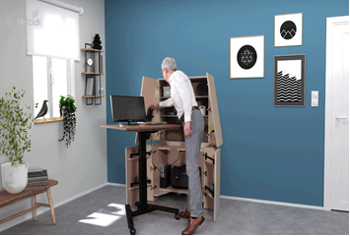
122023_a
The height adjustable Steeforce Pro 570 SLS SC desk support frame on castors turns the newly interpreted bureau into an ergonomic office workstation. Work done, homeworking vanishes from view to leave a piece of furniture with homely appeal. Photo: Hettich

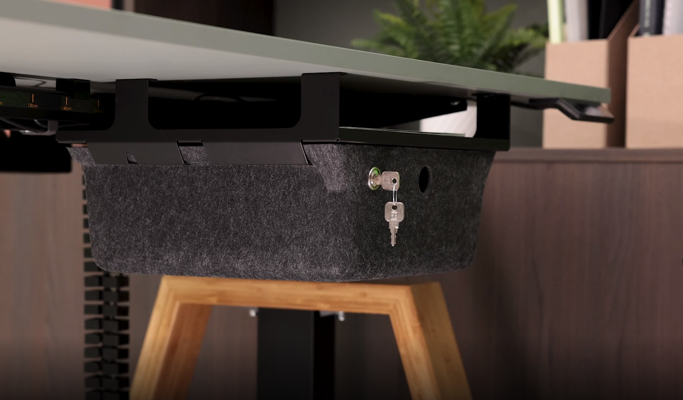
122022_b
Mobile underdesk organiser in felt look brings feel good ambience to the bookable workstation while providing storage for personal belongings. At the end of the working day, it quickly stows away again in the locker unit. Photo: Hettich

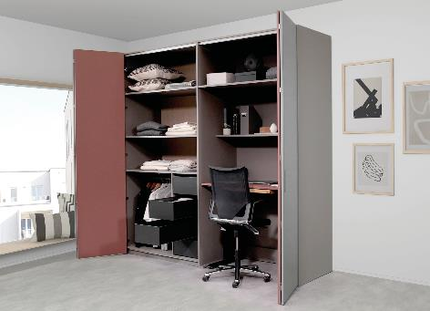
122023_c
This wardrobe with WingLine L folding sliding door fitting conceals a height adjustable Steelforce Pro 300 slim desk complete with office chair. Photo: Hettich

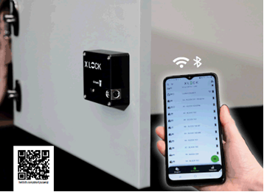
122023_d
Using a free app, Hettlock Bluetooth brings versatile usage and easy management to the locker unit. Photo: Hettich

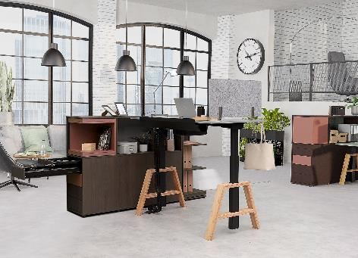
122023_e
Customised, homely looking wooden base elements make the Steelforce Pro 670 SLS desk support frame an attractive eye catcher in the office or homeworking environment. Photo: Hettich

About Hettich
Hettich was founded in 1888 and is today one of the world's largest and most successful manufacturers of furniture fittings. Over 8,000 members of staff in almost 80 countries work together towards the objective: developing intelligent technology for furniture. On this basis, Hettich inspires people across the globe and is a valuable partner to the furniture industry, retailers and the trades. The Hettich brand is synonymous with consistent values: with quality and innovation. For reliability and closeness to customers. Despite its size and international significance, Hettich has remained a family run business. Independent of investors, the company's future is shaped freely, humanely and sustainably. www.hettich.com

