Hettich's "Technology & Innovations Catalogue 2023"
New product releases in the line up

The new "Technology & Innovations" from Hettich, or "T&I" for short, is out now! As every year, the Hettich catalogue once again features all sorts of exciting new products for 2023 too.

Under the "Soft closing comfort for all" banner, the new Novisys fast assembly hinge will be making its debut in 2023: developed and "made by Hettich", this product now makes integrated Silent System convenience the standard for all users. Impressing with its efficient use of resources and made to last,, this quality product demonstrates reliable soft closing performance. Furniture manufacturers benefit twice over because Novisys provides the key to creating on trend furniture lines with added value at great cost efficiency.

The ComfortSpin turntable from Hettich organises cabinet interiors with effortless ease. In cabinets too, items at the back spin round to the front in one easy turning movement that smoothly rotates through 360°. Easily fitted and immediately ready for use, the clever turntable provides a full view of contents in refrigerators, bathroom cabinets, sideboards and other furniture. And to clean it, ComfortSpin removes ever so easily too.

The AvanTech YOU drawer system scores with design diversity and creative flexibility. Coming with even more appeal and a greater focus on consumer preferences, the AvanTech YOU Illumination feature even provides the option of giving furniture its own signature lighting: clip on LED DesignProfiles or illuminated glass inlays create stunning mood effects and a touch of elegance. From now on, assembly is even easier because Hettich is no longer offering its Illumination sets for cutting to size but in precision, ready to fit dimensions for any nominal drawer length before leaving factory.

2023 is also seeing Hettich offer a whole raft of attractive product highlights in the outdoor sector: the Veosys stainless steel hinge defies moisture, cold or heat, making it a rugged allrounder for hinged doors in a wide range of applications. It is not affected by temperature fluctuations, moisture or salt, leaving the integrated Silent System to deliver reliable performance temperatures both low and high. In this way, the user friendly functions familiar from indoor furniture can now also be enjoyed in the garden or on the roof terrace. The corrosion resistant Veosys continues to demonstrate its exceptional performance even after 120 hours in the neutral salt spray test (NSS) to DIN EN ISO 9227. This means it is also recommended for use in spa centres, gyms or laboratories or hospitals.

In outdoor furniture, the Quadro Compact full extension drawer runner system impresses with smooth, quiet running performance, exceptional stability and a controlled, quiet closing action with Silent System. The Push to open system can be used for handleless fronts. Quadro Compact comes with corrosion resistance to level 3 in compliance with DIN EN 1670 for use outdoors. With its range of drawer runners, Hettich can provide load capacities up to 40 kilograms.

On the cutting edge: with its characteristic contour, the tried and proven InnoTech Atira drawer system comes in an unpretentious and sleek look – and does so too now in on trend outdoor kitchens. Different colours, a wide range of add on elements plus versatile interior organisation solutions provide a high level of individuality. InnoTech Atira is suitable for outdoor use in compliance with DIN EN 1670, corrosions resistance to level 2.

The latest "T&I" from Hettich in digital form comes with a convenient feature: in the online flip page catalogue, clicking the article number takes you directly to the Hettich eShop. This is where further useful information can be found on every product. Further details on the latest catalogue are available on Hettich's landing page:
https://web.hettich.com/en-de/products-eshop/technology-and-innovations

The following picture material is available for downloading from the "Press" menu at www.hettich.com:
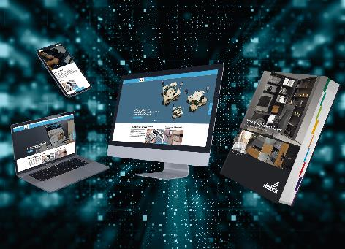
062023_a
This is where to discover Hettich's new product releases for 2023: the new Technology & Innovations 2023" catalogue is specifically geared towards volume production with bulk packaging and directly linked with practical eService lineup. Photo: Hettich

About Hettich
Hettich was founded in 1888 and is today one of the world's largest and most successful manufacturers of furniture fittings. Some 8,000 colleagues in almost 80 countries work together towards the objective: developing intelligent technology for furniture. On this basis, Hettich inspires people across the globe and is a valuable partner to the furniture industry, retailers and the trades. The Hettich brand is synonymous with consistent values: with quality and innovation. For reliability and closeness to customers. Despite its size and international significance, Hettich has remained a family run business. Independent of investors, the company's future is shaped freely, humanely and sustainably. www.hettich.com

