Newcomer Novisys: soft closing convenience for everyone
Hettich develops attractively priced hinge with integrated soft closing function

Furniture and user friendly convenience go hand in hand – and do so now in every segment. Introducing Novisys, Hettich gives furniture manufacturers a fast assembly concealed hinge that provides exceptional value for money and makes integrated soft closing convenience a standard feature for a wide range of furniture doors. For this sustainable and long life quality product, Hettich has introduced a number of changes.

Developing a modern hinge, Hettich is meeting the growing expectations on comfort and convenience among price conscious furniture buyers. This is where "made by Hettich“ is the quality promise that distinguishes Novisys from other low priced hinges: reliable soft closing performance coupled with long service life. Furniture manufacturers can use Novisys to create on trend lines of furniture with added value across all segments on a cost effective basis. Doing so, they will not only be using a quality product that provides outstanding value for money but also benefit from Hettich's platform principle.
Boosting process optimisation, Novisys is easy to combine with other hinge systems from Hettich. User friendly upgrades for the broad and varied Sensys range are equally available as are virtually all customised door mounting options. Permitting a choice of attachment methods and drilling patterns, Novisys even makes it easier to switch between products in manufacturing.

Novisys is all about efficiency
Conserving material makes ecological and economic sense. Applying its innovative Novisys hinge technology, Hettich is treading new paths in terms of resource efficiency. Here, less material too ensures sound functionality and long product life. Furniture manufacturers can meet the growing demand for greater convenience in the lower price segments while benefiting from tremendous cost efficiency and getting satisfied customers. Not only does the product impress but also Hettich's all round service with technical advice, local contacts for short term support, warranty packages and much more besides. Hettich offers professional supply chain management for every aspect of its products. Shipping logistics aims to achieve a seamless dovetailing of supply and furniture manufacturers' production processes. This includes appropriate packaging solutions just as much as it does the rational planning and steering of shipment and warehousing processes.

Marketing launch for Novisys with integrated soft closing function will start in the second quarter of 2023. For further details and ordering options go to www.hettich.com/novisys

The following picture material is available for downloading from the Press section at www.hettich.com:

Images
Captions

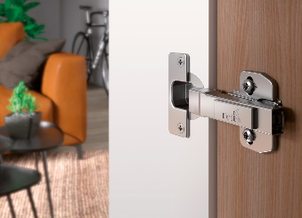
P98_a
Providing outstanding value for money, Hettich's Novisys fast assembly hinge brings the convenience of integrated soft closing to the vast majority of furniture ranges. Photo: Hettich

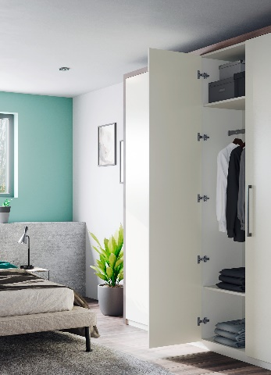
P98_b
Novisys with integrated soft closing function gives hinged door furniture added perceived quality and convenience. Photo: Hettich

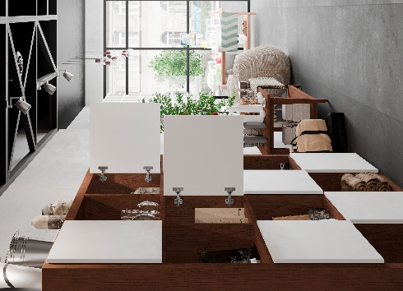
P98_c
Particularly in the home furnishings segment, Novisys with the integrated function of soft closing convenience helps to determine consumers' decisions on the furniture they buy. Photo: Hettich

About Hettich
Hettich was founded in 1888 and is today one of the world's largest and most successful manufacturers of furniture fittings. 8 000 members of staff in almost 80 countries work together towards the objective: developing intelligent technology for furniture. On this basis, Hettich inspires people across the globe and is a valuable partner to the furniture industry, retailers and the trades. The Hettich brand is synonymous with consistent values: with quality and innovation. For reliability and closeness to customers. Despite its size and international significance, Hettich has remained a family run business. Independent of investors, the company is free to shape its future in a humane and sustainable manner. www.hettich.com

