Hettich France gets "Qualiopi" certificate
Excellent quality in vocational training

In December 2021, Hettich France passed the mandatory audit for reviewing the quality of vocational training providers in France and has been officially entitled to carry the "Qualiopi" certificate since 1 January 2022. This certifies Hettich France's excellent quality in basic and further vocational training – a core competence that is becoming increasingly important for the company, particularly in times of a skilled worker shortage.

The French "Qualiopi" seal is awarded by accredited certification bodies on the basis of a uniform, national quality reference system and can only be renewed after three years by a further audit. The audit procedure shouldn't be underestimated: to get this state certification, every company is required to meet seven criteria and 32 quality indicators set by the "Référentiel National Qualité" (RNQ) for vocational training.

For Jean-Luc Fuchs, Managing Director of Hettich France, the "Qualiopi" certificate means more than just an image factor: "Hettich is a family run business with a history stretching back over 130 years. We think long range in terms of generations and don't focus our company strategy on short term effects but very consciously on sustainable development. As a result, we see sound basic and further vocational training as the best investment in the future that we can make. For us, the Qualiopi certificate is wonderful confirmation that we are on the right track with our commitment in this regard."
Hettich France Web

The following picture material is available for downloading from www.hettich.com, menu: Press:
Images
Captions
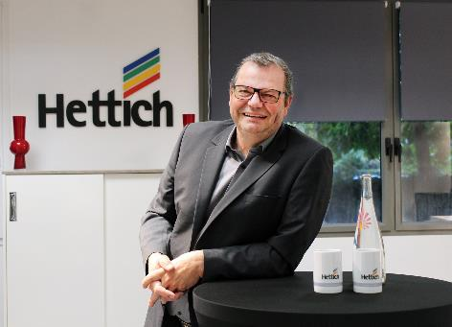
052022_a
Jean-Luc Fuchs, Managing Director of Hettich France: "The Qualiopi certificate means we can now also prove the high quality of our basic and further vocational training." Photo: Hettich
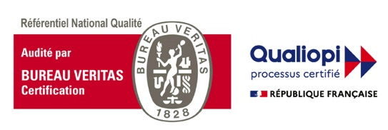
052022_b
In December 2021, Hettich France passed the mandatory audit for reviewing the quality of vocational training providers in France and has been officially entitled to carry the "Qualiopi" certificate since 1 January 2022. Graphic: Comité français d’accréditation – COFRAC

About Hettich
Hettich was founded in 1888 and is today one of the world's largest and most successful manufacturers of furniture fittings. Over 6,600 members of staff in almost 80 countries work together towards the objective: developing intelligent technology for furniture. Hettich thus inspires people all over the world and is a valuable partner for the furniture industry, trade and craft. The Hettich brand stands for consistent values: for quality and innovation. For reliability and customer proximity. Despite its size and international significance, Hettich has remained a family business. Independent of investors, the company's future is shaped freely, humanely and sustainably. www.hettich.com

