The Hettich team mourns the death of Dr. Erwin Hettich

Dr. Erwin Hettich, the long-standing managing partner of the Hettich Group, passed away on 30 July 2022 at the age of 89. The Hettich team bids farewell in deep mourning and full of gratitude.

In 1964, Dr. Erwin Hettich joined the management of the Hettich family business in his early 30s. Initially, he was responsible for purchasing and finance. Dr. Erwin Hettich then headed the marketing and sales department and was the company's representative in external contacts, a position he held in high regard by customers. For a total of over 30 years
Dr. Erwin Hettich was a member of the management board and took over the chairmanship of the management board in 1990 until his retirement at the end of 1993.

Dr. Erwin Hettich lived customer orientation and his particular talent and strength lay in communication. Thus, during Dr. Erwin Hettich's dedicated work, the company expanded internationally and became one of the largest hardware manufacturers in the world.

The death of Dr. Erwin Hettich leaves us deeply saddened. His family, the shareholders, the advisory board, the management and the entire Hettich team will remember him as a great personality and will continue to develop the Hettich Group in his spirit.

The following picture material is available for downloading from www.hettich.com, menu: Press for download:
Image
Caption
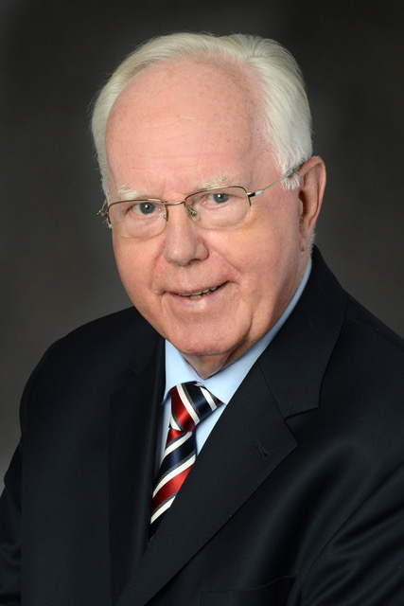
322022_a

Dr. Erwin Hettich (†) was a managing partner for many years who always maintained intensive and personal contact with his customers.

About Hettich
Hettich was founded in 1888 and is today one of the world's largest and most successful manufacturers of furniture fittings. Over 7,400 members of staff in almost 80 countries work together towards the objective: developing intelligent technology for furniture. Hettich thus inspires people all over the world and is a valuable partner for the furniture industry, trade and craft. The Hettich brand stands for consistent values: for quality and innovation. For reliability and customer proximity. Despite its size and international significance, Hettich has remained a family business. Being independent of investors means that the company has a free hand in shaping its future with a focus on the human element and sustainability. www.hettich.com

