iF Design Award for K08 hinge from Hettich
Convenience and design treat for wine refrigerators

In terms of technical features and visual appeal, manufacturers have reached the pinnacle in appointing their wine refrigerators: following the iF Award and reddot Award for the Quadro Compact FE 20 runner in 2022, the iF Award 2023 has now gone to the K08 hinge with integrated soft closing Silent System for wine refrigerators. This completes the award winning line up of appliances featuring Hettich products that meet the most exacting expectations on convenience and design.

Sommeliers have long recommended professional wine refrigerators for providing wine with optimum storage, and true wine enthusiasts know: enjoying fine wines starts with the wine refrigerator. After all, correct storage plays a key part in determining the quality of a wine and in pampering the palate on every score. Ideally, bottles are kept at constant temperature under controlled humidity in a dark place that's free from vibration. Developing the K08 hinge and Quadro Compact FE 20 runner, Hettich has masterminded fittings devised specifically for wine refrigerators that not only address the exacting demands on storing wines but also the expectations placed on design. Both fitting solutions are available in a dark finish and integrate perfectly into the overall look.

Makes the difference: K08 hinge
In the premium market particularly, user convenience plays an important part. The K08 hinge guarantees luxurious user convenience right across the board. The integrated soft closing function is calibrated to slow down and precisely control door movement, leaving it to close in complete silence while avoiding any vibration whatsoever. What's more, the user friendly hinge gives the wine refrigerator door a wide opening angle so that shelves holding the wine bottles can be pulled out all the way. This makes the right bottle of wine easy to choose and provides quick access. Coming in a dark, elegant look, the hinge blends inconspicuously into the predominantly dark finished design of wine refrigerators. The hinge attachment arm has been developed specifically for wine refrigerator glass doors and underscores the overall look. The K08 hinge is also quick and easy to install.

Vibration free movement: Quadro Compact FE 20
The Quadro Compact FE 20 runner with integrated soft closing Silent System guarantees shelf running action of incomparably smooth quality in the wine refrigerator. Hybrid ball bearings as well as buffering end stops permit vibration free running performance, and the soft closing Silent System makes sure that the pull-out shelves quietly glide back in again with very little vibration. Dark in finish, Quadro Compact FE 20 becomes almost invisible, making the bottle shelves appear to float behind the glass door.

The market for wine refrigerators is growing because more and more discerning consumers are deriving pleasure from celebrating the perfect moment and from standing apart by adding extras to home furnishings. With the K08 hinge and Quadro Compact FE runner for wine refrigerators, Hettich offers award winning user friendly fittings to further expand the product sector and create distinguishing features through quality and convenience.

Click this link to discover what one sommelier finds so good about the K08 hinge for wine refrigerators:
https://www.hettich.com/short/hvsx6c4

The following picture material is available for downloading from the "Press" menu at www.hettich.com:

Images
Captions
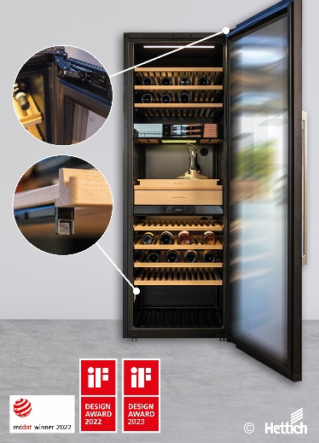
152023_a
From top to bottom, wine refrigerators can be equipped with award winning fittings from Hettich. Photo: Hettich

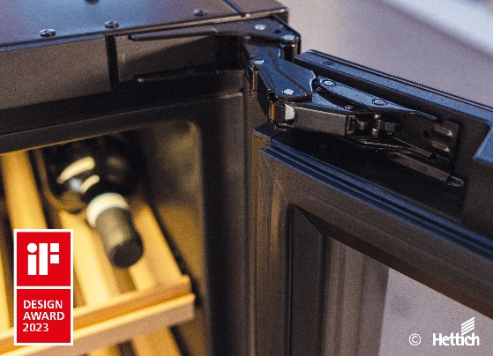
152023_b
The iF Design Award 2023 went to the K08 hinge for the perfect way it integrates into the dark coloured finish of wine refrigerators. Photo: Hettich

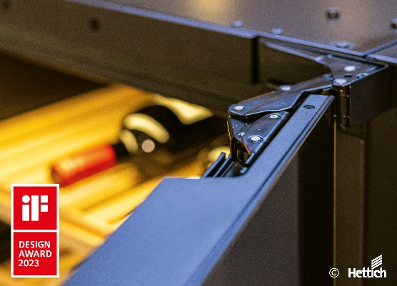
152023_c
The K08 hinge provides incomparably smooth and vibration free door closing action along with exceptional practical convenience from extra wide opening angle. Photo: Hettich

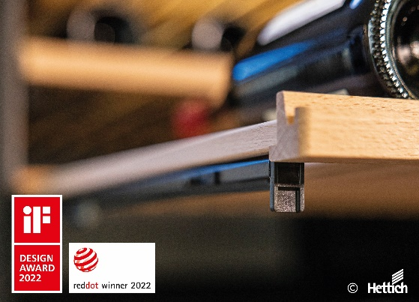
152023_d
The double award winning Quadro Compact FE 20 runner gives the pull-out shelves vibration free running performance and is barely visible. Photo: Hettich

About Hettich
Hettich was founded in 1888 and is today one of the world's largest and most successful manufacturers of furniture fittings. Over 7,400 members of staff in almost 80 countries work together towards the objective: developing intelligent technology for furniture. On this basis, Hettich inspires people across the globe and is a valuable partner to the furniture industry, retailers and the trades. The Hettich brand is synonymous with consistent values: with quality and innovation. For reliability and closeness to customers. Despite its size and international significance, Hettich has remained a family run business. Independent of investors, the company's future is shaped freely, humanely and sustainably. www.hettich.com

