FurnSpin premiere at Hettich
Exceptional spin on high quality furniture design
Is there a way of completely reinventing the use of storage space? Hettich has found one: the innovative FurnSpin fitting for the premium segment does away with old style formats and puts a creative new spin on furniture design. Open doors or flaps no longer get in the way – most of the cabinet body can now be moved with effortless ease. A stylish turn reveals what's inside. Hiding everything from view again, a further spin returns the furniture to its closed state. "The Joy of FurnSpin" fascinates in all types of furniture.

Discerning furniture customers from the premium segment are looking for greater individuality, for distinctive perceived quality and astonishing solutions not everyone has – these are precisely the expectations Hettich's innovative fitting is able to meet. Because FurnSpin permits ground breaking spatial and furniture concepts with stunning performance in a quality of design that clearly stands apart from the standard lineup. The characteristic "spin" is simply a pleasure and gives users an emotional and magical furniture experience that leaves a lasting mark.

Two items of furniture all in one
FurnSpin shows off the exciting interchange between "closed" and "open" with stunning effect. An elegant spin from closed furniture front to open shelf instantly changes the room's atmosphere: closed for a tidy and clean look whenever needed, or opened up with everything in view and affording fast access from two sides. Either way, storage space can be used for keeping provisions you don't necessarily want everyone to see, or for homely accessories you like to be on show.

Inspiringly different
The fitting's unique "translatory rotational movement" can literally turn furniture inside out. Doing so, FurnSpin synchronises two different forms of movement: swivel action as well as rotation through 180 degrees. Benefiting from perfected kinematics, the cabinet body moves along a defined path, preventing any collision between furniture edges. The astounding part: FurnSpin would seem to cancel out centrifugal force. Torque is balanced so carefully that even very light objects don't fall over or slip about in furniture, but stay firmly in place.

Whether in the kitchen, bathroom, bedroom, living room or office – multitalented FurnSpin can be used everywhere. Designers, creative minds and manufacturers alike can let their imaginations run free to give customers individually tailored furniture in all sorts of different variations. For instance, the new fitting can be combined with Hettich's delicate looking Cadro frame system. Depending on furniture size, the appropriate FurnSpin option can be selected from different weight categories. The system moves floor to ceiling furniture just as easily as a small glass display cabinet. What's more, FurnSpin also comes with all the familiar user friendly functions such as soft closing or push-to-open for creating handleless furniture design. At the same time, the fittings remains virtually hidden; after all, concealed working components are one of the top priorities for discerning designers, furniture manufacturers and consumers. FurnSpin's versatility brings a new quality to prestigious storage furniture, efficiently helping brand manufacturers and interior designers to underscore their commitment to creating innovative, premium solutions. At interzum 2023, Hettich will be presenting its top innovation for the first time in numerous inspiring furniture concepts. It is then planned to start marketing the high quality FurnSpin fitting in the fourth quarter of 2023.
More on FurnSpin at: https://furnspin.hettich.com/

The following picture material is available for downloading from the "Press" menu at www.hettich.com:

112023_a
"The joy of FurnSpin" gives users an emotional, magical furniture experience that leaves a lasting mark.
Photo: Hettich

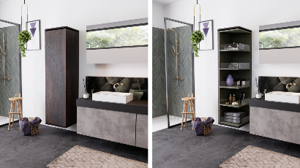
112023_b
FurnSpin shows off the exciting interchange between "closed" and "open" with stunning effect. Photo: Hettich

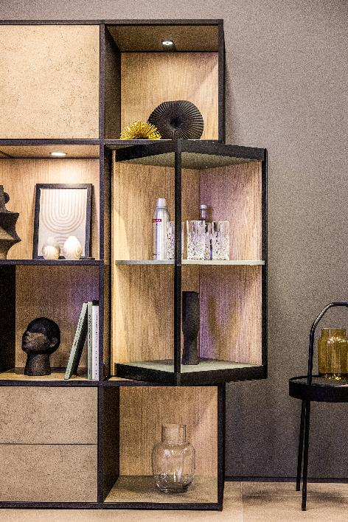
112023_c
FurnSpin brings elegant dynamic to interior design: with a sweep of the hand, the entire cabinet body can be turned from the closed to the open position. Photo: Hettich

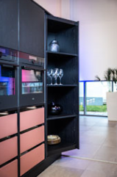
112023_d
FurnSpin moves even heavy, floor to ceiling furniture with effortless ease. Photo: Hettich

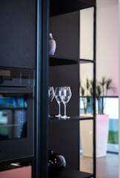
112023_e
Turned gently and safely: even lightweight glasses can't tip over or slide about here. Photo: Hettich

About Hettich
Hettich was founded in 1888 and is today one of the world's largest and most successful manufacturers of furniture fittings. Some 8,000 colleagues in almost 80 countries work together towards the objective: developing intelligent technology for furniture. On this basis, Hettich inspires people across the globe and is a valuable partner to the furniture industry, retailers and the trades. The Hettich brand is synonymous with consistent values: with quality and innovation. For reliability and closeness to customers. Despite its size and international significance, Hettich has remained a family run business. Independent of investors, the company's future is shaped freely, humanely and sustainably. www.hettich.com

