"interzum award 2023" for FurnSpin from Hettich
Top "Best of the Best" accolade

Once again, an innovative product from Hettich wins the prestigious "interzum award": the "FurnSpin" fitting system left the expert jury in no doubt within a field of challenging contenders, attracting the highest "Best of the Best" accolade with its "well thought out and innovative design".

"Receiving the interzum award confirms the quality and ingenuity of your work while underscoring your product's international standing in the industry," commented show organiser Koelnmesse.
FurnSpin is inspiringly different: the innovative fitting for the high end segment does away with old style formats and puts a creative new spin on furniture design. Open doors or flaps no longer get in the way – most of the cabinet body can now be moved with effortless ease. A stylish turn leaves furniture to reveal what's inside. Hiding everything from view again, a further spin returns furniture to its closed state. "The Joy of FurnSpin" from Hettich fascinates in all types of furniture.

The fitting's unique "translatory rotational movement" now literally turns furniture inside out. Doing so, FurnSpin synchronises two different forms of movement: swivel action as well as rotation through 180 degrees. Benefiting from perfected kinematics, the cabinet body moves along a defined path, preventing any collision between furniture edges. The astounding part: FurnSpin would seem to cancel out centrifugal force. Torque is balanced so carefully that even very light objects don't fall over or slip about in furniture, but stay firmly in place.

Presentation of the "interzum awards 2023" took place on 8 May 2023 in Cologne. interzum visitors have until 12 May 2023 to witness this year's winning FurnSpin product in real life on the Hettich stand or in a Koelnmesse exhibition on the trade fair boulevard. FurnSpin is being presented online at www.interzum.com. Even more information on FurnSpin can be found direct from Hettich at: https://furnspin.hettich.com/

The following picture material is available for downloading from the "Press" menu at www.hettich.com:
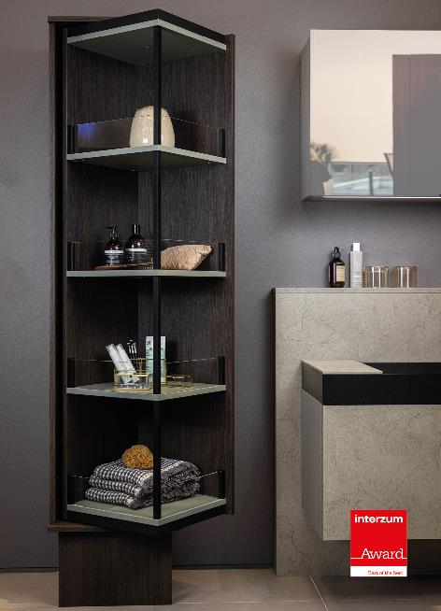
142023_a
"Best of the Best" accolade in "interzum award 2023":
FurnSpin brings elegant dynamic to high end interior design. With a sweep of the hand, the entire cabinet body can be turned from the closed to the open position. Photo: Hettich

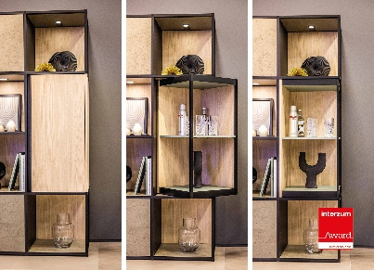
142023_b
FurnSpin is inspiringly different: open doors or flaps no longer get in the way – most of the cabinet body can now be moved with effortless ease. Photo: Hettich

About Hettich
Hettich was founded in 1888 and is today one of the world's largest and most successful manufacturers of furniture fittings. Some 8,000 colleagues in almost 80 countries work together towards the objective: developing intelligent technology for furniture. On this basis, Hettich inspires people across the globe and is a valuable partner to the furniture industry, retailers and the trades. The Hettich brand is synonymous with consistent values: with quality and innovation. For reliability and closeness to customers. Despite its size and international significance, Hettich has remained a family run business. Independent of investors, the company's future is shaped freely, humanely and sustainably. www.hettich.com

