It’s all in Hettich: interzum 2023
The functional hardware specialist shows what it takes to be successful.

Success is the reward of strong partnerships. Hettich is using interzum 2023 as an opportunity to present itself as a success driver with a plethora of forward-thinking options for universal collaboration. Along for the ride: Incredible inspiration for innovative furniture and industry-specific services, along with processing technology will be brought to Cologne. Undisputed highlight is the launch of FurnSpin – the spectacular turn-swivel fitting that's set to take the furniture industry to a whole new level. And there's another highlight on the sustainability front: For the first time, Hettich's show presence has been given carbon neutral certification by an external partner.

It's all in Hettich, the keys needed for our customers to be successful. The show booth in hall 8.1, booth C31/B40, will be giving the trade audience insight into the fittings manufacturer's wide-ranging expertise and ingenuity as well as its immense understanding of everything pertaining to both the market and consumer demand. Hettich will be providing compelling ways of addressing how the furniture industry, trades and specialist retailers can respond to the changing expectations consumers are placing on home living, lifestyle and the working environment. The megatrends of individualization, urbanization, new work, digitization and sustainability are continuing to drive change forwards – not only in terms of new furniture and interior concepts. A shortage of skilled workers is making simplified and efficient processes ever more important in production and assembly. Hettich is leading the way in digitizing its services and assembly machinery, and is, among other capabilities, showcasing solutions based on augmented reality.
In the wake of "It's all in Hettich", the fittings manufacturer's branding campaign underlines its promise to the trade, retailers and industry to provide everything they need to boost sales in the furniture sector. Hettich is exactly the right partner for tomorrow's challenges and a success driver for creating spaces that won't fail to fascinate. That is why Hettich consistently develops its solutions from the consumers’ perspective, demonstrating foresight, curiosity, courage and openness. Hettich firmly believes these solutions can only succeed if everyone involved works closely together in a spirit of trust and is ready to share knowledge and expertise.
interzum 2023 is inviting visitors to discover what the hardware manufacturer is all about.

Acting sustainably: Carbon neutral show presentation
For the first time, Hettich is getting the myclimate Foundation (myclimate.org) to give its entire trade fair presentation carbon neutral status for interzum 2023. The aim is to avoid CO2 emissions as far as possible, or at least reduce them, by implementing measures in transportation management, in the booth's technical outfit, by reusing booth construction material and exhibits, serving seasonal produce from the region's caterers, efficiently deploying booth personnel, including travel to the event and overnight stays, right through to dispensing with give aways. With the greatest impact on CO2 emissions coming from getting Hettich's team to the fair and home again, colleagues from overseas will be booking flights that offset carbon to the greatest possible extent. Many participants will be coming by rail, company car owners will car share and, within Cologne, booth personnel will be using public transportation instead of a team shuttle. Hettich is supporting a certified climate protection project to offset CO2 emissions that are still generated.

Show debut for FurnSpin & Novisys
Anyone who did not know what a rotation movement is before visiting the Hettich stand will definitely be smarter afterwards - and what’s more, completely blow over. The unique FurnSpin turn-swivel fitting lets cabinet elements turn full circle about their very own axis. Rotation brings a new and previously unprecedented dimension to furniture. Leaving FurnSpin to boost the appeal of tomorrow's lines of exclusive furniture.
Yet Hettich is also thinking just as innovatively in terms of the mass market, presenting Novisys, a high performing, fast assembly concealed hinge developed specifically for the furniture industry to provide integrated soft closing convenience for furniture doors in the mid price segment. By introducing Novisys, Hettich is also demonstrating that sustainability will play an ever more important part in developing tomorrow's products without compromising on quality.

Impressive showcase & customer journey
Each and every one of the furniture exhibits displayed at Hettich's booth is an inspiration in more ways than one: New product applications, attractive furniture ideas and trend focused interior solutions. The new "roominspirations" website shows exhibits embedded in individualized home environments: theme based apartments and the New Work showroom not only let visitors discover the furniture concepts online in 3D, but also create them all by themselves: Hettich provides the CAD data, processing information and images that's needed, while inviting visitors to take Hettich's ideas that bit further.

New & proven keys to success
The successful Workplace exhibits immediately show that they are the result of a synergy of Hettich's high furniture and office competence. Leaving not a margin of doubt, they combine the needs of workstations in today's office and of those working from home. A sense of well-being, comfort, ergonomics and multifunctionality are all part of the experience. And is where the new height adjustable Steelforce desk support frames from Hettich play an integral part.
AvoriTech now gives customers an exclusive drawer system with an 8 mm drawer side profile. Ideal for high end kitchen and furniture design with a purist look. Easy to customize in all sorts of different ways, the AvanTech YOU drawer system has become a driving force. Not only in material and color, but also with illumination. When it comes to trends, there's nothing like an outdoor kitchen. With this in mind, Hettich has developed Veosys, a weatherproof hinge, that allows worry-free outdoor entertainment.

Anyone unable to attend interzum 2023 and Hettich's trade show booth in person can immerse themselves in the various theme worlds on the new "roominspirations" website or look for specific solutions by category. https://interzum.hettich.com

The following images are available for download from the "Press" menu at www.hettich.com:

Images
Captions
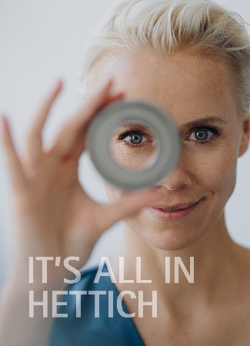
132023_a
Chief motif of the "It's all in Hettich" brand campaign visualizes the fittings manufacturer's keen focus on users and the vision it has of developing products for tomorrow's world. Photo: Hettich

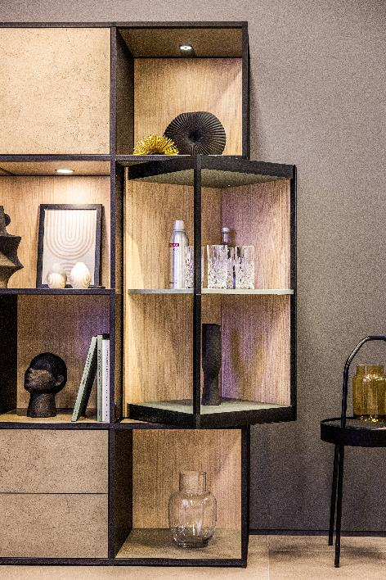
132023_b
All new, FurnSpin from Hettich brings elegant dynamic to superior furniture design: With a sweep of the hand, the entire cabinet body can be turned from the closed to the open position. Photo: Hettich

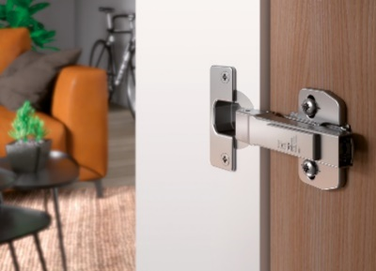
132022_c
Show debut: Providing outstanding value for money, Hettich's Novisys fast assembly hinge brings the convenience of integrated soft closing to the vast majority of furniture ranges. Photo: Hettich

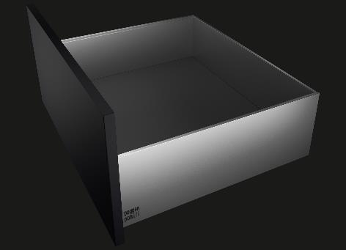
132023_d
New benchmark for perfected, purist furniture design: the AvoriTech drawer platform from Hettich with a slender drawer side profile of just 8 mm in width. Photo: Hettich

About Hettich
Hettich was founded in 1888 and is today one of the world's largest and most successful manufacturers of furniture fittings. Some 8,000 colleagues in almost 80 countries work together towards the objective: developing intelligent technology for furniture. On this basis, Hettich inspires people across the globe and is a valuable partner to the furniture industry, retailers and the trades. The Hettich brand is synonymous with consistent values: with quality and innovation. For reliability and closeness to customers. Despite its size and international significance, Hettich has remained a family run business. Independent of investors, the company's future is shaped freely, humanely and sustainably. www.hettich.com

