Hettich now majority shareholder in height adjustable table (HAT) specialist actiforce.
This move adds yet more interior furnishing solutions to the product portfolio.

Another milestone in the history of both companies: the Hettich Group acquired a majority stake in height adjustable table specialist actiforce (www.actiforce.com) in June 2021. Their sit-stand workstation solutions complement the Hettich product range.

Actiforce remains an independent company, with the existing management team still at the helm as co-owners. Having taken over the majority of actiforce shares, Hettich has broadened its product portfolio, giving it wider access to the market.

Actiforce’s digital and analogue systems bring the convenience of quick, quiet adjustment to all desk and table types.
Seventeen years ago, this pioneer created a completely new market by inventing Vision Lift. Actiforce is an expert in the components business as well as in turn-key solutions. The company develops, manufactures and offers everything from electronic to mechanical components.

At home as well as in the office, working in an ergonomic, health conducive environment is an aspect that is becoming increasingly important. Ergonomics and user friendly comfort and convenience from electrical height adjustment are taking on greater significance in the home too. As such, trends like “Home Cocooning” and thinking in terms of new (homeworking) office worlds, are providing further growth potential for strategic partnerships. Sharing expertise and experience will further strengthen Hettich’s position as a provider of innovative workplace and furnishing solutions.

“Height adjustable systems are finding their way into everyday life on an increasing scale. In the office sector, this includes the market for ergonomic workplaces. More and more desks can be adjusted in height, providing the ability to alternate between sitting and standing as a key ergonomic factor. This is active health maintenance both in the office and in homeworking,” says Uwe Kreidel, Managing Director Hettich.

“Hettich is a world market leader with a wealth of experience in motorised desks and tables. We are delighted to share our experience and expertise with the Hettich Group. This cooperation partnership will now place both companies on a far broader base and complement their expertise,” adds Jason de Weerd, CEO actiforce.

The following picture material is available for downloading from www.hettich.com:

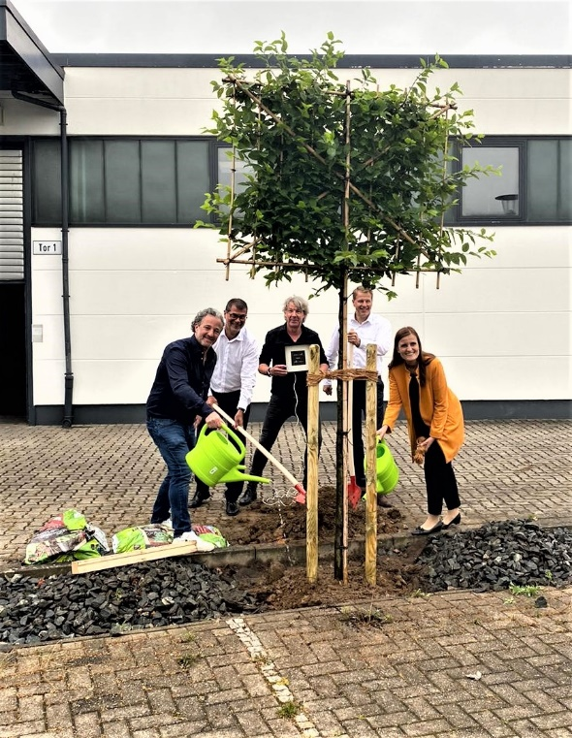
272021_a
Jason de Weerd and Holger Fricke together with Jana Schönfeld, Uwe Kreidel and Michael Lehmkuhl plant a tree as a symbol for the common future. Not in the picture: Harry Slingerland
photo: Hettich/actiforce

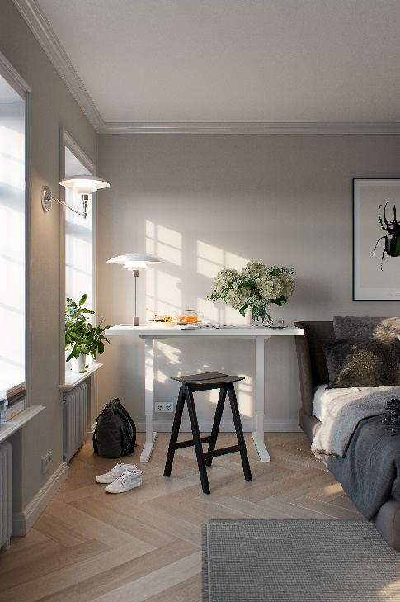
272021_b
Ergonomics in a small space. Steelforce 300
photo: actiforce

About Hettich
Hettich was founded in 1888 and is today one of the world's largest and most successful manufacturers of furniture fittings. Over 6,600 members of staff in almost 80 countries work together towards the objective: developing intelligent technology for furniture. Hettich thus inspires people all over the world and is a valuable partner for the furniture industry, trade and craft. The Hettich brand stands for consistent values: for quality and innovation. For reliability and customer proximity. Despite its size and international significance, Hettich has remained a family business. Independent of investors, the company's future is shaped freely, humanely and sustainably.
www.hettich.com

About actiforce
Actiforce is a manufacturer of high quality, height adjustable tables and related accessories. Founded in 2004 in the Netherlands, the company currently employs 340 people. Production facilities are located in Malaysia and at the company’s German headquarters in Nienburg. The main sales markets are America and Europe.
www.actiforce.com

