Hettich and EMAS: environmental audit passed with flying colours
Hettich's Kirchlengern/Bünde operating base has once again passed EMAS revalidation audit.

The Hettich Group is the only leading manufacturer of furniture fittings to meet the voluntary, stringent EU requirements laid down in EMAS – and doing so for over 20 years.

The Hettich Group has been taking part in the European Union's Eco Management and Audit Scheme (EMAS) for as long ago as the mid 1990s. Any environmental management system under EMAS includes the requirements laid down in international environmental management systems standard ISO 14001. The stringent EMAS criteria provide effective instruments that systematically take into account and measurably improve direct environmental aspects, such as energy and resource efficiency and hazard management, but also indirect environmental aspects, such as legal compliance. In the meantime, four of Hettich's German bases as well as our operations abroad in Spain and the Czech Republic now take part in the annual review cycles.

Once again, the Hettich Group's largest operating base in Kirchlengern/Bünde has now passed this independent, external validation by the state approved environmental auditors. "Passed yet again, this audit is visible proof of our ongoing efforts to make targeted improvements to our environmental performance in all sorts of sustainability activities", says a delighted Lisa Castro Lago, Corporate Social Responsibilty Manager at Hettich. "Participating in EMAS, the world's most stringent environmental management system, brings transparency to the progress we are making in environmental management and enables us to communicate our certified results on a verifiable basis."

The following picture material is available for downloading from www.hettich.com:

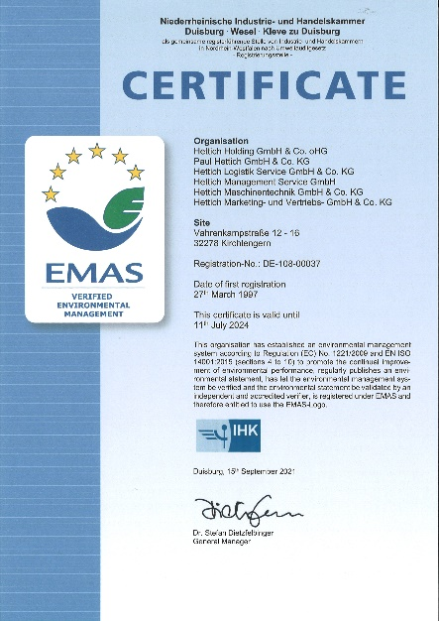

352021_b
Hettich's Kirchlengern/Bünde operating base has once again received EMAS certification.
Photo: EMAS/Hettich

About Hettich
Hettich was founded in 1888 and is today one of the world's largest and most successful manufacturers of furniture fittings. Over 6,600 members of staff in almost 80 countries work together towards the objective: developing intelligent technology for furniture. Hettich thus inspires people all over the world and is a valuable partner for the furniture industry, trade and craft. The Hettich brand stands for consistent values: for quality and innovation. For reliability and customer proximity. Despite its size and international significance, Hettich has remained a family business. Independent of investors, the company's future is shaped freely, humanely and sustainably. www.hettich.com

