Worldwide solidarity at Hettich

Hettich gives € 54,000 in support for voluntary work worldwide

As in 2020, the Hettich team has continued to engage in voluntary work in times of the coronavirus pandemic. Across the globe, colleagues from Hettich operating bases have been involved in various projects within the "Hettich Ehrenamt 2021" volunteering campaign. 108 projects in Germany, the Czech Republic and Australia each received funding to the tune of € 500. This means the Hettich Group made out donation cheques worth a total of € 54,000 in 2021. Of this, € 32,500 alone went to projects in Germany which involve Hettich colleagues.

Anyone working at Hettich can apply for funding in aid of projects they do voluntary work for. Funding in the amount of € 500 go to projects related to social matters, education, science, nutrition, exercise, culture and the environment.

"Commitment to society is an integral part of our corporate values and is very close to our hearts. This is why we are delighted that so many of our colleagues are involved in charitable associations and have been supporting this commitment through the 'Hettich Ehrenamt' volunteering campaign for no less than eight years now," says Laura-Sophie Putschies, Corporate Communications at Hettich.

Since the "Hettich Ehrenamt" volunteering campaign was launched to mark the company's 125th anniversary in 2013, over 1,150 projects have already received funding of no less than € 650,000.

The following picture material is available for downloading from www.hettich.com, menu: Press:
Images
Caption

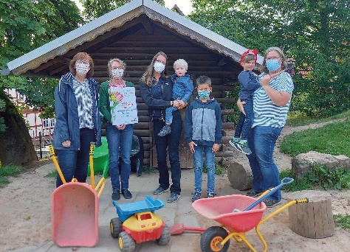
452021_a
Hettich colleague Sigrun Heinscher from Frankenberg is actively involved in refurbishing and converting an old garden summer house at the Linnertor kindergarten into a play and recreation area for the children there. The donation will be used to purchase the materials that are needed for the conversion and extension work. Photo: Hettich

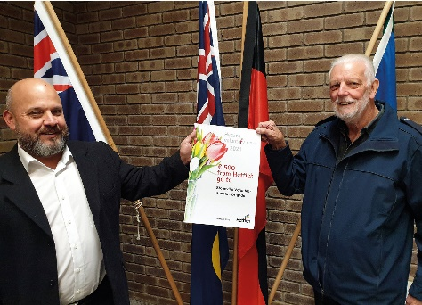
452021_b
Hettich colleague Andrew Haigh from Australia is involved in the Stoneville Volunteer Bushfire Brigade, located in the Perth Hills in Western Australia. The donation is earmarked for extending the fire brigade building. Alternatively, the brigade will be donating the money to people who have lost their homes to fires this year. Photo: Hettich

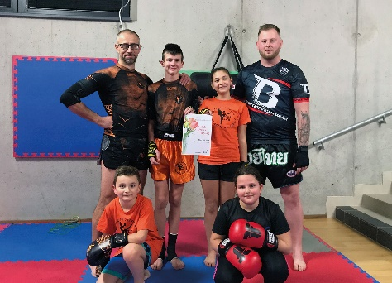
452021_c
Hettich colleague Martin Ondráèek from the Czech Republic is involved as a volunteer coach with the Nové Město na Moravě / Žďár nad Sázavou Fight Club organisation. This is where children, teenagers and adults learn martial arts and combat sports, with the focus here being on Muay Thai and kickboxing.
The donation will be used for buying new sports equipment to improve training conditions for children. Photo: Hettich

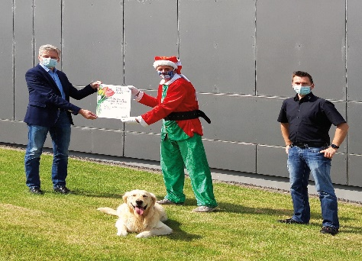
452021_d
Hettich colleague Stefan Oluschinsky is involved as a supervisor at
"Lichtblicke für Menschen mit Herz" (Rays of Hope for Good-Hearted People) which tried to make children's wishes come true all year round. The donation will be used to help socially disadvantaged children and young people under the banner of "Christmas Magic" in Lübbecke. Photo: Hettich

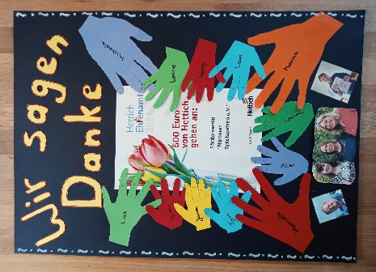
452021_e
Hettich colleague Sascha Müller is involved in the Nammer Spielspatzen friends' association in Porta Westfalica in activities such as maintaining play equipment and furniture, gardening and organising public events. The donation will be used to make the day care centre's playground equipment safe for children. Photo: Hettich

About Hettich
Hettich was founded in 1888 and is today one of the world's largest and most successful manufacturers of furniture fittings. Over 6,700 members of staff in almost 80 countries work together towards the objective: developing intelligent technology for furniture. Hettich thus inspires people all over the world and is a valuable partner for the furniture industry, trade and craft. The Hettich brand stands for consistent values: for quality and innovation. For reliability and customer proximity. Despite its size and international significance, Hettich has remained a family business. Independent of investors, the company's future is shaped freely, humanely and sustainably. www.hettich.com

