Hettich at Esprit Meuble 2021
Solutions customised for the modern home and working world

When the industry meets at Esprit Meuble in Paris from 20 to 23 November, Hettich will be pointing the way: on stand F49, the fittings specialist will be showing creative solutions for customised furniture design and modern spatial concepts. Highlights include new features for the AvanTech YOU drawer platform, the Cadro aluminium frame system and folding door solutions with WingLine L for transformable spaces. Already internationally acclaimed, Hettich's "Tiny Home" storage wizard will also be on show at Esprit Meuble for all to witness in real life.

With a turnover of over € 1 billion, Hettich is one of the world's largest and most successful manufacturers of furniture fittings. At Esprit Meuble, the specialist will be presenting some startlingly fresh ideas for the French market.

Individuality is what it's all about: a new generation of furniture that can be designed in many different ways comes with clear added value for furniture manufacturers, shop and interior fitters, retailers and consumers. The versatile and adaptable AvanTech YOU drawer system from Hettich takes the effort out of customising design to meet any preference in colour, format and material. The platform principle means all components can be combined in any chosen way. Now offering new DesignCapes in copper and concrete look, Hettich has added two on trend design options to its standard AvanTech YOU range. By way of option, AvanTech YOU now even gives furniture its own signature lighting: clip-on LED DesignProfiles or illuminated glass inlays create stunning effects and a touch of elegance. – These and other new releases from Hettich will be on display for all to witness in real life at Esprit Meuble.
www.hettich.com

The following picture material is available for downloading from www.hettich.com, menu: Press:

372021_a
Hettich at Esprit Meuble: from 20 to 23 November 2021 trade visitors will have the opportunity on stand F 49 to let Hettich fill them with precisely the inspiration they're looking for. Graphic: Esprit Meuble

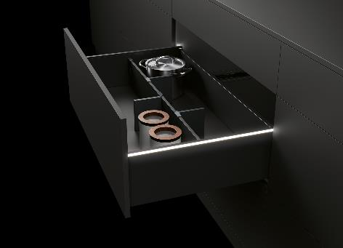
372021_b
As an option, AvanTech YOU from Hettich now gives drawers their own LED signature lighting. Photo: Hettich

About Hettich
Hettich was founded in 1888 and is today one of the world's largest and most successful manufacturers of furniture fittings. Over 6,600 members of staff in almost 80 countries work together towards the objective: developing intelligent technology for furniture. Hettich thus inspires people all over the world and is a valuable partner for the furniture industry, trade and craft. The Hettich brand stands for consistent values: for quality and innovation. For reliability and customer proximity. Despite its size and international significance, Hettich has remained a family business. Independent of investors, the company's future is shaped freely, humanely and sustainably. www.hettich.com

