New Work: From the classic office to the modern working world
Hettich presents flexible home office and office solutions

Our working worlds will change permanently - that much is certain. The Corona pandemic has fuelled digitalisation and enormously accelerated the change through the megatrend New Work. In a very short time, familiar working structures were dissolved and new concepts established, for which a future-oriented framework must now be created. At the HettichXperiencedays 2021, Hettich is taking a close look at what the office of the future and our workplaces will look like, offering exciting keynotes with experts from the office sector. In the New Work themed area, Hettich provides innovative ideas on the transformation of the classic office into a flexible, collaborative, and mobile working environment, and on the integration of home office into the living environment.

Almost every company has felt the changes in recent months and recognised the advantages of working from home, online meetings and digital tools. The new forms of work offer more flexibility and often lead to more efficient results, while the better work-life balance provides more worker satisfaction. That is why many approaches are being adopted and further developed. The most important thing is that the work environment, i.e. rooms and furniture, adapts to different work requirements. Spatially fixed workplaces are increasingly disappearing in favour of flexibly usable zones for adaptable, interdisciplinary work or for working quietly. Since people can be productive anywhere, the proportion of remote working is increasing and with it the demand for desk sharing models, mobile and home office solutions. Hettich has developed practical and creative room and furniture concepts to meet all requirements.

Phone box in an open plan office
In the future, the office will increasingly become a meeting place to initiate creative processes together and to cultivate a sense of community. A telephone box is the ideal complement for holding a discreet telephone conversation, a meeting in private or for providing a quiet area to work in. The telephone box is just as customisable in size as it is in interior design. As a slim room-within-a-room solution, it is possible to fit the telephone box in even the smallest office space. There is even room inside for various storage options and a comfortable, height-adjustable standing aid. A homely design ensures the feel-good effect.

Caddy as a mobile workplace
The where doesn't matter, it's the how. Whether working together centrally, decentrally or temporarily - with the compact, rollable Caddy, the workstation is always with you. With its work surface that can be extended to form a desk, it proves to be a flexible workstation that also has a lot of storage space to offer. This means that every workstation can be organised to perfectly suit individual habits.

Home office furniture with little space requirement
Many living spaces are not designed for working. Uncomfortable stopgap solutions interfere with productivity and blur the line between work and private life. Hettich conceals a comfortable workstation in a homely, compact sideboard. The height-adjustable desk allows ergonomic working while sitting or standing and offers clever storage space for office supplies.
After work, the workstation becomes an inconspicuous sideboard again.

Cosy Stair: Work-life-balance in the niche
Niches under the stairs or sloping ceilings can be transformed into multifunctional places of well-being through optimal use of space. On the upholstered seating and reclining surface with adjustable headboard, you can relax or work comfortably as required. An attachable table and the surrounding storage space for office materials and printers provide a comfortable home office. The perfect combination of cocooning and productivity.

Currently, exciting keynotes at the HettichXperiencedays enlighten registered participants about which aspects will still be of great importance in the New Work.
www.xdays.hettich.com

Folgendes Bildmaterial steht auf www.hettich.com, Menü: Presse zum Download bereit:
Abbildungen
Bildunterschriften
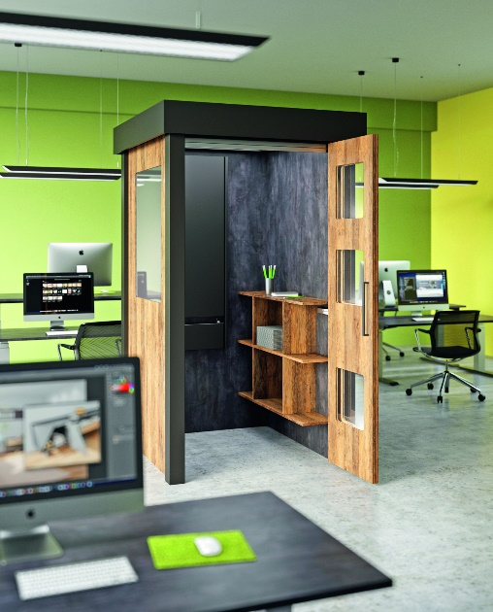
P95_a

A telephone box as a space-saving room-within-a-room solution in an open-plan office offers a variety of uses with a demand for quiet.
Foto: Hettich

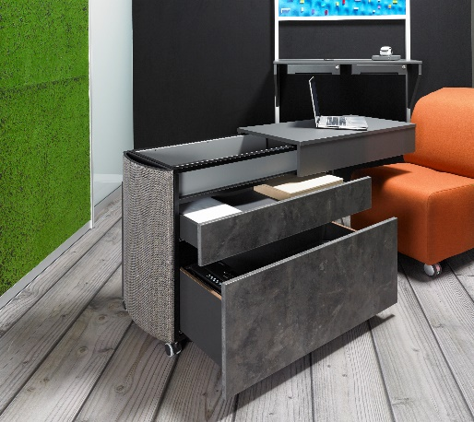
P95_b

This compact and rollable caddy makes the workplace mobile.
Foto: Hettich

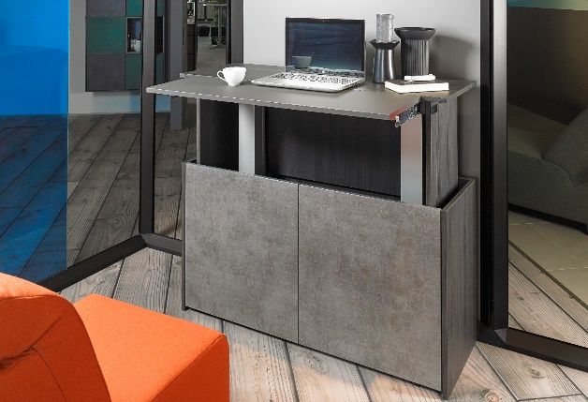
P95_c

Unobtrusive sideboard with integrated workstation for flats that have little space for a home office.
Foto: Hettich

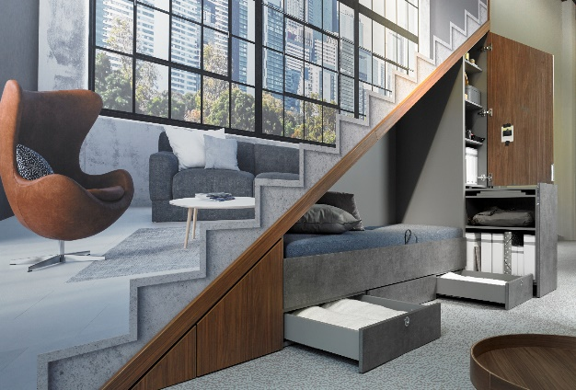
P95_d

The feel-good space under the stairs or sloping roof can be transformed into a comfortable home office in just a few easy steps.
Foto: Hettich

