Hettich's AvanTech YOU attracts accolade in Japan
Drawer platform gets "Good Design Award 2021"

The innovative AvanTech YOU drawer platform from Hettich has won the "Good Design Award 2021" from the Japan Institute of Design Promotion (JDP).

The long established "Good Design Award" is the only comprehensive evaluation and recommendation system for product design in Japan. The prizes, which are awarded annually, are also regarded internationally as proof of quality excellence in functionality and design.

"The Good Design Award's high standing, which also extends beyond Japan, makes the latest accolade for AvanTech YOU something we particularly value," explains Martin Blickmann, Managing Director of Hettich Japan. "I am delighted that the jury has once again acknowledged the outstanding functionality and performance of one of our products. Because solutions from Hettich give our customers the key to constructing quality furniture with designs that make everyone's lives more enjoyable. – The central mission of the Good Design Award movement goes perfectly with Hettich's high standards and expectations. AvanTech YOU, our drawer system for endless design options, has made it into the league of this year's award winners - and this instils us with quite a sense of pride because it now marks the sixth time we've received the Good Design Award since 2014. And with Hettich always being good for innovative product solutions, I'm sure we'll remain successful contenders for the Good Design Award in the future too."

AvanTech YOU – as individual as you
In their evaluation of AvanTech YOU, the jury above all commended the concealed working components and the many different options for individualisation. The innovative drawer system impresses with its high standard of design from a pure design led drawer side profile in a thickness of just 13 mm. The vast range of options within the platform open up unimagined scope for high quality, customised furniture creations and exclusive interior design. AvanTech YOU's straightforward installation and adjustment concept is geared precisely to the needs of furniture manufacturers, fabricators and fitters. And, last but not least, AvanTech YOU's user friendly functions make the system's high quality something users never fail to notice with every day that passes. Hettich is constantly advancing its drawer platform: only this spring was the new "AvanTech YOU Illumination" feature unveiled, now making it possible to give each drawer its very own LED signature lighting.
International acknowledgement from the Japanese Good Design Award 2021 for the versatile drawer system yet again confirms the added value AvanTech YOU gives to architects, tradespeople and industry across the globe.

The following picture material is available for downloading from www.hettich.com, menu: Press:
Images
Captions
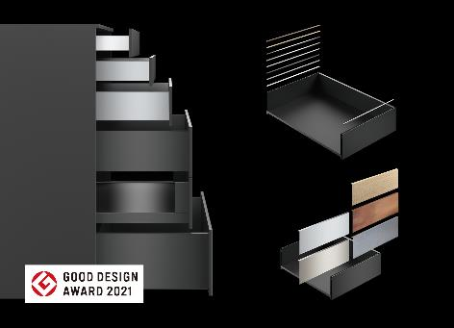
412021_a
Award-winning design excellence: the innovative AvanTech YOU drawer platform from Hettich also impressed the jury of Japan's "Good Design Award 2021" with its concealed working components and the many different options for individualisation. Photo: Hettich

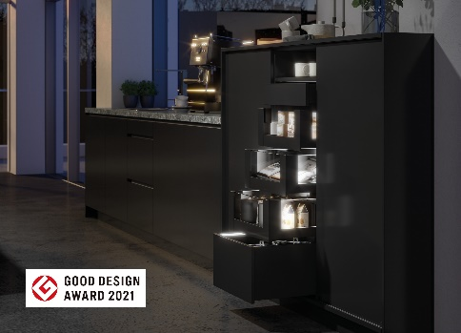
412021_b
AvanTech YOU Illumination makes furniture shine: the LED signature lighting creates stunning effects and a touch of elegance: Photo: Hettich

412021_c
Martin Blickmann, Managing Director of Hettich Japan: "The Good Design Award's high standing, which also extends beyond Japan, makes the latest award for AvanTech YOU something we particularly value." Photo: Hettich

About Hettich
Hettich was founded in 1888 and is today one of the world's largest and most successful manufacturers of furniture fittings. Over 6,600 members of staff in almost 80 countries work together towards the objective: developing intelligent technology for furniture. Hettich thus inspires people all over the world and is a valuable partner for the furniture industry, trade and craft. The Hettich brand stands for consistent values: for quality and innovation. For reliability and customer proximity. Despite its size and international significance, Hettich has remained a family business. Independent of investors, the company's future is shaped freely, humanely and sustainably. www.hettich.com

