"HettichXperiencedays 2021" a huge success
Hybrid trend show attracts 61,500 participants worldwide

The big, digital "Best of" event at the beginning of September took the "HettichXperiencedays 2021" trend show to a further pinnacle. Spotlighting the megatrends of urbanization, individualization and new work, Hettich has successfully used its new hybrid format to present innovative furniture worlds to its customers and partners the world over since its world premiere mid March.

Staging "HettichXperiencedays 2021", Hettich ventured into new territory – and this courage was well rewarded. A novel, flexible concept spanning a period of several months plus a highly committed and dedicated Hettich team were the keys to the success of what is probably the biggest media project in the company's history. This year, despite the difficult situation, the hybrid international event and trend platform made it possible for Hettich to meet its customers and partners as well as new prospective clients from all over the world both on and offline, to inspire them with furniture concepts and innovative solutions for tomorrow's home and working world and also to pass on useful knowledge from the industry. The "HettichXperiencedays" banner was also the invitation to all participants: "Let’s move markets!"

More than 1,000 events around the globe
Worldwide, 61,500 participants were registered either in virtual form or on location between mid March and early September alone. All international Hettich teams were actively involved in implementing this major project, with each location having the opportunity to contribute to its overall success with local campaigns and events. All in all, over 1,000 showroom tours were conducted on and offline within six months, more than 1,000 individual events were organized and over 250 theme based workshops took place. Added to this was the varied keynote program offering a wide range of highly topical subjects in up to 12 languages for the different target groups.

Outlook: Continuing to move the markets
The positive response to the innovative hybrid format has given the Hettich team new impetus, and the valuable experience gained from this project at Hettich can now be channeled into taking forward all manner of work domains.

And the next move? Hettich's regional operating bases will, of course, continue to offer all customers and prospective clients virtual tours of the "HettichXperiencedays" highlights as well as on location showroom visits. The "HettichXperiencedays" portal at https://xdays.hettich.com will remain online, giving registered users access to all content at any time, be it in the form of information on the megatrends or the extensive media library offering international keynotes or videos of virtual tours in several languages.

The virtual presentation of the trend domains in the "3D Xperienceworld" will remain a particular highlight for users to discover on their own: This is where they'll find plenty of inspiration for more design, more functionality and more user friendly convenience – for large and small rooms, for flexible, urban living, for new work and homeworking, for shops and hotels, for white goods and also for the outdoor segment. All exhibits are shown in actual working practice, including useful additional information, such as lists of fittings, CAD drawings, product videos or picture material.

As a "living organism", Hettich's Xdays platform will continue to provide users at international level with new inspiration in the future too because coverage will be updated on an event related basis and packed with new, interesting topics. So, under the "Let's move markets!" banner, it's still worthwhile registering free of charge at: https://xdays.hettich.com

The following picture material is available for downloading from www.hettich.com, menu: Press:
Images
Captions
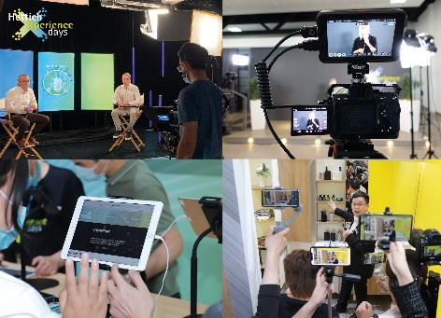
332021_a
Accompanying "HettichXperiencedays 2021", there were over 1,000 individual events at Hettich operating bases worldwide between mid April and early September alone. Photo: Hettich

332021_b
Hettich is continuing to provide new impetus for the industry on the digital Xdays platform. Free registration at: https://xdays.hettich.com Graphics: Hettich

About Hettich
Hettich was founded in 1888 and is today one of the world's largest and most successful manufacturers of furniture fittings. Over 6,600 members of staff in almost 80 countries work together towards the objective of developing intelligent technology for furniture. Hettich thus inspires people all over the world and is a valuable partner for the furniture industry, trade and craft. The Hettich brand stands for consistent values: For quality and innovation. For reliability and customer proximity. Despite its size and international significance, Hettich has remained a family business. Being independent of investors means that the company has a free hand in shaping its future with a focus on the human element and sustainability.

