New: TopLine L with split profiles
Short package length, full user convenience

The TopLine L sliding door system sets standards in designing large wardrobes and ease of use; now too for profile packaging, shipping and one person installation. With immediate effect, Hettich is offering TopLine L with split steel profiles. This shortens package length to pallet size while making shipping far more efficient.

Placing a focus on benefiting both customer and environment, Hettich has advanced its TopLine L sliding door system so that the extra long runner and guide profiles can be split without compromising on convenience. A profile set now comes in a maximum length of 2.35 m, resolving the problems involved in shipping bulky, long items. The capability of conveniently shipping and handling the package on a pallet in logistics gives the RTA furniture and online furniture retail market segments attractive new potential for fitting sliding door wardrobes with TopLine L, because whatever's smaller and split into sections is easier to carry and can be installed at the consumer by only one person. Shipping split profiles also comes with benefits in terms of customer satisfaction and work input: it means less damage which is reflected in fewer complaints.

Split profiles provide no end of convenience
Splitting runner and guide profiles does not compromise TopLine L's tried and proven user-friendly functions, such as incredibly smooth door running action, soft opening and closing with Silent System, minimal door offset or narrow door panel reveals. Wardrobe doors travel silently and gently over the profile joint. TopLine L with split profiles makes it easy for furniture manufacturers to enter volume production and serve new markets.

The following picture material is available for downloading from www.hettich.com, menu: Press:
Images
Captions

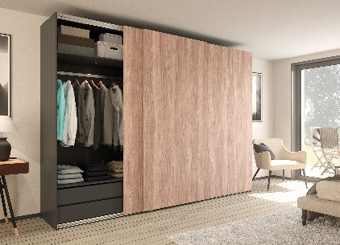
P96_a
TopLine L with split profiles guarantees luxuriously smooth running performance even in ceiling height wardrobes with sliding doors weighing up to 50 kg each. Photo: Hettich

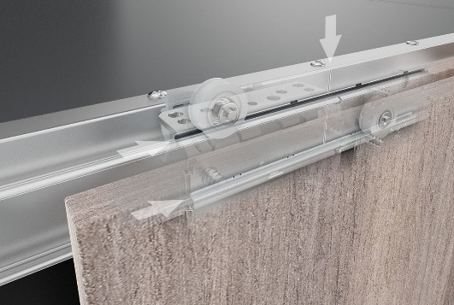
P96_b
The working components used in TopLine L with split profiles are barely visible and silently move wardrobe doors across the profile joint. Photo: Hettich

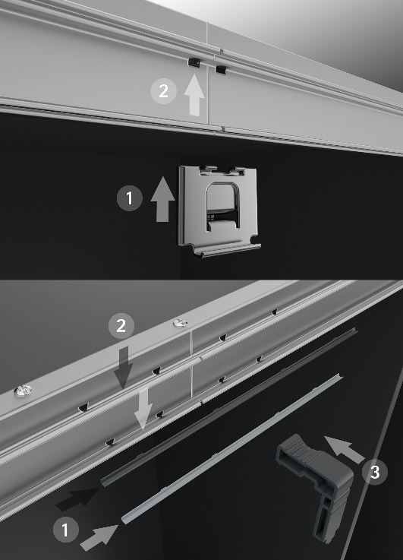
P96_c
Intelligent installation accessories mean just one person can fit the profiles with ease. Photo: Hettich

About Hettich
Hettich was founded in 1888 and is today one of the world's largest and most successful manufacturers of furniture fittings. Over 6,600 members of staff in almost 80 countries work together towards the objective: developing intelligent technology for furniture. Hettich thus inspires people all over the world and is a valuable partner for the furniture industry, trade and craft. The Hettich brand stands for consistent values: for quality and innovation. For reliability and customer proximity. Despite its size and international significance, Hettich has remained a family business. Independent of investors, the company's future is shaped freely, humanely and sustainably. www.hettich.com

