Hettich: "We are testing low carbon emission steel"
Pilot project to make production more sustainable

Fittings specialist Hettich has already embarked on the forward looking journey towards "green steel": in a pilot project this summer, the company sourced German produced cold-rolled coils with a reduced carbon footprint for components in its Sensys range of concealed hinges. Initial quality tests proved positive, this being an encouraging result for Hettich. In the long term, the aim is to work with customers and partners to develop and manufacture not only low carbon emission products but also products that are completely carbon neutral.

Jan Hobert, lead buyer for steel at Hettich Management Service GmbH in Kirchlengern, oversaw Hettich's "low carbon emission steel" pilot project. "The first three cold rolled coils we purchased from the Bilstein Group in September have a significantly lower carbon footprint than steel produced in the convention way. The entire production process cuts carbon emissions by over 70 per cent." In absolute figures, this means: only 630 kg/t of CO₂ compared to 2,190 kg/t. In other words, these three coils alone saved around 90 tonnes of CO₂. This equates to the annual carbon emissions from 50 cars doing an average annual mileage of 15,000 km a year. Throughout the entire Hettich Group, the avoidance potential from using the climate friendlier material amounts to over 450,000 tonnes of CO₂ per annum. But for Hettich, the second result of this test run is equally as groundbreaking, as Jan Hobert explains: "Our internal tests prove that the low carbon emission steel is in no way inferior to conventional material in terms of quality and processability."

Wanted: allies for new solutions
The pilot project at Hettich was initially limited to one specific hinge component because larger quantities of the low carbon emission steel are not available at short notice, and the surcharge per tonne is still fairly substantial. At the moment, there is no way either to estimate whether and the extent to which it will be possible to make products with a reduced carbon footprint on a volume production basis. This will, at all events, involve far reaching changes in supply and production. Nonetheless, Hettich is determined to continue in this direction, Managing Director Uwe Kreidel is keen to stress: "The pilot project was only an initial major step on the way to processing low carbon emission steel in volume production. We are continuing to work on new solutions and are looking forward to working with interested customers with whom we can even develop carbon neutral products in the long term across the stepping stone of making low carbon emission products. It's a future opportunity we definitely want to take on board."

Steel: high material quality for long useful life
Steel has always been a key issue for fittings manufacturer Hettich. The benefits that come with this material are crucial to the high quality and durability of products: steel is fully recyclable and even "multi-recyclable", which means it can be melted down and reused an infinite number of times. On top of this, steel can be adapted to suit any new requirements through alloying, secondary treatment and further processing. It is easy to cut, press and transport, and because steel is magnetic, it's also easily sorted and separated from other materials. In its product development activities, Hettich also focuses on optimising material management when it comes to using steel: as much as necessary from a technical perspective – yet as little as possible. And to make sure materials are easy to recycle at the end of a long product life, the company focuses attention on design systems that permit ingrade recycling wherever possible, ease of dismantling and tool-less component separation. – the flip side of the steel coin, however, is the huge amount of primary energy that's required for conventional production in a blast furnace.

Alternative steel production as a way of elevating climate protection
In Germany alone, the steel industry currently generates about one third of the country's industrial greenhouse gas emissions. To achieve the goals of European climate protection policy and national climate protection plans – which call for greenhouse gas neutrality by the middle of the century – it will mean restructuring resource intensive process of producing steel. Launched in 2020, the German government's "Steel Action Concept" sends out a signal for climate friendly steel "made in Germany" and for recycling more and more materials. All of Germany's prominent steel manufacturers are working on alternative production processes to reduce carbon emissions and ultimately avoid them altogether. In future, hydrogen and electricity from renewable sources could completely replace the carbon previously needed for producing steel, thereby reducing carbon emissions in steel production by over 95 per cent.

It is against this background that Hettich wants to set a new course in good time – particularly in view of the huge uncertainties stemming from the latest upheavals and spiralling prices on the international steel markets. Jürgen Werner, Managing Director at Hettich, explains: "With a significant proportion of our customers located regionally in East Westphalia-Lippe, we are trying to keep the supply chain for steel as efficient as possible in a move to weather the crisis as best we can. The prospect of being able to source lower carbon emission steel from German production in the medium or long term will be a central key to boosting planning certainty and providing greater sustainability."

The following picture material is available for downloading from www.hettich.com, menu: Press:
Images
Captions
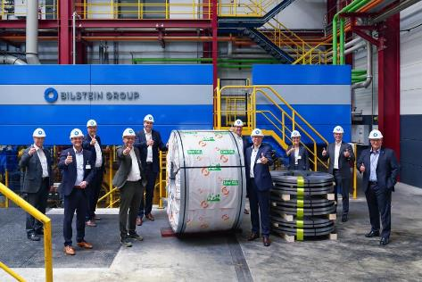
442021_a:
Hettich pilot project "Low carbon emission steel": The first three cold rolled coils delivered to Hettich in September have a significantly lower carbon footprint than steel produced in the conventional way. Photo: Hettich/Bilstein

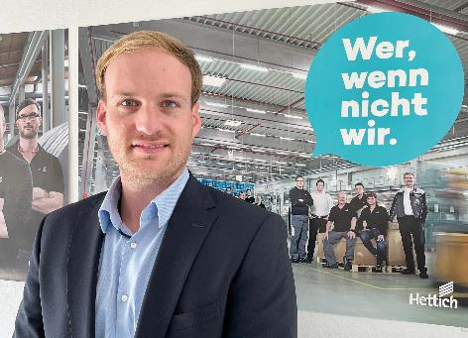
442021_b:
Jan Hobert, lead buyer for steel at Hettich: "Our internal tests prove that the low carbon emission steel is in no way inferior to conventional material in terms of quality and processability." Photo: Hettich
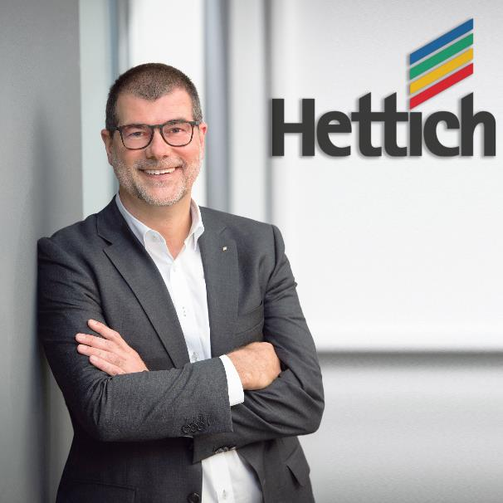
442021_c:
Uwe Kreidel, Managing Director at Hettich: "We are continuing to work on new solutions and are looking forward to working with customers who are interested in developing carbon neutral products in the long term across the stepping stone of making low carbon emission products." Photo: Hettich

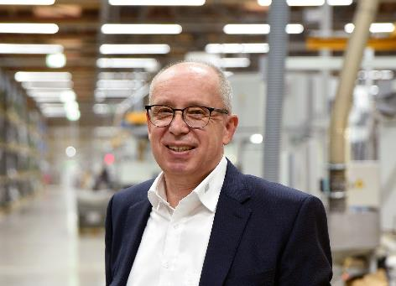
442021_d: Jürgen Werner, Managing Director at Hettich: "With a significant proportion of our customers located regionally in East Westphalia-Lippe, we are trying to keep the supply chain for steel as efficient as possible in a move to weather the crisis as best we can. The prospect of being able to source lower carbon emission steel from German production in the medium or long term will be a central key to boosting planning certainty and providing greater sustainability." Photo: Hettich

About Hettich
Hettich was founded in 1888 and is today one of the world's largest and most successful manufacturers of furniture fittings. Over 6,600 members of staff in almost 80 countries work together towards the objective: developing intelligent technology for furniture. Hettich thus inspires people all over the world and is a valuable partner for the furniture industry, trade and craft. The Hettich brand stands for consistent values: for quality and innovation. For reliability and customer proximity. Despite its size and international significance, Hettich has remained a family business. Being independent of investors means that the company has a free hand in shaping its future with a focus on the human element and sustainability.

