Hettich shows innovations at Esprit Meuble 2021
Customised furniture design and transformable spatial concepts

Esprit Meuble 2021 sees Hettich focusing on solutions customised for the modern home and working world. The fittings specialist will be presenting some startlingly fresh ideas for the French market. Highlights on Hettich's stand F49 are modern day design features for the AvanTech YOU drawer platform as well as solutions for transformable spaces with the WingLine L folding door system. Visitors will also be able to explore the internationally acclaimed and award winning "Tiny Home" storage miracle.

Individuality is what it's all about: a new generation of furniture that can be designed in many different ways comes with clear added value for all those who want to put their very own stamp on their furniture. Hettich shows how this can be done both creatively and cost effectively.

AvanTech YOU Illumination: showing furniture in its best light
The versatile and adaptable AvanTech YOU drawer system from Hettich takes every effort out of customising design to meet any preference in colour, format and material. The platform principle means all components can be combined in any chosen way. This opens up a vast range of creative options for furniture with an individual look and for exclusive interior design. Offering new DesignCapes in copper and concrete look, Hettich has this year added two on trend design options to its standard AvanTech YOU range. And now "AvanTech YOU Illumination" even gives furniture its own signature lighting: clip on LED DesignProfiles or illuminated glass inlays create stunning mood effects and a touch of elegance. A practical rechargeable battery pack provides the necessary energy,without the need for any costly and complicated wiring. Hettich has already won several international design awards for its bright idea this year alone.

WingLine L: for more room in the room
The WingLine L folding sliding door system with Push/Pull to move even opens ceiling height, handleless wardrobe doors almost by themselves in response to a light press – doing so too with impressive panorama effect. Even an entire kitchen block can vanish from view behind the folding doors. The fitting can be provided with soft opening and closing. Under stairs and sloping ceilings, WingLine L provides the answer to utilising previously wasted storage space with visual appeal. And wherever space comes at a premium, the folding sliding door system comes with a high level of user convenience and ergonomic accessibility, such as in smaller type wall units or top mounted cabinets in the kitchen. With minimal door protrusion, WingLine L also makes it possible to fit drawers and pull-outs behind the folding sliding door.

"Tiny Home": has everything on just 18 m²
Living space in the urban environment is scarce and expensive, and floor plans are getting smaller. Does that mean restricting yourself? Not with Hettich: the fully equipped "Tiny Home" single person apartment lacks absolutely nothing. Put to optimum use, spaces combine all the necessary function zones and also provide maximum storage space from floor to ceiling. The "Tiny Home" only uses standard products from Hettich. They give the key to integrating the user friendly functions from a conventional apartment into the micro floor plan. The mini apartment shows superb design quality in every last detail, leaving predominantly handleless furniture fronts to create surfaces that speak spaciousness. The "Tiny Home" from Hettich demonstrates that it's possible to live comfortably even in the smallest of spaces.

Hettich's comprehensive product range is packed with inspiration for appealing design and convenient functions for the modern home and work environment. Discover even more refreshing furniture ideas on the megatrends of individualisation, urbanisation and new work at www.hettich.com
or the portal https://xdays.hettich.com/

The following picture material is available for downloading from www.hettich.com, menu: Press:
Images
Captions
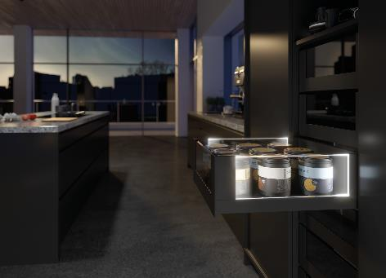
432021_a
Stunning mood effects and a touch of elegance: as an option, AvanTech YOU from Hettich now gives drawers their own LED signature. Photo: Hettich

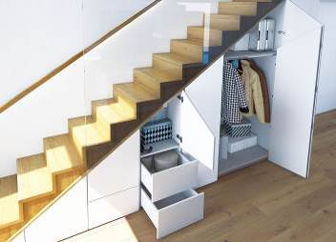
432021_b
The WingLine L folding door fitting also impresses when it comes to interior design – under stairs, for example. Photo: Hettich

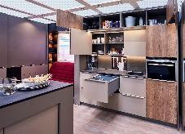
432021_c
The "Tiny Home" has absolutely everything: 18 m² of living space feature intelligent Hettich storage solutions from floor to ceiling. This makes living in comfort possible on a tiny floor plan too. Photo: Hettich

About Hettich
Hettich was founded in 1888 and is today one of the world's largest and most successful manufacturers of furniture fittings. Over 6,600 members of staff in almost 80 countries work together towards the objective: developing intelligent technology for furniture. Hettich thus inspires people all over the world and is a valuable partner for the furniture industry, trade and craft. The Hettich brand stands for consistent values: for quality and innovation. For reliability and customer proximity. Despite its size and international significance, Hettich has remained a family business. Independent of investors, the company's future is shaped freely, humanely and sustainably. www.hettich.com

