Hettich at Prowood 2021
Solutions customised for the modern home and working world

Hettich will be using Prowood in Ghent from 17 to 21 October 2021 to showcase its new products and services. In Hall 2, stand 2335, visitors from the trades and retail will have the opportunity to gather first hand experience of all many different creative solutions for customised furniture design. Among the highlights from Hettich are the new Cadro frame system and the AvanTech YOU drawer platform. But the lineup of eService or Hettich's joint presentation with partner tapio on digital processing also make attending the show worthwhile.

Individuality is what it's all about: a new generation of furniture that can be designed in many different ways comes with clear added value for fabricators, retailers and consumers. Hettich will be showing creative and cost effective ways of achieving any personal design preference.
AvanTech YOU Illumination: showing furniture in its best light
The versatile and adaptable AvanTech YOU drawer system from Hettich takes every effort out of customising design to meet any preference in colour, format and material. The platform principle means all components can be combined in any chosen way. This opens up a wide range of design options for interior design. By way of option, "AvanTech YOU Illumination" now even gives furniture its own signature lighting: clip on LED DesignProfiles or illuminated glass inlays create stunning mood effects and a touch of elegance. A practical rechargeable battery pack provides the necessary energy,without the need for any costly and complicated wiring.

Cadro frame system: the easy way to individualise furniture
The delicate Cadro frame system from Hettich creates a new generation of furniture that can be designed in many different ways. Cadro comprises various aluminium profiles in matt black or stainless steel look, matching connecting nodes and other accessories. This produces creative, practical furniture concepts with quality design appeal. Cadro can be used to configure precision fit customised designs for open or closed furniture – whether for mounting on the wall, standing on the floor, attaching to other pieces or completely free standing. Cadro is very easy to combine with other Hettich fittings and systems.

The new Actro 5D generation: stability and luxuriously smooth running action for large wooden drawers
Long life, incredible stability and outstanding running performance are characteristic of the new Actro 5D generation from Hettich. The high performance runner system for wooden drawers can take loads of up to 70 kg and, providing precision adjustment, ensures perfect front panel alignment – even on very large, handleless fronts. The latest Actro 5D product generation has been consistently optimised for fast, straight forward installation. All very intuitively and without the need for tools, the front panel can be adjusted in 5 directions. Agreeably low opening forces as well as Actro 5D's smooth, quiet running action give the user an added feel of luxurious convenience.

TopLine XL sliding door system: strong for extra large wardrobe formats
Developed specially for large and heavy fronts, TopLine XL from Hettich sets new standards in bringing purist design to ceiling height wardrobes. Its extremely shallow design with inconspicuously integrated Silent System makes the fitting almost invisible. The ease of installing the system alone is nothing short of impressive: the large format door panels can be set down on the floor without the risk of damaging the bottom fittings, quickly hung and easily adjusted. With "TopLine XL", doors weighing up to 100 kg gently open and close with effortless ease. Specially developed rollers with particularly good shape retention provide the basis for this new, easy running action. The system also takes you by surprise with a technical innovation for even greater practical convenience in 3-door wardrobes: the middle door opens intuitively both to the left and right. Whether on opening with incredible ease or gently closing – TopLine XL always runs smoothly and quietly.
AvanFit 300 advanced and tapio: digital assistance for even greater assembly efficiency
The new generation of semi automated AvanFit 300 advanced assembly machine from Hettich now makes it even easier to assemble AvanTech YOU drawers and pot-and-pan drawers. Because the AvanFit 300 advanced "knows" which width to set next before constructing each and every drawer. This obviates the need for any manual adjustment. But how? The assembly machine can be operated externally via any online network. Using a planning software tool, the appropriate values within a cabinet body, such as drawer width and depth or back panel and drawer side profile height, can be set automatically for each drawer on the basis of the CAD data. If the machine's not to be accessed externally, settings can also be made via an optical system, such as a scanner, or it can be programmed directly on the control panel. The machine is connected to the tapio digital ecosystem which means that the current machine status and settings can be viewed from an external source at any time. As such, AvanFit 300 advanced significantly boosts efficiency in the production process makes it far more cost effective to provide customised drawer designs.

The following picture material is available for downloading from www.hettich.com, menu: Press:
Images
Captions
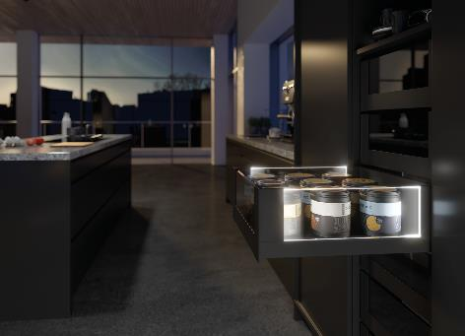
402021_a
Stunning mood effects and a touch of elegance: as an option, AvanTech YOU from Hettich now gives drawers their own LED signature lighting. Photo: Hettich

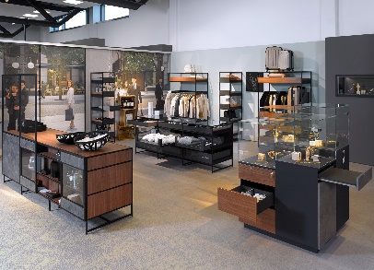
402021_b
The Cadro frame system can be used to customise shop furniture with an exclusive feel for all sorts of different segments. Photo: Hettich

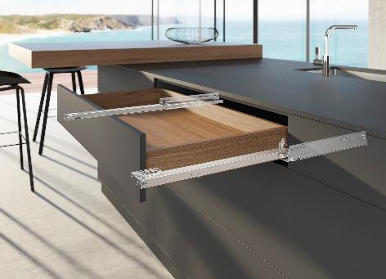
402021_c
The sturdy, new generation of the Actro 5D for wooden drawers provides top performance for modern, large format furniture design. Photo: Hettich

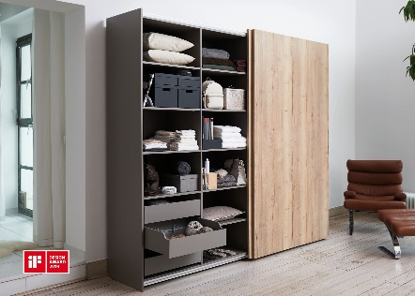
402021_d
Awarded for outstanding design: with its extremely shallow design,
the TopLine XL sliding door fitting blends into the design of furniture where it can hardly be seen. Photo: Hettich

About Hettich
Hettich was founded in 1888 and is today one of the world's largest and most successful manufacturers of furniture fittings. Over 6,600 members of staff in almost 80 countries work together towards the objective: developing intelligent technology for furniture. Hettich thus inspires people all over the world and is a valuable partner for the furniture industry, trade and craft. The Hettich brand stands for consistent values: for quality and innovation. For reliability and customer proximity. Despite its size and international significance, Hettich has remained a family business. Independent of investors, the company's future is shaped freely, humanely and sustainably. www.hettich.com

