Double win for Hettich in iF Design Awards
Awards go to AvoriTech drawer system and Quadro runner for dishwashers
No fewer than two newly developed products from Hettich have attracted the prestigious iF Design Award this year: in the "Kitchen" category, the jury awarded prizes to the slimline AvoriTech drawer system and the Quadro runner for dishwashers.

AvoriTech: slimline, high quality design
Modern luxury kitchens are defined by minimalist aesthetic appeal, exclusive materials and their particular quality in terms of finish and functionality in every last detail. The AvoriTech drawer system with its slimline 8 mm drawer side profile and rear panel meet precisely these demands from discerning kitchen buyers in the high end segment. Reduced in looks to the essentials, AvoriTech combines elegant understatement with innovative drawer technology. And the platform principle makes it extremely easy to customise designs and use any materials consumers choose. Well known luxury kitchen manufacturer Poggenpohl, for instance, has opted for a finish in elegant, anodised aluminium. Protected steel cable synchronisation from the associated Actro YOU runner platform guarantees smooth drawer running action. This gives the system a high level of lateral stability while also minimising sag, even for heavy pull-outs weighing up to 70 kg. As a result, AvoriTech drawers featuring large, handleless front panels are left with neat, exact reveal alignment. The practical technology for adjusting the drawer vertically and horizontally has been fully integrated into the slimline drawer side profile. The adjustment elements for aligning the front panels are easily accessible behind an inconspicuous cover. What's special here: despite the extremely slender drawer side profile, there's no need to alter the height of tilt of the entire drawer - only the front panel is adjusted to leave it parallel with the cabinet body. This permits fast, precision adjustment of the drawer front.

Quadro: new user friendly rack convenience in the dishwasher
Introducing the Quadro runner system for dishwashers, Hettich is now taking practical convenience familiar from the furniture sector and applying it to white goods as well. Designed specifically for this permanently moist environment, Quadro runners used in the dishwasher are by no means "wet behind the ears" when it comes to performance and durability: the racks move in and out very smoothly and with effortless ease. This controlled, linear movement goes particularly easy on dishes and glasses, with the optional Silent System soft closing mechanism also gently moving the rack into the home position. When loading and emptying, the over extension runner provides convenient access over the rack's entire depth. This makes optimum use of space because the Quadro's compact, slender design keeps to the sidelines, providing maximum dishwasher rack volume. A further benefit is the system's hygiene factor in everyday use: with the Quadro profiles being open in structure, food residues are simply flushed out and can't get stuck.
V-Zug, the reputable premium manufacturer of electrical appliance, is already using Quadro with tremendous success for the top racks in its Adora line of dishwashers with OptiLift.

www.hettich.com

The following picture material is available for downloading from www.hettich.com, menu: Press:
Images
Captions
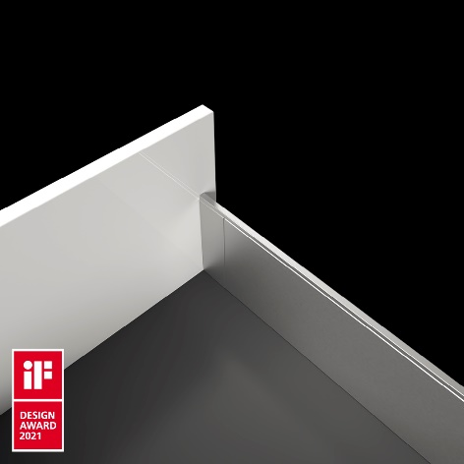
192021_a
iF Design Award 2021 for AvoriTech from Hettich: the drawer system with 8 mm drawer side profile combines elegant understatement with innovative drawer technology. Photo: Hettich

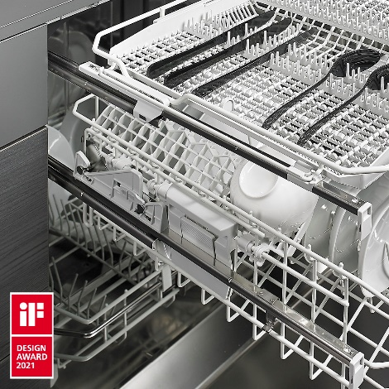
192021_b
iF Design Award 2021: Quadro runners for dishwashers have been developed for extreme conditions. This means the practical convenience familiar from the furniture segment can now be used for white goods too. Photo: Hettich

About Hettich
Hettich was founded in 1888 and is today one of the world's largest and most successful manufacturers of furniture fittings. Over 6,600 members of staff in almost 80 countries work together towards the objective: developing intelligent technology for furniture. Hettich thus inspires people all over the world and is a valuable partner for the furniture industry, trade and craft. The Hettich brand stands for consistent values: for quality and innovation. For reliability and customer proximity. Despite its size and international significance, Hettich has remained a family business. Independent of investors, the company's future is shaped freely, humanely and sustainably. www.hettich.com

