Interzum Award goes to AvanTech YOU with signature lighting
Accolade for outstanding design acumen

Taking the jury by storm, Hettich's versatile AvanTech YOU drawer system with its new design elements featuring integrated lighting has attracted the 2021 Interzum Award in the "High Product Quality" category for outstanding design merit.

The growing megatrend of individualisation is reinforcing customer demand for customised design flexibility in kitchen and home furnishings. Even at standard lineup level, the drawer platform provides a plethora of design combinations in terms of colour, shape and material. Providing the option of giving drawers signature lighting, AvanTech YOU plays with attractive design features that tick every box when it comes to contemporary taste and style.

In essence, the award spotlights outstanding design in terms of form and functionality. The slimline drawer side profile in a mere 13 mm with invisibly integrated front-panel adjustment function permits elegant, flawless design in any combination. Equally, signature lighting integrates both elegantly and easily. Easily clipping into place, a designer profile illuminates open drawers on the inside in homogeneous LED light at 4,000K or makes an eye catching feature on the outside too. This is where stunningly lit glass inlays with polished or ground edges create lighting effects that are second to none. In each case, a practical rechargeable battery pack provides the necessary energy. There's no need for costly electrical connections, leaving high quality design with signature lighting to steal the show without any added cost whatsoever.
The following picture material is available for downloading from www.hettich.com, menu: Press:
Images
Captions
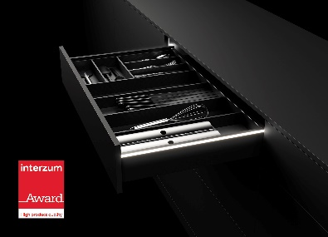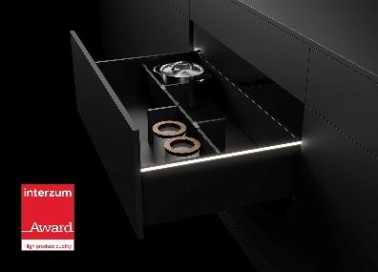
L: P92_a
R: P92_b

On request, AvanTech YOU gives furniture its very own lighting signature. Photo: Hettich

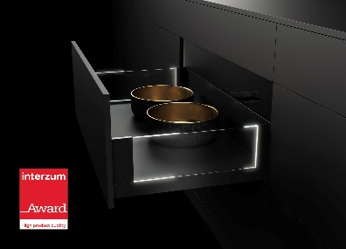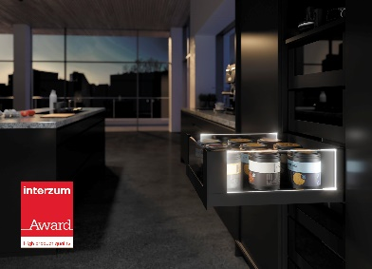
L: P92_c
R: P92_d

AvanTech YOU with signature lighting conjures amazing effects in combination with glass inlays. Photo: Hettich

