"Now getting new product releases straight to the customer"
In 2022 too, the "Hettich on tour" roadshow is continuing on its journey throughout Europe

A good idea can get things moving: the new roadshow concept started out as a service for fabricators and Hettich's specialist retailers in Germany, Austria and Switzerland. Meanwhile, the "Hettich on tour" project has catapulted across the whole continent. From May 2020 to December 2021 alone, Hettich's teams clocked up some 160,000 miles through almost 20 European countries. From spring 2022, after a short winter break, the "Hettich on tour" vehicles will be back on Europe's roads – on their way to their next set of eager customers.

Despite the pandemic and cancelled trade fairs, the Hettich roadshow has called in on around 10,000 Hettich partners from Estonia to Portugal: "Hettich on tour" has given fabricators, specialist retailers and customers from the furniture industry the opportunity to experience Hettich's top new products on their own doorstep and test them out in person – needless to say, in times of the coronavirus, in full observance of applicable social distancing rules and hygiene measures. This unprecedented service was welcomed by all with open arms.
On-location training for all the customer team
When Hettich planned a roadshow aimed specifically at fabricators and specialist retailers in the summer of 2019, no one could ever have imagined how this almost insignificant project was set to snowball in such a short time. Straight after "Holz-Handwerk" in spring 2020, "Hettich on tour" set out to reach those customers not likely to make their way to the woodworking and wood processing trade fair in Nuremberg. The idea was to present Hettich's latest new product releases right on their doorstep: the Actro 5 D drawer runner, the AvanTech YOU drawer platform and the TopLine XL sliding door system.

Hettich project manager Dirk Beinke explains the particular concept behind "Hettich on tour": "Our message to customers is: let's make life easy for you! Hettich's bringing out new product releases, this time though directly to you. In just a short time you can train everyone from apprentice to top management, without any travel costs whatsoever." Unlike previous roadshows, Hettich has moved away from large show trucks. "We have deliberately gone for normal van transporters we've converted ourselves to suit our purposes", Dirk Beinke says. "This gives us much more flexibility: a small footprint, an autonomous system from solar panels on the vehicle's roof, plus our own sales representatives driving them."

Showing closeness to customers in spite of COVID
When COVID meant cancelling the "Holz-Handwerk" trade fair in spring 2020, this roadshow concept proved to be a stroke of genius for Hettich: under the "Distancing Still Means Closeness to Customers" banner, two converted Hettich vehicles initially went on tour across Europe from May 2020 with our new product highlights, first in Germany, Belgium and the Netherlands, as well as through Austria, Switzerland and Italy's northern "Alto Adige" or South Tyrol province. Customers everywhere were blown away: by the end of 2020 alone, Hettich managed to get to 2,000 of its customers and welcome over 3,000 visitors to the mobile show transporters.

Demand for "Hettich on tour" had since spread to other target countries, because staff at Hettich's European operating bases or sales offices quickly realised how successful the campaign was to be. Suddenly, everyone wanted to be part of it, and customers too started asking when Hettich could call by. No sooner said, two more vans were fitted out to go on tour from summer 2020 with a focus on France and Spain, and, from summer 2021, also in Eastern Europe.

Colleagues dedicated from north to south
The tightly scheduled tour dates across Europe quickly became a major organisational project laden with red tape. Dirk Beinke recalls: "Getting the vehicles from one country to the next was sometimes quite a time-consuming hurdle because of all formalities, but all colleagues worked together so wonderfully well: on Friday evening, our Latvian team had finished its tour, over the weekend the show entourage went down to the Czech Republic, and after handover and briefing, the colleagues there were quickly able to get the tour started on the Monday."
And another rewarding upshot of the European tour so far: in the last eighteen months, we've only had to call out a breakdown service four times for all four vehicles.

The success we've seen from "Hettich on tour" has so far exceeded our wildest expectations and, in the wake of this, we've also managed to attract all manner of new customers. Particularly in Eastern European countries, Hettich has used this approach to forge closer ties with the trades and retail. Dirk Beinke: "When a global corporation takes the trouble to travel far away from Bucharest to a small processor in Romania's rural countryside, feeling valued as a customer is never far away. This is precisely the team partnership we have wherever we are."

On it goes from spring 2022
Preparations are already underway for the new "Hettich on tour" season starting in spring 2022 with two vans: Ireland, Romania and Turkey are just some of the focuses for next years tours. Hettich colleagues are properly trained and kitted out for working under pandemic conditions. Where exactly "Hettich on tour" is calling at from spring 2022 will in each case be announced in the newsbox at hettich.com, with the teams promptly reporting on their travel experiences in good time on the social media channels.

The following picture material is available for downloading from www.hettich.com, menu: Press:
Images
Captions

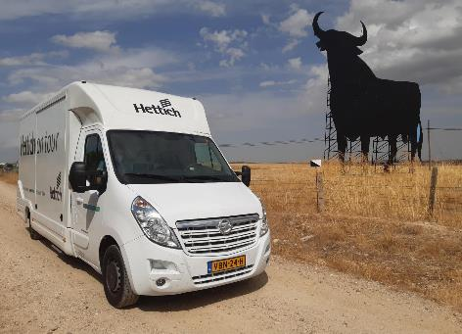
022022_a
On the road from Northern to Southern Europe to partners from industry, the trades and retail. In pandemic times, "Hettich on tour" shows how close Hettich is to its customers. Photo: Hettich

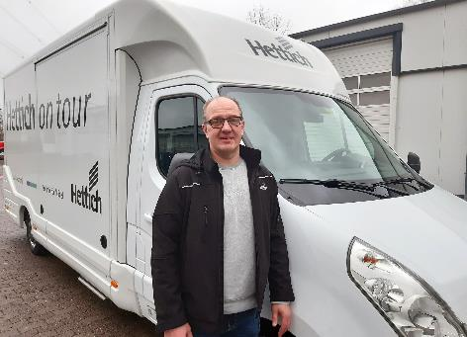
022022_b
Dirk Beinke, project manager of "Hettich on tour”: "Our message to customers: Let us make it easy for you! Hettich's bringing out new product releases, this time though directly to you. In just a short time you can train everyone from apprentice to top management, without any travel costs whatsoever". Photo: Hettich

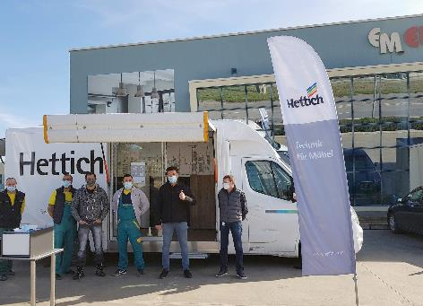
022022_c
”Hettich on tour”: the roadshow is passing through several European countries and brings the latest top new products directly to fabricators and specialist retailers. Photo: Hettich

022022_d
Experiencing product highlights like AvanTech YOU, Actro 5D, TopLine XL and e-services first hand despite Corona: "Hettich on tour" is presenting the latest highlights in two specially converted vehicles. Photo: Hettich

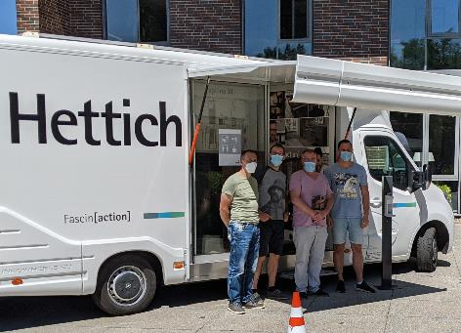
022022_e
On its tour, Hettich has also already made stops at furniture manufacturers in Germany (here: June 2021 at Laue GmbH Objektausstattungen in Eberswalde). Photo: Hettich

About Hettich
Hettich was founded in 1888 and is today one of the world's largest and most successful manufacturers of furniture fittings. Over 6,600 members of staff in almost 80 countries work together towards the objective: developing intelligent technology for furniture. Hettich thus inspires people all over the world and is a valuable partner for the furniture industry, trade and craft. The Hettich brand stands for consistent values: for quality and innovation. For reliability and customer proximity. Despite its size and international significance, Hettich has remained a family business. Being independent of investors means that the company has a free hand in shaping its future with a focus on the human element and sustainability.

