Stability and luxuriously smooth running action for large wooden drawers
The new generation Actro 5D drawer runner

Generously sized drawers and narrow reveals are the mark of today's high-end furniture lines. This calls for high performing drawer runners which, even when heavily laden, reliably demonstrate strength and stamina: Hettich's new Actro 5D runner for wooden drawers ensures perfectly aligned front panels with a look of absolute precision. Large, handleless fronts coalesce into one homogeneous surface on which the uninterrupted wood decor is left to unfurl its full visual impact.

Long life, incredible stability and outstanding running performance are characteristic of the new Actro 5D generation from Hettich. The sturdy runner system provides a load capacity of up to 70 kg and, when pulled open, keeps wooden drawers particularly level. Agreeable low opening forces as well as Actro 5D's smooth, quiet running action give the user an added feel of luxurious convenience. Optimised synchronous control makes it possible: safely protected by the runner profile, it ensures a smooth movement cycle between the profiles and minimises running noise.

Top performance for large format furniture design
Additional convenient features also mean that Actro 5D significantly broadens creative flexibility for handleless furniture design: fitted with Push to open Silent, wooden drawers open with effortless ease in response to a mere tap on the front panel, leaving them to close again softly and silently. Thanks to effective multisynchronisation beyond cabinet body width, the system can also be used for extra wide front panels across two wooden drawers: a light press at any point on the XXL front reliably triggers the opening function every time. Hettich has further solutions for out of the ordinary fitting situations in the kitchen or bathroom: a flexible adapter can be used for asymmetrically shaped drawers and, wherever a U bend is in the way, a bypass adapter guarantees full functionality from push to open Silent for the wooden drawer. Specifically for pull-out shelves, the Actro 5D also provides a retaining function that prevents the shelf from sliding back in unintentionally.

Front panel adjustment and handling easier than ever
The latest Actro 5D product generation has been consistently optimised for fast, straightforward installation and front panel adjustment. 5 way adjustment is tool-less and completely intuitive: the front panel can be adjusted vertically, laterally and in depth simply by touch and without detaching the drawer. The tilt and radial adjusters behind the drawer rear panel are easy to grip by undoing the drawer and pulling it forward a short distance on the runner.

Easily responding to customer wishes
With the Actro 5D generation, Hettich has made its successful platform system yet more accommodating: the Actro 5D's cabinet body drilling pattern is identical to the one used by the new AvanTech YOU drawer platform. This now means it's only one small step to the many design options provided by the innovative drawer system that fits on the Actro YOU (up to 40 kg / 70 kg) and Quadro YOU (up to 30 kg) runners. Particular advantage: these two runner systems can also be used under wooden drawers with identical dimensions whenever adjusting front panel height is all that's necessary from a construction and design aspect. This means the versatile platforms from Hettich make it easy for industry and fabricators to secure a strong position in different furniture segments while matching value for money to whatever their customers want.

The following picture material is available for downloading from the "Press" menu at www.hettich.com:
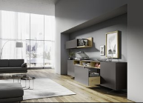
P89_a
Handleless design exquisitely executed: the new Actro 5D runner from Hettich for wooden drawers ensures perfectly aligned front panels. Photo: Hettich

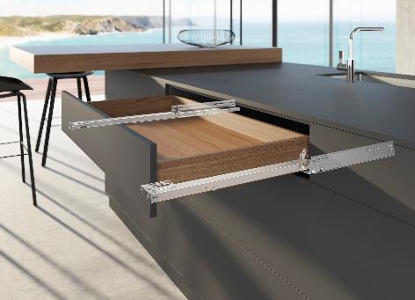
P89_b
The sturdy, new generation of the Actro 5D for wooden drawers provides top performance for modern, large format furniture design. Photo: Hettich

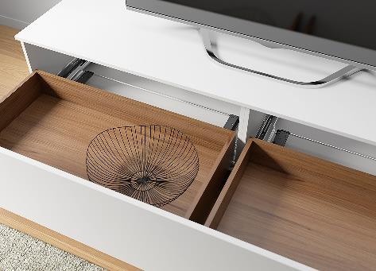
P89_c
Effective multisynchronisation for extra wide front panels: Actro 5D can even be used with Push to open Silent for XXL drawer formats. Photo. Hettich

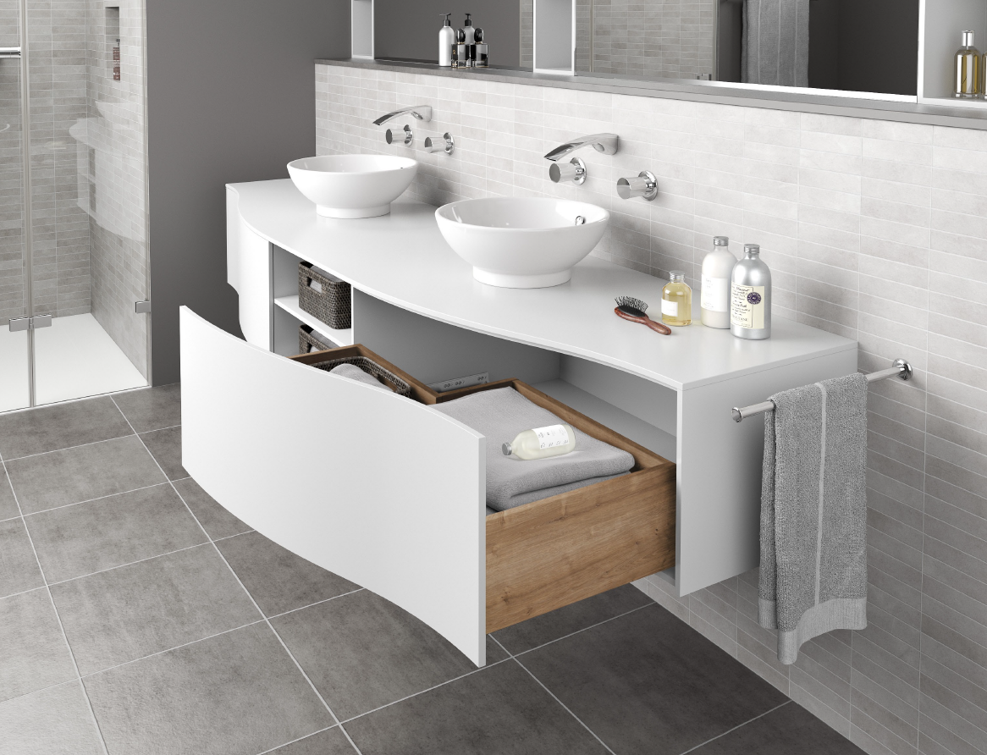
P89_d
On a perfect roll: thanks to flexible synchronisation adapters, Actro 5D also makes Push to open Silent work on asymmetrically shaped wooden drawers. Photo: Hettich

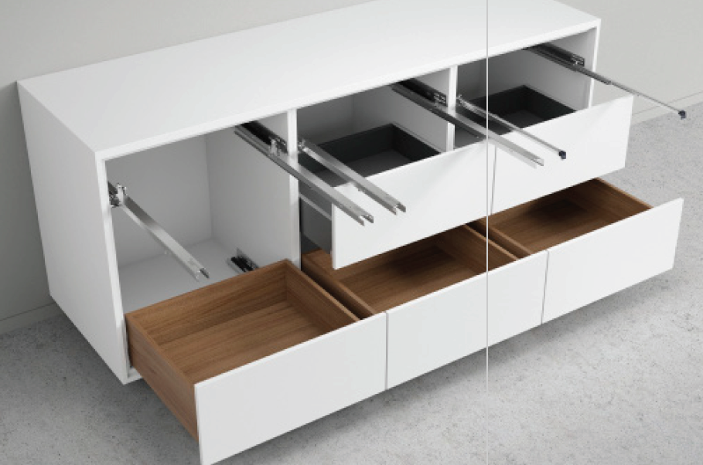
P89_e
The platform makes it possible: changing over to the AvanTech YOU drawer system is incredibly easy. Photo: Hettich

