Hettich Group: good business figures despite COVID-19
€ 1.1 billion turnover in 2020

The Hettich group of companies, one of the world's largest manufacturers of furniture fittings with headquarters in Kirchlengern, once again generated sales of around € 1.1 billion in 2020, more of less reaching last year's level. Seventy per cent of business was done abroad. Worldwide, Hettich invested € 72 million in new products, buildings and machinery. Hettich currently employs over 6,600 members of staff around the globe, more than 3,500 of them in Germany.

Despite coronavirus pandemic and global economic uncertainties – the Hettich Group brought a challenging 2020 to a successful close too. In the 2nd quarter of 2020, sales initially took a sharp dip in the wake of global lockdowns and retailers forced to close. New trends, in contrast, defined the second six months: home improvements, greater DIY activity, more home working as well as the rediscovered home kitchen ambience left Hettich on a high in the second half. China's economy was particularly quick to recover from the pandemic.

Sascha Gross, Managing Director Hettich Holding, explains: "Despite furlough, lockdowns in many countries and delayed impacts on supply chains – our primary aim was always to maintain deliveries to our customers in the manner to which they are accustomed". Managing Director colleague Jana Schönfeld, Hettich Holding, adds: "Tremendous dedication and commitment on the part of the global Hettich team put us in great stead to ride out the volatile business environment we were seeing last year. We are so grateful to all colleagues and share a sense of pride in what we have achieved."

Home improvements and home working as the driving forces

Purchasing behaviour changed in 2020. In times of economic uncertainty, consumers plan their purchases more consciously and, in many countries, pay more attention to high product quality. With home living and working worlds merging all the time, the industry is now called upon to come up with new ideas for furnishing and furniture concepts.

The COVID crisis has made it all the more urgent to address the world's megatrends: urbanisation with its demands from limited living space, the growing demand for individualisation, as well as the key aspect of "New Work", including working from home. These trends are already part of modern-day home living and working environments and will continue to gain significance. It's time to completely rethink and redefine spaces and furnishings in terms of the functions they perform. Hettich's concepts provide a wealth of answers while also leaving room for unorthodox solutions.

Investing in the future
In 2020, the Hettich Group invested € 72 million into the future. The investment focus was on new products, expanding capacity and developing infrastructure. Production facilities were expanded in Germany, the Czech Republic and China.

COVID bonus – a thank you to the global Hettich team

Like many companies, the Hettich team was faced with all manner of challenges in the course of the worldwide COVID-19 pandemic. In appreciation and recognition of their huge personal dedication and commitment in an extraordinary 2020, every Hettich staff member worldwide received a COVID bonus at the end of the year.

Needless to say, Hettich made sure that all of the prescribed hygiene and distancing rules were in place. Office working colleagues used the mobile office as far as they could – up to 40% during the first lockdown, meanwhile as many as 60% do. Almost all contact with customers took place on a digital basis too. Following last year's positive experience, this is where Hettich sees a buoyant trend for the future too: opting for whichever place of work is right for the challenges of the day. These may be meeting places within the company when it comes to getting together and sharing ideas. The mobile office can be used as a place to retreat to for concentrating and doing design work in, or for participating in video conferences. Virtual based working has brought all Hettich colleagues worldwide even closer together.

Sustainable business management – The commitment: being better than the standard

Combining business success with taking responsibility for the environment and society – that's the long-term goal behind Hettich's corporate strategy, as a family owned company. In place now for many years, the Group's sustainability principles are based on the aspects of sustainable management, long lasting products and conserving resources for the next generation. For the Hettich Group, sustainability not only means managing the environment. Besides responsibility for social welfare and society, Hettich's strategy additionally focuses on consistently investing in safe, environmentally friendly and resource saving technologies and processes in its own production activities, infrastructure and logistics. Long lasting product solutions with the most exacting demands on quality and safety as well as environmental compatibility and energy efficiency – continual improvements help to benefit the environment across the board.

HettichXperiencedays 2021

Innovative products, a close partnership with customers and suppliers, and sustainable added value: these form the bedrock that's set to take the Hettich Group forward in 2021. Just launched, HettichXperiencedays will be showing customers a plethora of new ideas and concepts on every global megatrend: from March onward, Hettich's hybrid event will be on and offline across the globe for several weeks to come. Anyone registering online as a trade visitor on the xdays.hettich.com online web portal will be able to take full advantage of the full HettichXperiencedays lineup.

The following picture material is available for downloading from www.hettich.com, menu: Press:
Images
Caption
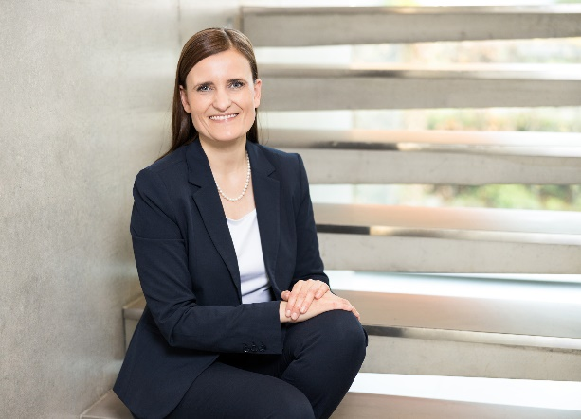
102021_a
Jana Schönfeld, Managing Director of Hettich Holding, is over the moon with everything we've all achieved in the past financial year.
Photo: Hettich

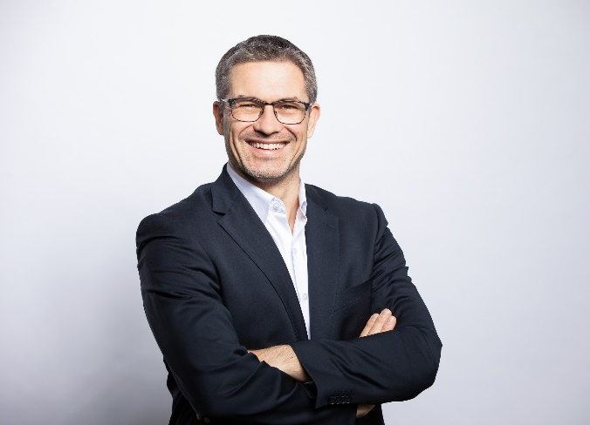
102021_b
Sascha Gross, Managing Director of Hettich Holding: "Even in COVID year 2020, our aim was always to keep customers well supplied in they way they expect from us.”
Photo: Hettich

About Hettich
Hettich was founded in 1888 and is today one of the world's largest and most successful manufacturers of furniture fittings. Over 6,600 members of staff in almost 80 countries work together towards the objective: developing intelligent technology for furniture. Hettich thus inspires people all over the world and is a valuable partner for the furniture industry, trade and craft. The Hettich brand stands for consistent values: for quality and innovation. For reliability and customer proximity. Despite its size and international significance, Hettich has remained a family business. Independent of investors, the company's future is shaped freely, humanely and sustainably. www.hettich.com

