€ 1 billion sales threshold crossed again
Hettich Group continues to grow in 2019

The Hettich group of companies, one of the world's largest manufacturers of furniture fittings with headquarters in Kirchlengern, generated sales of € 1.1 billion in 2019. This represents an increase of 3.2 percent over 2018.

72 per cent of business was done abroad. In 2019, over € 100 million were once again invested world wide. Around the globe, Hettich employed an annual average of 6,700 members of staff, with over 3,600 in Germany.

In view of widely varying business trends on the world's markets, the new sales hike is hugely significant. "Our dedicated team, working hand in hand with our customers and suppliers, has once again broken the one billion euro sales mark. We managed to achieve the further increase in 2019 because we strictly serve the needs of different markets and because the entire Hettich team pulls together worldwide", says Sascha Gross, Managing Director of Hettich Holding.
The effects of the coronavirus pandemic will have a significant impact on business performance in 2020.

Driven by product innovations
Time and again, innovative new products make Hettich a key source of momentum for the industry. The current year is expected to receive further impetus from the latest product developments in drawers and sliding door systems: marketing of the innovative AvanTech YOU drawer platform is set to start in the spring. It permits customised drawer design and also impresses with its exceptionally slimline, purist design that completely manages without any visible screw heads or cover caps. Thanks to the platform principle, the product is very easily matched in colour, shape and material to the specific needs and expectations of buyers.

"Enjoy comfort" is the motto of Hettich's TopLine XL sliding door system designed specifically for large and heavy door panels. This all begins with simple installation: even large format door panels can be set down on the floor without the risk of damaging the bottom fittings, quickly hung and easily adjusted. In addition to generously proportioned wardrobe design, the focus for the user is on sliding pleasure: with TopLine XL, doors weighing up to 100 kg move gently and with effortless ease.
And the extended digital lineup is also reason to sit up and take note: Hettich has significantly broadened its e-services and can now assist its partners even more efficiently from the initial idea to product procurement and from planning to furniture assembly and installation. From the newly designed Furniture Fittings & Applications catalogue, QR codes take you straight to the relevant e-services on the Hettich website. When it comes to ordering, the customer will in future find all products and useful sources of information in the brand new "Hettich eShop" – needless to say, from mobile devices too. The modern online tools will make the work of carpenters and retailers even faster and more efficient.

Investments
In 2019 the Hettich Group once again invested around 10% of its annual turnover in the future. The investment focus, for example, was on the innovative AvanTech YOU drawer platform and on expanding production capacities in and for Asia's growing markets – a further production facility with floor space of 28,000 sq. m. has just been opened in India at the Indore operating base.

Sustainable business management
Sustainability and social responsibility have always been part of corporate philosophy at Hettich and, typically, these principles are also firmly embedded in working with customers. This starts with sustainable management as a 4th generation family run business and extends through to energy and resource efficiency in production as well as the reusability of shipment packaging. Hettich has been committed to the exacting requirements of the EMAS regulation since as long ago as 1997. In 2019 too, the Kirchlengern/Bünde operation once again passed the external EMAS audit, extending the EU eco-management seal of approval.

The following picture material is available for downloading from www.hettich.com, menu: Press:
Illustration
Caption
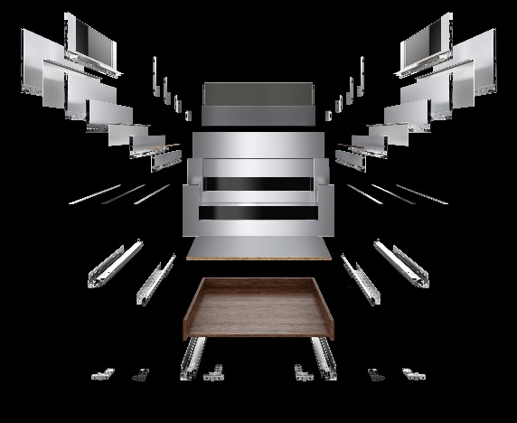
172020_a
Versatile and cost effective thanks to platform: AvanTech YOU from Hettich permits the use of one drawer on two different runners with the same cabinet body drilling pattern. Photo: Hettich

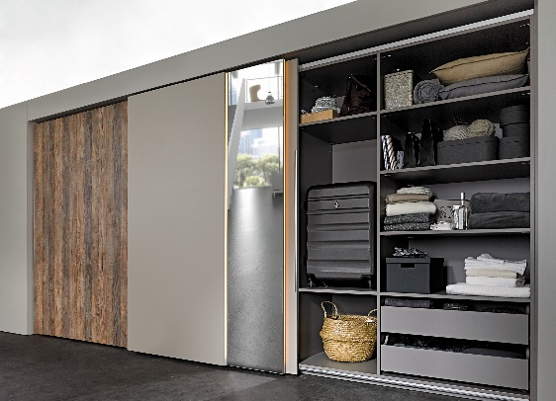
172020_b
Easy clip on installation: even ceiling height constructions are easy to realise with the new TopLine XL sliding door fitting from Hettich. Photo: Hettich

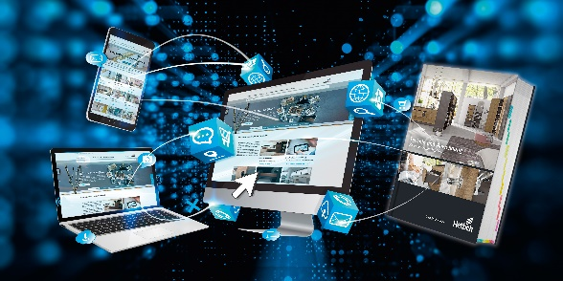
172020_c
Product knowledge and service tools whatever the time and place: the latest Furniture Fittings & Applications catalogue from Hettich is directly linked with the full range of practical online services. Photo: Hettich

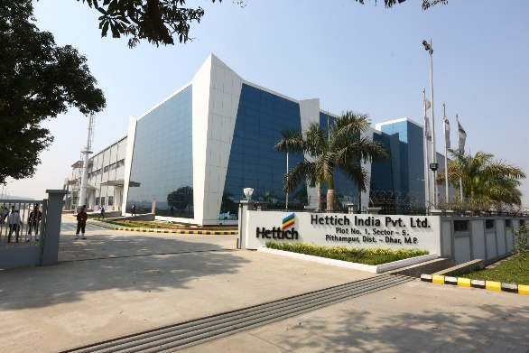
172020_d
In February 2020, Hettich opened the Hettich world's largest production facility at Indore, India. Photo: Hettich

About Hettich
Hettich was founded in 1888 and is today one of the world's largest and most successful manufacturers of furniture fittings. Over 6,700 members of staff in almost 80 countries work together towards the objective: developing intelligent technology for furniture. With it, Hettich fascinates people across the globe and is a valuable partner to the furniture industry, retailers and the trades. The Hettich brand stands for consistent values: for quality and innovation. For reliability and closeness to customers. Despite its size and international significance, Hettich has remained a family owned business. Being independent of investors means that the company has a free hand in shaping its future with a focus on the human element and sustainability. www.hettich.com

