Chiratae Ventures appoints Dr Andreas Hettich to its global advisory board

Chiratae Ventures, India's leading venture capital advisory firm based in Bengaluru, appoints Dr. Andreas Hettich to its Global Advisory Board as of 28 January 2021. Dr. Andreas Hettich is Chairman of the Advisory Board of the Hettich Group, one of the world's leading manufacturers of furniture fittings with annual sales of 1.1 billion euros.

Dr. Hettich is also a non-executive director of Hettich India Private Limited and managing partner of his own holding group, Dr. Hettich Beteiligungen GmbH, which has investments in companies such as EWIKON, Halemeier, and the educational company "das Forscherhaus", among other entrepreneurial commitments. Dr. Hettich is also a member of the advisory and supervisory boards of Jowat, Peter Lacke, FSB and Georg Nordmann Holding.

Well-known members complete the advisory board

Chiratae Ventures' Global Advisory Board includes Ratan Tata (Chairman Emeritus of Tata Sons), Kris Gopalakrishnan (Co-Founder of Infosys), Bruno E. Raschle, (Founder, Managing Director and Non-Executive Vice Chairman of Schroder) and Manish Choksi (Non-Executive Vice Chairman of Asian Paints). Chiratae India's Advisory Board includes Dr Ferzaan Engineer, a multi-entrepreneur in healthcare and founder of Cytecare Cancer Hospitals, an Indian hospital network specialising in cancer treatment.

Vision and mission - international exchange is key to success

"The Indian startup scene is one of the fastest growing in the world. Chiratae Ventures plays a key role in building a sustainable startup landscape and developing industry-leading brands," comments Dr Andreas Hettich on joining Chiratae's global advisory board. "I am delighted to be working with the company at this exciting time when we are entering a new normal and can join outstanding Indian entrepreneurs in their journey to success by picking up many innovative ideas and systematically taking them forward."

Sudhir Sethi, Founder and Chairman of Chiratae Ventures is looking forward to their cooperation in the Global Advisory Board. "Dr. Hettich's unique business experience and vision will further strengthen our mission by sharing our knowledge and strategic insights across all sectors. We believe our portfolio companies can benefit tremendously from his unique perspective and years of business experience to succeed internationally in the future."

About Chiratae Ventures
Founded in 2006, Chiratae Ventures India Advisors (formerly IDG Ventures India) is India's leading advisor to technology venture capital funds. The funds advised by Chiratae Ventures India Advisors have a combined total of nearly $800 million under management and more than 95 companies in the consumer media & tech, cloud/software, health-tech and fin-tech sectors. Notable portfolio companies include Bounce, Cure.fit, FirstCry, Flipkart, Forus, Lenskart, Manthan, Myntra (acquired by Flipkart), NestAway, Newgen (NSE: NEWGEN), PlaySimple, PolicyBazaar, Rentomojo, Unbxd and Uniphore. www.chiratae.com

The following image material is available for download at www.hettich.com, menu: Press for download:

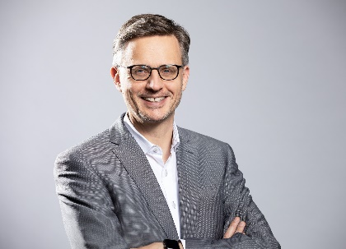
042021_a
Dr. Andreas Hettich is looking forward to the international cooperation on the Global Advisory Board of Chiratae Ventures. Photo: Hettich

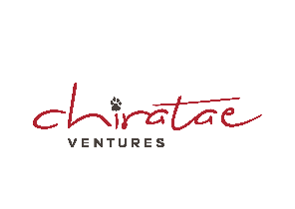
042021_b
Chiratae Ventures, India's leading venture capital firm based in Bengaluru, sees great added value in working with Dr Andreas Hettich. Logo: Chiratae

About Hettich
Hettich was founded in 1888 and is now one of the world's largest and most successful manufacturers of furniture fittings. More than 6,700 employees in almost 80 countries work together towards the goal of developing intelligent technology for furniture. This is how Hettich inspires people all over the world and makes it a valuable partner for the furniture industry, trade and craftsmen. The Hettich brand stands for consistent values: for quality and innovation. For reliability and customer proximity. Despite its size and international importance, Hettich has remained a family business. Independent of investors, the company's future is shaped freely, humanely and sustainably. www.hettich.com

