"Hettich Ehrenamt" volunteering campaign defies times of corona

€ 61,000 worldwide for nonprofit projects involving members of staff…

The Covid-19 pandemic has not prevented the Hettich team from taking part in voluntary activities – on the contrary: over 130 colleagues at Hettich operating bases around the world applied to participate in the "Hettich Ehrenamt 2020" volunteering campaign with various projects. The 122 projects selected in Germany, the Czech Republic, France, Australia, Italy and Japan were funded to the tune of 500 euros each. Across the globe, the Hettich Group made out donation cheques worth a total of € 61,000 in 2020.

"Particularly in times of corona, nonprofit associations reliant on financial support from outside are struggling hard. This makes us all the more pleased that 2020 will once again let us give meaningful support to numerous projects within our 'Hettich Ehrenamt' volunteering campaign. It fills us with pride that our colleagues are dedicated to so many good causes, and we wish everyone involved continued motivation and every success", says Jana Schönfeld, Managing Director at Hettich.
Since the "Hettich Ehrenamt" volunteering campaign was launched to mark the company's 125th anniversary in 2013, over 1,000 projects have already received funding of no less than € 600,000.

The following picture material is available for downloading from www.hettich.com, menu: Press:
Images
Caption

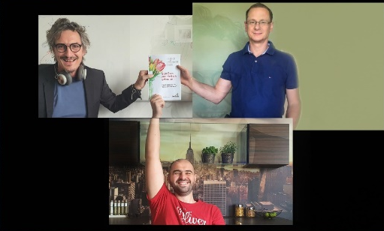
362020_b
Hettich employee Gerhard Götz supports the building work that is going on for children's villages and orphanages in Malawi/Africa as group leader of the "Malo A Mcherezo" Orphan Care Centre relief organisation. The donation is needed for constructing a wood drying facility as a sustainable basis for investing in furniture making. Photo: Hettich

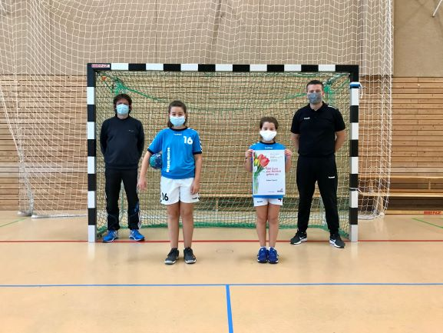
362020_d
Hettich employee Adam Czysch trains the 8-10 year-old female handball players at the SG Hermsdorf-Waidmannslust sports association in Berlin. The donation will be used for new jerseys. Photo: Hettich

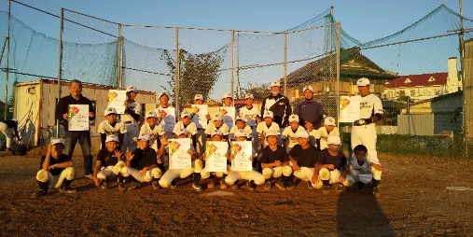
362020_e
Hettich employee Kazuhiro Noda is involved in Japan as a coach at the Midorigaoka-Green-Hills baseball club. The donation will be used for providing training equipment as well as canopies to prevent heat stroke. Photo: Hettich

About Hettich
Hettich was founded in 1888 and is today one of the world's largest and most successful manufacturers of furniture fittings. Over 6,700 members of staff in almost 80 countries work together towards the objective: developing intelligent technology for furniture. With it, Hettich fascinates people across the globe and is a valuable partner to the furniture industry, retailers and the trades. The Hettich brand stands for consistent values: for quality and innovation. For reliability and closeness to customers. Despite its size and international significance, Hettich has remained a family owned business. Being independent of investors means that the company has a free hand in shaping its future with a focus on the human element and sustainability. www.hettich.com

