"Nice one, Guv!"
Hettich: Golden agers develop "ComfortSpin"

Since its launch in May 2019, the practical "ComfortSpin" turntable from Hettich has won numerous awards. And if, as the saying goes, every success has many fathers, Hettich knows after this product development: grandfathers and grandmothers too have the stuff to write a true success story. Because behind the innovative "ComfortSpin" are twelve resourceful senior citizens from Chemnitz/Germany as the "mastermind team".

In its search for creative minds for innovative products, fittings specialist Hettich (Kirchlengern/Germany) has shown courage to explore new avenues: but when Hettich Innovation Manager Daniel Rehage (47) looked around for an open innovation network at his new abode in Chemnitz a few years ago, he couldn't have imagined where the journey would lead. His aim was to develop future-proof concepts as well as optimise production processes. An initial contact with Chemnitz University of Technology quickly sparked the idea of finding suitable experts through the Seniors College there.

From Seniors College to their own innovation office

The project was presented at Chemnitz University of Technology at the beginning of 2016, and the interest among the "advanced students" was so great that Rehage was able to get his new innovation team off the ground just a few months later: the diverse group is made up of graduate engineers and other academics, including former designers, electrical engineers, technologists, a patent engineer and an ergonomist. Since then, the twelve or so experts in their mid-sixties to mid-eighties, including one woman, have mostly been meeting up once a week to rack their brains over innovations for the furniture and household segments. Added to this are regular meetings in smaller working groups.

The team moved from its modest initial quarters to larger project rooms on a Chemnitz industrial estate back in 2017: this is where Hettich development engineer Andreas Matthes (42), who also provides the golden agers with technical support, builds all the prototypes in the team's own workshop. A fully equipped show kitchen was added to the premises in 2018 to test the prototypes for their suitability in everyday use.

Besides the complex development work on the technical side, the "ComfortSpin" project team in Chemnitz has also turned its attention to professional market research – including an assessment of needs and, of course, the question of what price consumers are willing to pay for their product. "For this purpose, we produced our own questionnaires for test persons," says Bernd Lehmann (73), former design engineer at Thyssen-Krupp. Initial test subjects, for example, were found in the Seniors College at Chemnitz University of Technology. A programme then broadcast by Germany's MDR television station sparked interest among others for a second user survey. All of the results were so positive that fittings manufacturer Hettich decided to go into mass production with this new product.

Successful product debut

By May 2019, the time had come: Hettich officially launched the turntable on the market under the "ComfortSpin" name, initially selling it online. It didn't take long for the innovative product from the Chemnitz think tank to win its first awards, including the IF Industry Forum Design Prize for product design in gold. – A resounding debut success which rightly fills the team of senior citizens with pride. In the meantime, the creative Chemnitz experts have also had the name of their "Wirfinder" group protected by copyright - this being a contraction of the German for 'We Inventors". Its official logo comes from Chemnitz designer Karl Clauss Dietel.

Faster from the idea to volume production
Hartmut Endlerlein, (82) Professor Emeritus of Ergonomics at Chemnitz University of Technology, emphasises that the Chemnitz developers' activity is not only about money: "The work invigorates us and keeps us young. Still being able to make use of our qualifications and skills in old age enriches our lives". Daniel Rehage, too, has learned a lot personally from the contact he has with his Chemnitz-based team. One important experience shows that the synergies provided by his experts from a variety of disciplines can sometimes take new products to market readiness more quickly than otherwise possible in the development departments.
Experience comes with age – and inspires new thinking
The older team members can also contribute valuable knowledge about their generation's needs, knowledge which younger developers may still lack. This is not only about ergonomics and ease of handling products but also, for example, about wanting practical storage space for medicines. "ComfortSpin" meets this need too because it's not only suitable for fitting in refrigerators but also in cupboards or on shelves. Unlike conventional turntables made of perspex, the rectangular "ComfortSpin" virtually makes full use of the surface it stands on in the cupboard and is still easy to turn through 360 degrees. This is made possible by a new type of ball bearing which is meanwhile protected by several patents.

The creative golden agers in Chemnitz have long been working on further applications for their innovative ball bearing for furniture and kitchen appliances. "The successful start-up project has given us all inspiration and, of course, makes us want to do more," Daniel Rehage says. "We are already working on new product ideas that intelligently combine ergonomics and technology for furniture. As such, the industry has every reason to get excited about "Wirfinder" solutions that will bring even more user convenience to our everyday furniture in the future.

The following picture material is available for downloading from the "Press" menu at www.hettich.com:
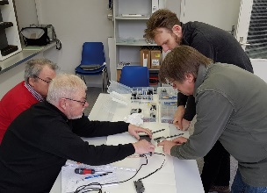
222020_a
Unusual think tank for new Hettich products: the Chemnitz-based "Wirfinder" golden ager team is working on innovative solutions for furniture and housekeeping (from left to right: Bernd Lehmann, designer and project engineer; Nobert Virgin, electrical engineer; Ulrich Siegert, patent engineer; Andreas Matthes, Hettich development engineer). – Photo: Hettich
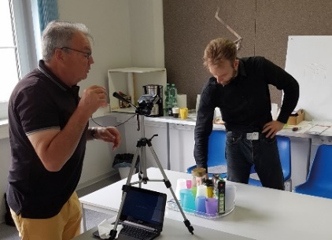
222020_b
Photo shoot in the team workshop: designer and project engineer Bernd Lehmann (left) and Hettich development engineer Andreas Matthes putting "ComfortSpin" on centre stage. – Photo: Hettich

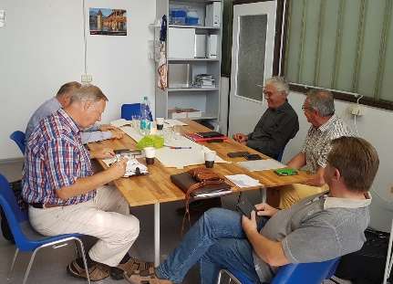
222020_c
Contributing many years of professional experience and keeping an alert mind through work: the "Wirfinder" in Chemnitz show exactly how it's done. – Photo: Hettich

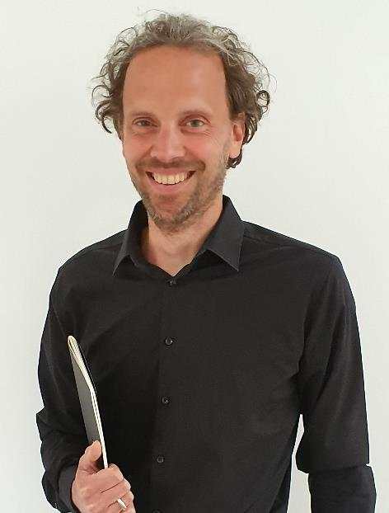
222020_d
Hettich innovation manager Daniel Rehage: "Without the ingenuity of the Chemnitz "Wirfinder" inventors there would be no 'ComfortSpin' today. The work of this unique team of experts has deeply impressed me." – Photo: Hettich

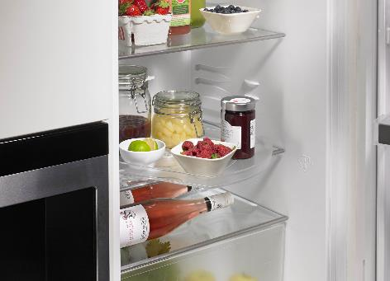
222020_e
The practical 'ComfortSpin' turntable provides the optimum combination of ergonomics and technology for furniture. – Photo: Hettich

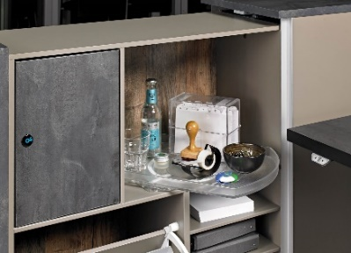
222020_f
On shelves and in cupboards too, 'ComfortSpin' keeps items neatly in place and easily accessible in just one turn. – Photo: Hettich

222020_g
The Chemnitz team's "Wirfinder" logo. – Graphics: Wirfinder

About Hettich
Hettich was founded in 1888 and is today one of the world's largest and most successful manufacturers of furniture fittings. Over 6,700 members of staff in almost 80 countries work together towards the objective: developing intelligent technology for furniture. With it, Hettich fascinates people across the globe and is a valuable partner to the furniture industry, retailers and the trades. The Hettich brand stands for consistent values: for quality and innovation. For reliability and closeness to customers. Despite its size and international significance, Hettich has remained a family owned business. Being independent of investors means that the company has a free hand in shaping its future with a focus on the human element and sustainability. www.hettich.com

