"HettichXperiencedays" 2021
Hybrid event platform shows Hettich's expertise worldwide

It's a turning point for Hettich: Still enabling the company to reach all customers and partners around the globe under pandemic conditions, it is organising a new type of hybrid event for 2021 that is groundbreaking for the industry: "HettichXperiencedays".

Since Corona, no one is planning trade fairs in the “normal” way anymore: will there be a new lockdown somewhere? Will there be customers who don't want to attend the fair or who are not allowed to? What is the best way to protect the health of employees, customers and partners as long as there's no vaccine available? These are the questions Hettich has been asking itself in recent months too – and finally come to a clear decision. The progressive answer for 2021 is: "HettichXperiencedays".

Dynamic platform principle provides flexibility
With pioneering spirit and the courage to venture into new territory, Hettich will next year be the first company from the supply industry to stage an event the likes of which have never been seen before. It is only logical that the inventor of the drawer platform should also want to apply the benefits of a flexible principle to its new event format: within the platform, all components can be combined.

However, as long as developments remain unpredictable, Hettich's main concern is to minimise the risks for all stakeholders. "With our 'HettichXperiencedays', we are sending a clear signal in 2021", Hettich UK Managing Director Tim Leedham says. "The new, dynamic event platform is revolutionary for our industry. In these uncertain times, it gives everyone involved the greatest possible flexibility and, in this way, provides maximum reach. We cordially invite our customers and partners from across the globe to take part in our event in whichever way they choose, either on a virtual basis or location. And 2021 promises to be a very special Hettich experience for all."

Longer duration – events around the globe
From spring 2021, 'HettichXperiencedays' will run for several weeks as a "hybrid", all inclusive programme. This means: besides physically presenting new releases and opportunities to visit the show in real life, numerous virtual formats with exciting live acts are also planned. Worldwide, Hettich will be providing an attractive, progressive mix of information, inspiration, show elements and networking. "Our event platform features various modules that can be combined in numerous ways. With the support of our international sales teams, we can offer a tailor made programme for every target group throughout the entire event", Leedham explains. "Despite Covid-19, this will give us the opportunity to engage in intensive dialogue with our customers and partners from all regional markets and to inspire them with our solutions – whether 'offline' on location, or online, just as the case may be."

Hettich has been hard at work during the last few months preparing for 2021, and the pioneering spirit can be clearly felt: it's high time to venture into new territory. When, if not now?
www.hettich.com

The following picture material is available for downloading from www.hettich.com, menu: Press:
Images
Captions
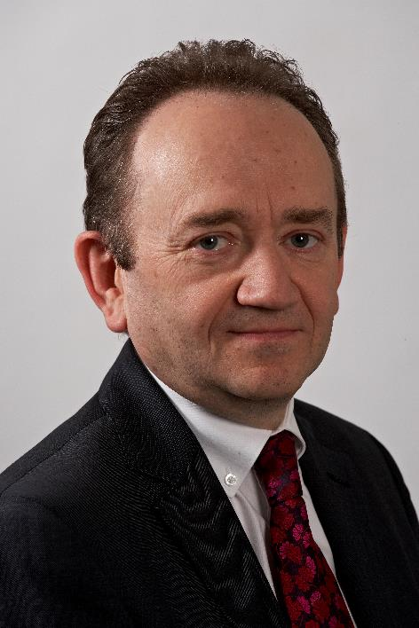
332020_a
Hettich UK Managing Director Tim Leedham: "With HettichXperiencedays 2021, it is our ambition to stage a first class hybrid show which will be something that not only our customers will talk about for a long time to come." Photo. Hettich

About Hettich
Hettich was founded in 1888 and is today one of the world's largest and most successful manufacturers of furniture fittings. Over 6,700 members of staff in almost 80 countries work together with the goal of developing intelligent technology for furniture. On this basis, Hettich inspires people across the globe and is a valuable partner to the furniture industry, retailers and the trades. The Hettich brand is synonymous with consistent values: with quality and innovation. For reliability and closeness to customers. Despite its size and international significance, Hettich has remained a family run business. Independent of investors, the company is free to shape its future in a humane and sustainable manner.

