HettichXperiencedays 2021 opens across the globe
Let's move markets!

Under the "Let's move markets!" banner, Hettich is presenting innovative furniture worlds for the megatrends of Urbanisation, Individualisation and New Work for its customers and partners at HettichXperiencedays 2021. The fittings manufacturer's big trend show was officially launched in mid-March.

The demands on everyday life, home living and work are rapidly changing. Global megatrends, which normally take many years to take effect, have accelerated enormously in the Covid crisis. This is why industry, retail and the trades must now respond if they want to hold their ground on the market in future with their products and services. The time has come to completely rethink spatial and furniture concepts. And Hettich is showing you how: at HettichXperiencedays, the company will be presenting a wealth of creative and innovative solutions that will let the industry address new market demands and changing customer wishes.

Identifying new market needs – and catering to them!

Urbanisation, Individualisation and New Work: these three big megatrends will be key, recurring themes throughout Hettich's presentations in 2021. To this end, the Hettich team has created theme-based apartments in different sizes while also featuring specific trend fields. This is where practical solutions can be found for large and small rooms, for versatile, urban living in small spaces, as well as concepts for tomorrow's working worlds, including homeworking, for outdoor living, shops and hotels, for high quality kitchen design and greater user friendly convenience for white goods. Across the board, the manufacturer demonstrates its cross-segment expertise: modern furniture solutions give users genuine added value in terms of design, functionality and practical convenience. Here, product highlights from Hettich, like the TopLine XL sliding door system, can now be seen in astonishingly new functions. The AvanTech YOU drawer platform is creatively combined with other furniture systems and offers additional standard decor finishes.

Megatrends pointing the way

Everywhere in towns and cities, living space is becoming scarcer and more expensive, floor space is getting smaller. How can you still live comfortably in a small amount of space? Hettich provides the answer to the Urbanisation megatrend with carefully considered mini floor plans, multifunctional furniture and optimum use of storage space.

Individuality is the freedom to choose. Consumers are placing new demands and expectations on the design, use and function of rooms and furniture. The furniture industry needs to be prepared for the growing megatrend of Individualisation. Consumers want their own personal furniture that can be customised in a way, for instance, that Hettich makes possible with its AvanTech YOU drawer platform.
The classic open plan office is "out": working environments and office structures are changing, leaving more and more people regularly working from home in a "home office". They all need affordable furniture solutions for their personal home living situation. Anyone able to offer them precisely has a clear edge. By the same token, though, office concepts in businesses need to be matched to the new demands. For the New Work domain, this is why Hettich is presenting easy to implement solutions in its trend show while also inviting customers to join hands in developing creative concepts for tomorrow's work environments.

From small to large: Hettich's themed apartments

The theme based apartments at HettichXperiencedays pick up on the megatrends in a variety of concepts. They demonstrate a host of practical solutions for designing interiors, furniture and function zones in a way that leaves no margin of doubt.

Flexible Apartment: all in on 25 sq.m.
Home living in a small space without compromise! This is increasingly in demand, particularly in big towns and cities. Hence, Hettich's motto for urban living: smaller the size, greater the flexibility. The all embracing solution in the "Flexible Apartment" shows what perfectly configured furnishing can do – being practical, multifunctional and affordable. And yet there's no cutting corners on good design either.

Transforming Apartment: master of transformation
The footprint stays as is, but the space transforms. Furniture adapts to the Living Space, and not the other way around. The "Transforming Apartment" from Hettich now lets you transform spaces in any way you choose: movable wall elements create space precisely where it is needed. This way, 50 square metres provides what feels like double the living quality. This is where TopLine XL, the sliding door system for extra large wardrobes and cabinets, demonstrates its qualities in an amazing new function: the sturdy system easily and securely moves even floor to ceiling elements, opening up new options for versatile interior design. An intelligently concealed "room in room" solution below a sloping ceiling comes with a particular "wow" factor.

Commuter apartment: small in size, yet big in use
With its successful combination of home living and working, the "Commuter Apartment" from Hettich is synonymous with a new, urban mobility. And even 14 sq.m provides enough space for all of the furniture and functions that are needed. What's more, a few unexpected extras can be accommodated too. Intelligently planned in this way, the mini floor plan creates a contemporary, feel good home wherever you work. An attractive concept, doubtlessly too for designing modern hotel rooms.
Tiny Apartment: the storage space wizard
The megatrend of urbanisation is changing ways of living. Tiny Homes provide a welcome solution wherever living space is scarce and expensive. A fully furnished home on only 18 square metres of floor space? No problem! The Tiny Apartment from Hettich caused quite a stir on the international stage when it made its debut in 2019: from floor to ceiling, the mini apartment astonishes with intelligent use of storage space and multifunctional furniture that's great fun even in a small space. – Feeling happy at home doesn't take much space at all.

Trend domain outdoor kitchen:
moments of culinary pleasure in the open
Increasingly, everyday living is moving outdoors. This makes cooking together in the garden or on the rooftop terrace a growing trend. Thanks to corrosion proof stainless steel fittings, the robust outdoor kitchen can even cope with heavily fluctuating weather conditions. It comes in a modern look and is practical in every last detail. Having this, who would want to cook indoors?
Trend domain shop design and interior fit:
high quality and individually tailored
A new generation of shop exhibits provides clear added value for shop and interior fitters, retailers and customers: Hettich presents highly practical concepts for a wide variety of applications, easy to realise and completely individual in terms of design. With merchandise presented as attractively as this, high street shopping is twice the fun! And kitchen manufacturers from the high end segment also need to take a closer look at these high quality furniture solutions from Hettich: the delicate Cadro frame system combined with the AvanTech YOU drawer system in new DesignCape colours provide attractive options for appealing kitchen design with immense functionality and working components that are hidden from view.
Trend domain New Work:
Tomorrow's office
Digitisation is driving the transformation of working environments. How will be working tomorrow? What will our workplaces look like then? Far more mobile and flexible, that's for certain. What's called for are transformable and adaptable work environments that provide ways of responding to constantly changing demands: from the individual needs to concentrate while working to confidential one-to-one conversation opportunity and large team workshop. Hettich has all sorts of amazing ideas in store for its customers on the subject of "New Work" which will provide the key to a perfect work-life-balance in the future too. From complete room systems with sliding and hinged elements or creative design solutions with plug in system, to the small, mobile caddy for the personal workstation, it's all here.

The central hub: xdays.hettich.com

With so many new things to discover, it's definitely worth immersing more than once in Hettich's various furniture worlds. This is why "HettichXperiencedays 2021" will be taking place across the globe for several weeks in an innovative hybrid format. Anyone wanting to look at the solutions in detail will discover plenty of opportunities to do so on the xdays.hettich.com online portal. Once registered as a trade visitor on the web portal, you can access the entire HettichXperiencedays lineup around the clock, in German, English, French, Spanish, Russian or Chinese.

This is where all participants can expect an attractive, progressive mix of information and inspiration. There's a wide range of e-services on offer as well as varied events on the megatrends and all of the other latest themes that are keeping the industry on its toes. With it being possible to combine all programme modules in any way, the portal can be used to create a very personalised "HettichXperiencedays" roadmap – either online via the digital tools, or wherever possible offline with a visit to a Hettich showroom anywhere in the world. We ensure that strict hygiene concepts will be in place everywhere.

This means Hettich is offering its global customers and partners the opportunity to take part in the HettichXperiencedays in whichever way they can or choose. And everyone wishing to take advantage of this offer can definitely expect a one and only Hettich experience with new solutions and products as well as copious ideas and suggestions for designing their own furniture compositions to suit tomorrow's world.
https://xdays.hettich.com
The following picture material is available for downloading from www.hettich.com, menu: Press:
Images
Captions

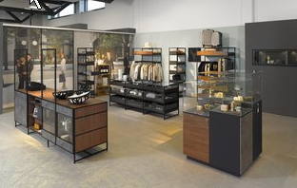
122021_a
Hettich's concepts for contemporary shop design are high in quality and individually tailored. Photo: Hettich

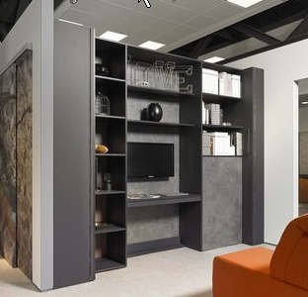
122021_b
The "Transforming Apartment" from Hettich now lets you transform spaces to suit any need with moveable wall elements. Photo: Hettich

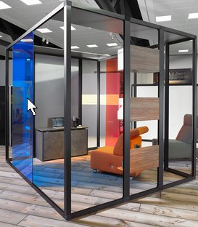
122021_c
"New Work" demands new office concepts: in future, the call will be for transformable and adaptable work environments. Photo: Hettich

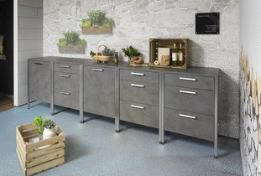
122021_d
Moments of culinary pleasure in the open: the dedicated fittings from Hettich let robust outdoor kitchens cope with wind and weather. Photo: Hettich

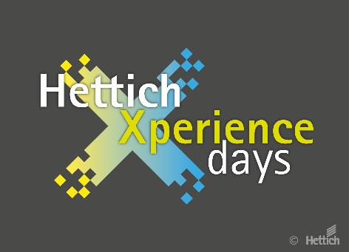
122021_e
HettichXperiencedays have started: 2021 sees Hettich present innovative furniture worlds for the key megatrends of Urbanisation, Individualisation and New Work. Photo: Hettich

About Hettich
Hettich was founded in 1888 and is today one of the world's largest and most successful manufacturers of furniture fittings. Over 6,700 members of staff in almost 80 countries work together towards the objective: developing intelligent technology for furniture. Hettich thus inspires people all over the world and is a valuable partner for the furniture industry, trade and craft. The Hettich brand stands for consistent values: for quality and innovation. For reliability and customer proximity. Despite its size and international significance, Hettich has remained a family business. Being independent of investors means that the company has a free hand in shaping its future with a focus on the human element and sustainability.

