Homeoffice ideas book from Hettich
Working at home in the best of moods

Corona has sent millions of people to the home based office overnight, making working from home the new norm. It's high time to start thinking about high quality furniture concepts for your own four walls. The new Homeoffice ideas book from Hettich shows how this can be done: with practical and easily implemented solutions that not only look good but also leave no margin of doubt in terms of function.

Office furniture manufacturers and designers need to adapt to changing market needs. Very popular to date, open-plan offices are facing unimagined competition. Because working from a home based office has been booming since the Corona pandemic, and this option will remain an integral part of the working world in the future.

Living and working – the best of both worlds
When working from home, the question is all about cleverly integrating a practical workplace into existing living spaces. After all, you want to work comfortably and productively from home too. Combining the best of both worlds – that's the approach at Hettich. The manufacturer knows all market segments inside out. Hettich has been present in the office sector with numerous fitting systems for decades and, on the subject of working from home too, the company regularly presents its innovative home furniture concepts that often only reveal the "workplace" function at second glance.

In the lavishly illustrated Homeoffice ideas book, Hettich once again shows its broad creative spectrum. The focus is on convenient and well-designed home furniture that also demonstrates its qualities in the home based office. The result is the perfect symbiosis of living and working with a wealth of new functions. This ranges from a small desk in a quiet corner to various items of compact multifunctional furniture and a "professionally" equipped home based office in a separate room. All of the concepts presented can be easily implemented with the current product range. As a trend scout and source of ideas, Hettich offers the industry precisely the practical fittings that are now needed in the home based office – and which in future will gain more and more significance in this sector.

Multifunctional, attractive and convenient
The classic divide between home living and working is disappearing. In "new" everyday office life, the activity determines the location: being able to concentrate when working from home on the one hand, but also creative teamwork with colleagues who prefer to remain in the office. Planning furniture for the home based office demands a high degree of multifunctionality and excellent utilisation of space. This is where the high quality fitting and pull-out systems from Hettich make optimum use of storage space while providing top functionality with clever features and details. And yet all without compromising on attractive, appealing design either. Because working at home should be homely, and that's what is instantly seen from looking at Hettich's ideas for the home based office.

Anyone regularly doing office work from home should, of course, invest in a comfortable desk chair. But that's only the beginning: a dining table may be inviting but a proper desk is more ergonomic. Working is made even more comfortable and healthy if the table is height-adjustable, letting you to switch from sitting to standing. – Easy to do, for example, with the LegaDrive power-assisted lifting column system. Personal work utensils can also be stored in many ways in the home based office: whether in the small SmarTray pencil tray or in the spacious Big Org@Tower Wood organisation system. The AvanTech YOU, ArciTech or InnoTech Atira drawer platforms open up further options for planning furniture. Smoothly running drawer runners, such as Quadro, Actro or Actro 5D, provide a high level of user convenience in a private home based office too.

Why must a shelf unit in a home based office always look the same? Sliding and folding door systems, such as SlideLine, VerticoSynchro or WingLine, create ever changing constellations of open and closed elements. Pull-out shelves on the Quadro runner give the user additional, practical storage surfaces when needed.

Further interesting design options are provided by "hiding" areas, functions or appliances whenever they are not needed. This is the perfect solution for anyone liking a tidy home: at the end of the day, the work utensils – and alternatively the entire home office space – then disappear behind folding doors, leaving everything out of view. Or how about a multifunctional piece of furniture that provides a short-term workplace and can then be turned back into a smart glass display cabinet in seconds flat?

So, there are lots of new things to discover. Anyone looking for creative solutions to make working from home noticeably more relaxed will find copious inspiration in the Homeoffice ideas book which can be downloaded free of charge directly from the Hettich website at:
https://web.hettich.com/en-de/products-eshop/drawer-systems/systems-for-office-furniture.jsp#&documentType=undefined
The following picture material is available for downloading from www.hettich.com, menu: Press:

Picture
Captions
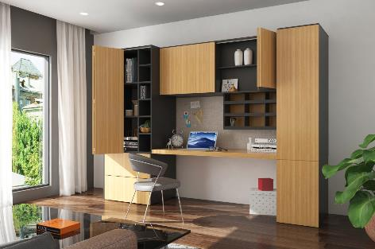
282020_a
A home based office solution for anyone liking a tidy home: at the end of the day, all work utensils are stored away and can disappear behind the folding doors. Photo: Hettich

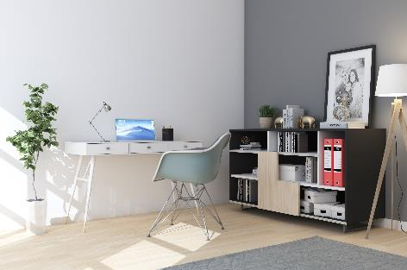
282020_b
Productive work corner: requiring little space, yet everything in easy reach. Photo: Hettich
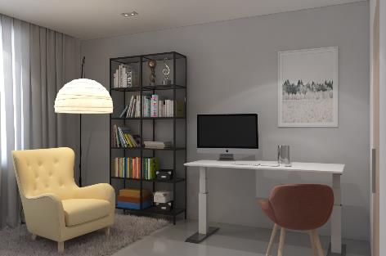
282020_c
Tired of sitting? A power assisted height adjustable desk makes working at home much more comfortable. Photo: Hettich

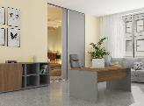
282020_d
Working as if in a real office: a separate study is ideal for work concentration but also for receiving customers. Photo: Hettich

About Hettich
Hettich was founded in 1888 and is today one of the world's largest and most successful manufacturers of furniture fittings. Over 6,700 members of staff in almost 80 countries work together towards the objective: developing intelligent technology for furniture. With it, Hettich fascinates people across the globe and is a valuable partner to the furniture industry, retailers and the trades. The Hettich brand stands for consistent values: for quality and innovation. For reliability and closeness to customers. Despite its size and international significance, Hettich has remained a family owned business. Being independent of investors means that the company has a free hand in shaping its future with a focus on the human element and sustainability. www.hettich.com

