Intermat fast assembly hinge
Wide range for all sorts of applications

With its broad lineup and over 100 door mounting options, the tried and proven Intermat fast assembly hinge from Hettich provides the right solution for a wide range of different applications. Combining Intermat with the optional Silent System gives kitchen and furniture manufacturers additional ways of differentiating furniture.

Furniture manufacturers across the globe use Intermat from Hettich. Time and again, this tried and proven range of hinges impresses with fast and easy installation, simple adjustment, a high level of product reliability and dependable quality. Over one billion of these reliable and high quality hinges have been produced since it was launched in 1993.

Intermat is a real allrounder: the range features hinges with opening angles of 110 degrees and 125 degrees, profile door hinges with a 95 degree opening angle, special hinges for unusual face angles from W-45 degrees to W+90 degrees, as well as hinges for glass doors and aluminium frame doors.
The Intermat lineup also covers all common drilling patterns and provides various ways of attaching the hinge cup. The range is ultimately complemented by stylish cover caps for the hinge arm, on request also with customised logo.

By using the optional Silent System, manufacturers can additionally upgrade Intermat as a way of further differentiating their furniture ranges. Only one Silent System unit is required for a standard door with two hinges. Soft closing action is matched to the size and weight of the door for optimum performance. For the user, this significantly enhances the quality feel of a home: benefiting from Intermat plus Silent System, doors close in a gently controlled movement for soothing peace and quiet.

The following picture material is available for downloading from "Menu: Press" at www.hettich.com:
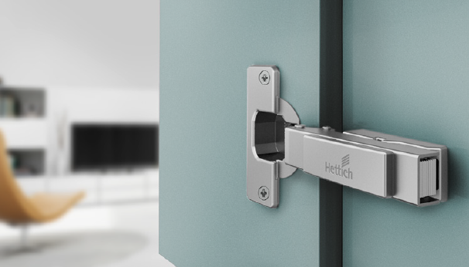
P86_a
Tried and proven fast assembly hinge: Intermat scores with tested durability, high quality and its great value for money. Photo: Hettich

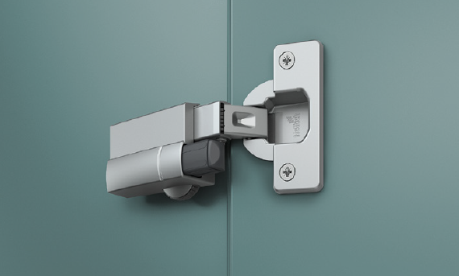
P86_b
Optional upgrade: Silent System makes it possible to differentiate furniture ranges with additional soft closing. Photo: Hettich
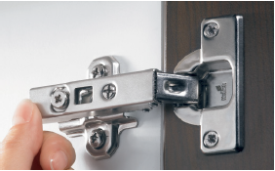
P86_c
Secure installation: a light press on the Intermat hinge is all it takes. As it clips on, it makes a sound that can be clearly heard, indicating precision engagement. Photo: Hettich

