Acting today – with a thought for tomorrow

Hettich publishes 2020 Sustainability Report

As a family business with a history spanning over 130 years, the long-term aim of Hettich's corporate strategy is to link business success with environmental and social responsibility.

Sustainability principles were implemented at Hettich back in the early 1990s. These are based on the aspects of sustainable business management, long lasting products and conserving resources for the next generation. But for the Hettich Group, sustainability not only means managing the environment.

Sustainable business management – The commitment: being better than the standard

Besides responsibility for social welfare and society, Hettich's strategy additionally focuses on consistently investing in safe, environmentally friendly and resource saving technologies and processes in its own production activities, infrastructure and logistics. Targeted basic and further training as well as company health management are also among the central measures. Over time, however, these have been joined by new aspects, such as sustainable mobility management, environmentally friendly travel planning and a changed corporate culture.

Long lasting products for customers, consumers and the environment

Hettich develops long lasting product solutions that not only meet the most exacting demands on quality and safety but also on environmental compatibility and energy efficiency. This pleases customers across the globe and also helps to improve sustainability. Statutory regulations and standards, too, are only seen as "minimum requirements" at Hettich, e.g. in "Chemical Compliance": for over 15 years now, the company has voluntarily regulated environmentally relevant product constituents much more stringently than demanded by the requirements set out in international law.

Conserving resources for the next generation

From 1996 to 2019, the Hettich Group reduced its specific CO₂ emissions worldwide by 55 per cent, with several Hettich operating bases getting all of their electricity from renewable energy sources. Using solar energy, the Kirchlengern based headquarters generates almost 190 megawatt hours of electricity a year from its own photovoltaic systems, and Hettich's German sites are also investing in the expansion of combined heat and power generation and the use of waste heat.

Personal responsibility within the Hettich team

"As a family business, our strategies are not aimed at short term success but at sustained existence. At Hettich, we are gradually implementing a process of thinking and acting that focuses on sustainability in our activities without losing sight of cost effectiveness and operating efficiency. Doing so, we actively involve all colleagues in our sustainability strategy," says Sascha Gross, Managing Director. "Added to this, we engage in transparent dialogue with our customers, suppliers, partners and many other stakeholders in an effort to promote these standards of quality as consistently as we can. Because we at Hettich take responsibility for the world we live in, for preserving natural resources and for protecting the health of our fellow human beings," adds Ute Schulz from the Corporate Responsibility Team.

Hettich's detailed 2020 Sustainability Report is available for downloading from the Internet in German and English: https://www.hettich.com/sustainability

The following picture material is available for downloading from www.hettich.com, menu: Press:

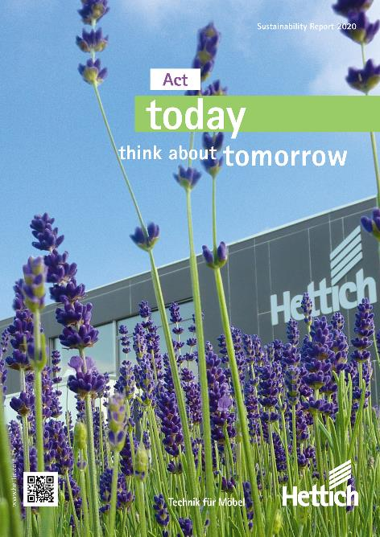
022021_a
"Acting today – with a thought for tomorrow": Hettich is committed to a sustainable corporate policy. The current 2020 report highlights priority fields of action and targets. Photo: Hettich

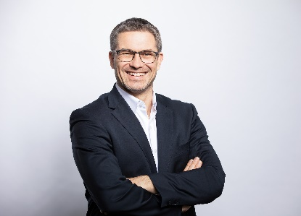
022021_b
Hettich Managing Director Sascha Gross: "At Hettich, we are gradually implementing a process of thinking and acting that focuses on sustainability in our activities without losing sight of cost effectiveness and operating efficiency." Photo: Hettich

022021_c
Ute Schulz, Team Corporate Responsibility: "We at Hettich take responsibility for the world we live in, for preserving natural resources and for protecting the health of our fellow human beings." Photo: Hettich

About Hettich
Hettich was founded in 1888 and is today one of the world's largest and most successful manufacturers of furniture fittings. Over 6,700 members of staff in almost 80 countries work together towards the objective: developing intelligent technology for furniture. Hettich thus inspires people all over the world and is a valuable partner for the furniture industry, trade and craft. The Hettich brand stands for consistent values: for quality and innovation. For reliability and customer proximity. Despite its size and international significance, Hettich has remained a family business. Independent of investors, the company's future is shaped freely, humanely and sustainably. www.hettich.com

