AvoriTech gets Poggenpohl off to a flying new start
New 8mm drawer side profile demonstrates drawer perfection in every last detail

Poggenpohl Möbelwerke GmbH (Herford) presented a premiere at the Küchenmeile 2020 trade show: "AvoriTech" is the name of Poggenpohl's brand new drawer system with a slender 8 mm drawer side profile. The pioneering new development is the result of successful cooperation partnership with fittings specialist Hettich. AvoriTech replaces Poggenpohl's current drawer system. Providing exquisite slimline design in perfectly crafted quality, the kitchen manufacturer wants to continue its reputation as a powerful source of inspiration on the market.

Poggenpohl has been setting standards in the premium and luxury kitchen segment for many decades. The manufacturer developed the 8 mm drawer side profile as long ago as 2007, launching it on an exclusive basis. "Our new AvoriTech drawer system is more than just an improvement," explains Poggenpohl Managing Director Ralf Marohn. "In cooperation with Hettich, we have completely revamped key aspects of the principle behind Poggenpohl's unique 8 mm drawer side profile, both in terms of practical functionality and aesthetic appeal. Doing so, we are taking the product technology behind the 8 mm drawer side profile to a higher level. AvoriTech enables us to remain true to our design line, underscoring our claim to leading the field in international premium and luxury kitchen design."

Less is sometimes more
The new AvoriTech system reflects the fine art of reduction: the drawer instantly captivates with its elegant contours and a look that is pure in design. Exquisite aluminium in matt surface finish, a material width of only 8 mm with each edge angled at exactly 90° – throughout, drawer side profile and rear panel cut a figure second to none. Meticulous craftsmanship perfects AvoriTech's unmistakable look.

The inner values
The AvoriTech drawer demonstrates its superbly crafted quality in every last practical detail: the adjustment elements are hidden from view behind unobtrusive cover caps. Material and colouring are exactly matched to the drawer side profiles and rear panels. Fitting almost flush with the surface, these caps are virtually invisible on the drawer. For installation, they are easily removed and refitted. This leaves the adjustment mechanism easily accessible even with the drawer in place, and the front panels are quickly and precisely aligned both laterally and vertically. Also easily accessible is the tilt adjustment facility behind the rear panel. Positioned one above the other, two front adapters also give the AvoriTech front panel a particularly high level of stability.

Revolutionary runner principle: extreme stability
Steel cable synchronisation guarantees outstanding running performance from the AvoriTech drawer runners. Long term, the sturdy system also ensures maximum lateral stability and minimal sagging. – And does so even for heavily laden pull-outs. This provides perfect reveal alignment and clean lines, making AvoriTech the preferred choice for handleless kitchens with large format fronts in the high end segment. And yet a further feature helps to prolong the life expectancy of drawers from Poggenpohl: with AvoriTech, there is no need to rout out any channels in the bottom panel. Leaving the chipboard surface uncut, the risk of swelling is minimised, making the entire system much better protected from moisture.
Poggenpohl presented the drawer innovation AvoriTech for the first time at the Küchenmeile in Herford, with the market launch taking place in spring 2021.
www.hettich.com

The following picture material is available for downloading from www.hettich.com, menu: Press:
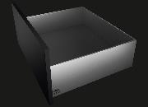
322020_a
Reduced look that is pure in design – uncompromisingly clean lines: AvoriTech takes the 8 mm drawer side profile to a new level in terms of design and practical functionality. Photo: Hettich
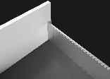
322020_b
Elegant contours: the AvoriTech drawer system demonstrates craftsmanship of the finest. Photo: Hettich
322020_c
Quality craftsmanship in every last practical detail: AvoriTech hides the adjustment elements from view behind unobtrusive cover caps. Photo: Hettich

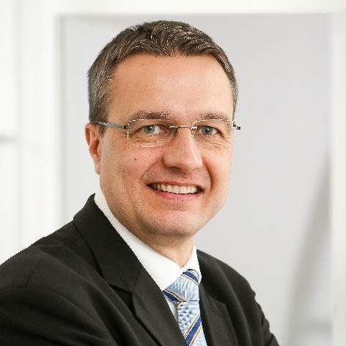
322020_d
Poggenpohl managing Director Ralf Marohn: "AvoriTech lets us remain true to our design line, once again underscoring our claim to leading the field in international premium and luxury kitchen design."

About Hettich
Hettich was founded in 1888 and is today one of the world's largest and most successful manufacturers of furniture fittings. Over 6,700 members of staff in almost 80 countries work together with the goal of developing intelligent technology for furniture. On this basis, Hettich inspires people across the globe and is a valuable partner to the furniture industry, retailers and the trades. The Hettich brand is synonymous with consistent values: with quality and innovation. For reliability and closeness to customers. Despite its size and international significance, Hettich has remained a family run business. Independent of investors, the company is free to shape its future in a humane and sustainable manner.

