Quadro Compact with fresh features
New comfort zones in the refrigerator
Refrigerators today are far more than simple appliances for storing food. Useful features are helping to make everyday kitchen routine more and more convenient for users. This is where Hettich is lending a hand as a provider of innovative solutions for the refrigeration segment. The manufacturer has now made some practical additions to its Quadro Compact product family: the present range of full extension runners for crisper drawers comes with a number of surprises in the form of new, intelligent functions for better ergonomics, a full view of contents and easy access to everything in the refrigerator.

Providing load capacities of 20, 40, 60 or 80 kg, the Quadro Compact product lineup caters to the refrigerator's entire drawer portfolio – from small, internal crisper to large, wide drawer. The full extension runners from Hettich impress with smooth, quiet running action and maximum lateral stability. Added to this, Silent System ensures controlled, quiet closing. Clever features are now available for crisper drawers from the Quadro Compact series. They help to make handling in the kitchen even easier.

Perfectly synchronised in XL too: Parallel System
The Quadro Compact's Parallel System makes drawers much easier to use, particularly the larger type ones. Opening and closing even extra-large pull-outs involves no effort at all – a touch of the finger at any point on the front is all that is needed. Working in the background, the Parallel System from Hettich takes care of perfect synchronisation. A pull system with sheathed wire cables provides the necessary lateral stability and smooth running action. Effectively protected against dirt or icing, the Parallel System can now reliably demonstrate its particular qualities: elegant, smooth and extremely quiet running performance for crisper drawers in a wide range of depths. And, after easily opening a drawer, the over extension function gives the user unobstructed access with everything in full view.

Taking off: system for releasing crisper compartments
Needless to say, Hettich also has the right answer for kitchen professionals who work efficiently and like to do everything in one go: using the practical Quadro Compact release mechanism on the front connection catch, crisper drawers can now be removed from the refrigerator and taken to the kitchen work surface together with contents. All ingredients are now instantly available precisely where they're needed. – Leaving work to commence on chopping the vegetables! The clever release mechanism for Quadro Compact FE 20 and FE40 pull-outs.

Duo for more storage space: Quadro Compact 2 in a line
Another cool idea for planning the kitchen: as an alternative to the classic refrigerator with hinged door, pull-out elements can be fitted directly below the kitchen worktop. The ingenious system behind Quadro Compact 2 in a line also makes optimum use of hard to reach storage space for refrigerating food: on opening the pull-out element, a second, lower level box automatically moves up, presenting contents which can then be taken out with effortless ease.

Elegant finish: convenience for wine refrigerators
For anyone appreciating fine wines, correct storage and temperature are the be all and end all to enjoy them at their best. Anyone who doesn't happen to have a wine cellar can opt for a wine refrigerator instead. The Quadro Compact is used here too: with its elegant, dark look, gentle, smooth running action and optional features, such as Silent System or Stay Close, the Quadro Compact FE 20 drawer runner is simply made for pull-out wine racks. Cheers!

The following picture material is available for downloading from the "Press" menu at www.hettich.com
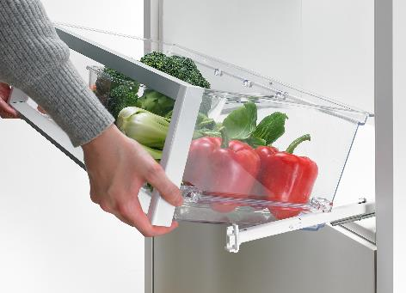
P88_a
Using the practical Quadro Compact release mechanism on the front connection catch, crisper drawers can be removed from the refrigerator and taken to the kitchen work surface together with contents. Photo: Hettich
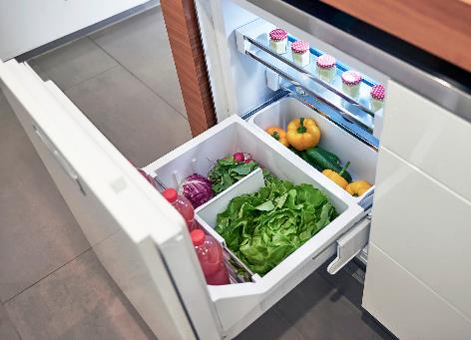
P88_b
Refrigerator of a different kind with Quadro Compact 2 in a line: on opening this pull-out element, a second box automatically moves up, making it easy to take out items of food. Photo: Hettich
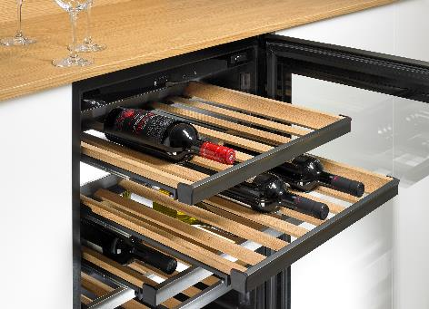
P88_c
Dark looks, smooth runner: the Quadro Compact FE 20 is simply made for pull-out wine racks. Photo: Hettich

