Hettich: Helpful e-tools for the cabinet maker
Do it the easy way!

Hettich wants to make work easier for cabinet makers and carpenters in every phase of a project and, to do this, offers practical online support from the initial idea, selecting products, ordering and planning to procuring material, realisation, assembly/installation and marketing. The quickest way is to go directly through the Hettich website at www.hettich.com: this provides direct access to the full range of e-services that are available. And should any additional questions arise, the Hettich service team will be pleased to help you in person.

Using the right tools, cabinet makers and carpenters can make their processes much faster and more efficient. The Hettich website provides a simple overview of all the information and e-services that are available from Hettich and also lets you access them directly: in your own workshop, on the road or at the customer's premises. Anyone saving the most important documents locally on their smartphone or tablet PC always has their personal "Hettich tool kit" at hand without the need for any data connection. The Hettich app provides a further working aid: it permits fast access to the contents of the online media library with catalogues, brochures, drawings or videos.

Useful tools for sales talks
The customer wants something exceptional? The Hettich Design Gallery offers plenty of ideas for unique furniture ideas you certainly won't find at retailers. Parts lists and technical drawings are also provided as a matter of course. This means that any creative furniture concept can be turned into reality straight away. Or does the customer want to know whether his or her choice reflects to the latest trends? In terms of materials, surfaces, colours, shapes and functions, the Hettich Trend Report provides quick, well-founded answers with an overall picture of the current highlights from the leading design and furniture fairs. Another key aspect for cabinet makers is the expert advice that is given on planning a kitchen: Hettich's Intelligent Kitchens concept provides a wealth of practical tips on how to organise kitchens in the proper way for short walking distances, ergonomic workflows and carefully considered storage solutions. This expertise also lets tradespeople score in talks with their customers. All tools are available at www.hettich.com and can be used free of charge at any time.

Planning certainty – everything done in the right way
Customers expect modern furniture design in top quality workmanship from the cabinet maker. With Hettich, the very latest design trends can be turned into reality with the right fitting technology. Cabinet makers can use various tools for perfect planning: Hettich Plan provides an overview of the various basic cabinet body designs, lets you configure them in any chosen way and then suggests the optimum choice of fittings. Extensive information, such as wood parts lists, fitting lists, CAD drawings and CAD exports is then available for production.
The Hettich CAD tool delivers all products in digital form as 2D and 3D drawings – and does so in over 50 different formats. The automatic generation of production documents shortens production times and increases planning certainty. This way, every piece of furniture is planned with ease and precision, from matching up dimensions or the exact positioning of fittings right through to setting the drilling points. And the virtual collision tests too help to avoid potential planning errors as early as the design phase.

The right choice, easily ordered
Anyone no longer wanting to use a printed catalogue to place orders will also find all products and sources of information in the brand new Hettich eShop. This always provides the latest product information and services – needless to say, on mobile devices as well. The search filters quickly take you to the right product. And with just a further click of the mouse, you also get assembly and installation instructions, videos or CAD drawings. Provided with all the information you need, you can now order the right product directly from the Hettich eShop or transfer your shopping basket to your own retailer's online shop.

Realisation and installation – all done to perfection
Suitable for use on mobile devices, the Hettich Technical Assistant not only helps you with installing and adjusting Hettich products but also provides further small installation tools. The various installation steps, short video sequences and answers to frequently asked questions are directly available at the click of the mouse. This way, most things can be sorted out in next to no time.

Hettich fittings are very easy to install and adjust. Installation and assembly animations help to get it right from the very start. Easy to understand and language-free, they provide step-by-step guidance to a perfect result. The clips are available on the Hettich YouTube channel in the product play lists, in the media library at www.hettich.com and, of course, in the Hettich app.

Never miss a thing: Social Media
Anyone following Hettich's social media channels on Facebook, Instagram, YouTube and LinkedIn is always up to date on the latest Hettich products and other interesting topics. The classic Hettich hotline is available for technical questions and orders and the fittings specialist can also be contacted by e-mail at eservice@hettich.com at any time.

The following picture material is available for downloading from the "Press" menu at www.hettich.com:
272020_a
Do it the easy way: the Hettich website www.hettich.com com provides useful online tools and services for the cabinet making trade. – Graphics: Hettich

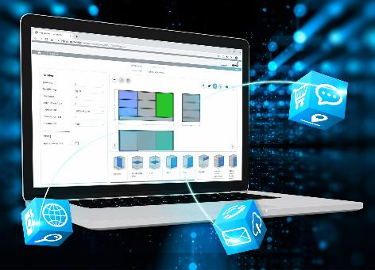
272020_b
Hettich Plan provides the key to planning furniture quickly and accurately with Hettich fittings on the computer or tablet. – Graphics: Hettich

272020_c
The Hettich Technical Assistant helps you in installing and adjusting our products and includes further practical installation tools. – Graphics: Hettich

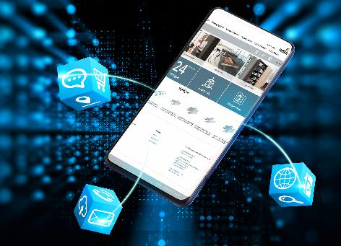
272020_d
The Hettich eShop always provides the latest product information and services – needless to say, on mobile devices as well. – Graphics: Hettich

About Hettich
Hettich was founded in 1888 and is today one of the world's largest and most successful manufacturers of furniture fittings. Over 6,700 members of staff in almost 80 countries work together towards the objective: developing intelligent technology for furniture. With it, Hettich fascinates people across the globe and is a valuable partner to the furniture industry, retailers and the trades. The Hettich brand stands for consistent values: for quality and innovation. For reliability and closeness to customers. Despite its size and international significance, Hettich has remained a family owned business. Being independent of investors means that the company has a free hand in shaping its future with a focus on the human element and sustainability. www.hettich.com

