Poggenpohl and Hettich enter cooperation partnership
Exclusive premiere in Herford

Pioneering innovations and unique perfection – this is at the focus of both Poggenpohl and Hettich. In future, Poggenpohl will be using the expertise of fittings specialist Hettich in key areas of its portfolio and is presenting a groundbreaking product innovation developed in cooperation with Hettich at the Küchenmeile show event.

With this new partnership, both companies are sending out a clear strategic signal. Poggenpohl Managing Director Ralf Marohn explains: "The name Poggenpohl stands for top quality, craftsmanship and trendsetting design. In Hettich, we have selected an innovative supplier who is able to meet Poggenpohl's high standards as a premium manufacturer. With this cooperation, Poggenpohl is now taking another important step into the future in the field of drawer and runner designs."

Uwe Kreidel, Managing Director of Hettich Marketing- und Vertriebs GmbH, Vlotho, is also looking forward to getting the cooperation partnership off to a successful start: "Poggenpohl is the oldest and best-known kitchen brand in the world and a key driving force in the premium and luxury kitchen segment. Together with Poggenpohl, we want to provide the very best solutions that a top kitchen manufacturer can offer its customers around the globe."
As part of Küchenmeile, Poggenpohl will be showing its partners the product that has been developed in cooperation with Hettich.
www.hettich.com
The following picture material is available for downloading from www.hettich.com, menu: Press:

Images
Captions
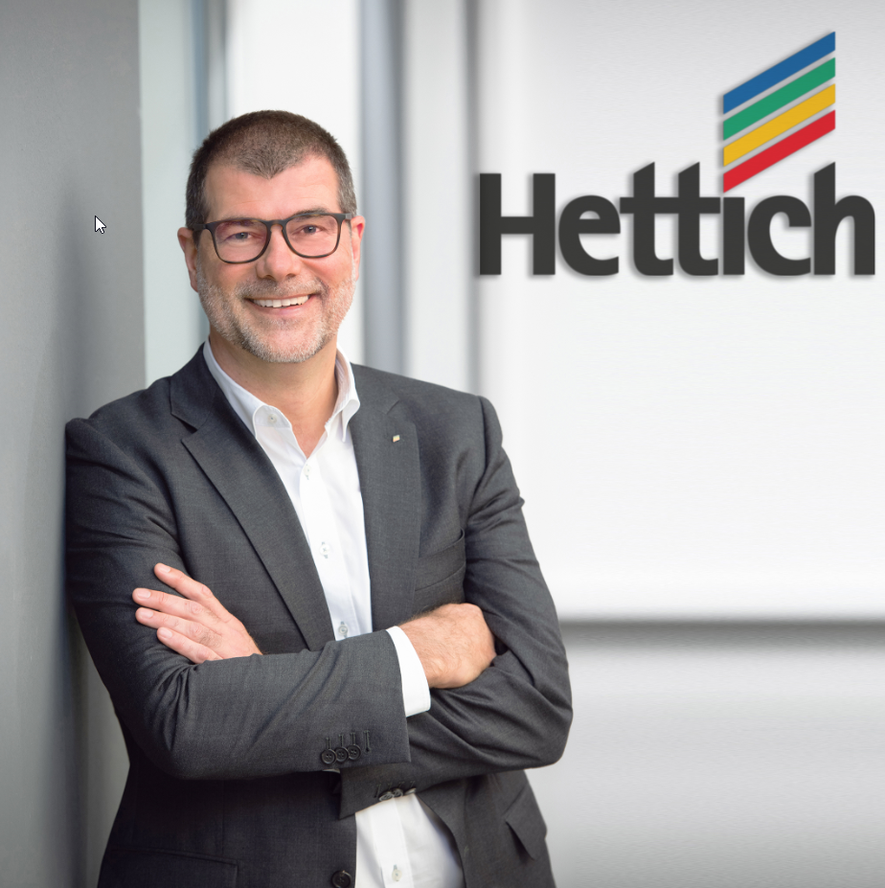
312020_a
Hettich Managing Director Uwe Kreidel: "Together with Poggenpohl, we want to provide the very best solutions that a top kitchen manufacturer can offer its customers worldwide." Photo: Hettich

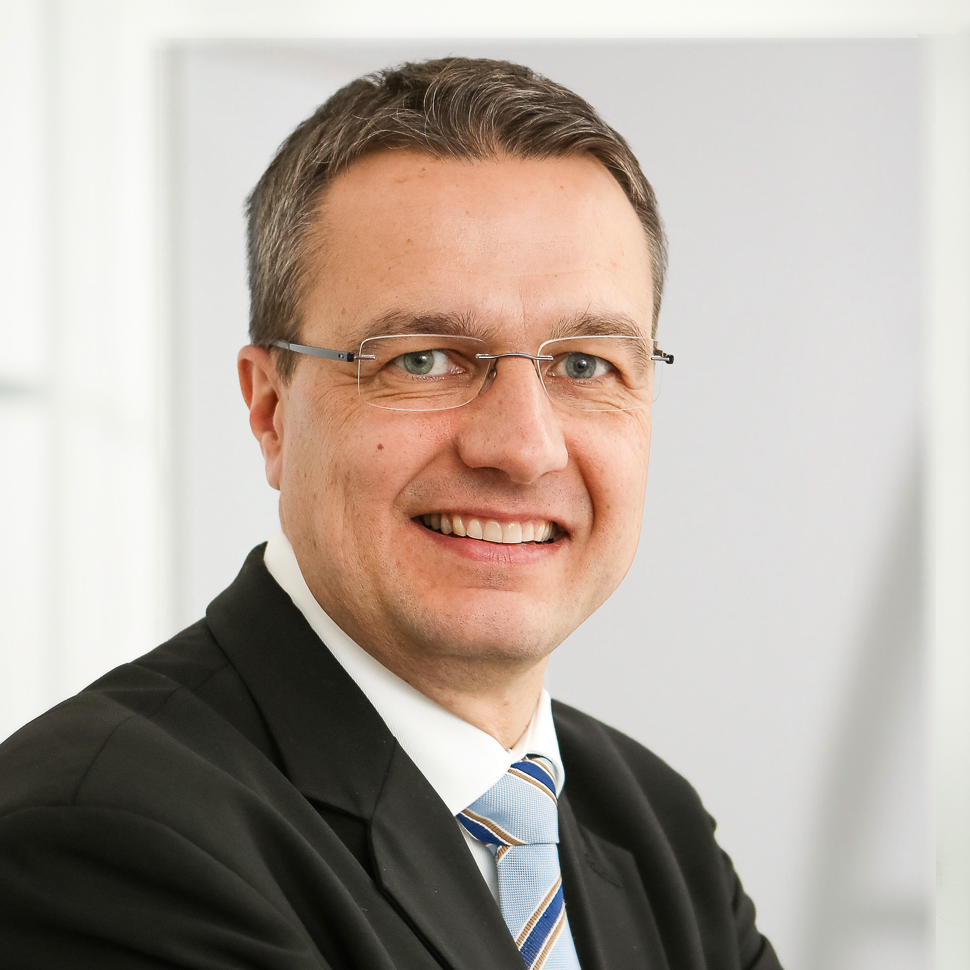
312020_b
Poggenpohl Managing Director Ralf Marohn:
"With Hettich, we have selected an innovative supplier who excellently implements Poggenpohl's high standards as a premium manufacturer."
Photo: Poggenpohl

About Hettich
Hettich was founded in 1888 and is today one of the world's largest and most successful manufacturers of furniture fittings. Over 6,700 members of staff in almost 80 countries work together towards the objective: developing intelligent technology for furniture. With it, Hettich fascinates people across the globe and is a valuable partner to the furniture industry, retailers and the trades. The Hettich brand stands for consistent values: for quality and innovation. For reliability and closeness to customers. Despite its size and international significance, Hettich has remained a family owned business. Being independent of investors means that the company has a free hand in shaping its future with a focus on the human element and sustainability.

